Project One: Catching anti protons using quadrupole Linear Paul trap.
Project Two: Creating a web interface for displaying ALPHA Spill Log data.

Summer Student Project 2019
Minhaj Uddin Ansari

Department: EP-UAD
Experiment: ALPHA
Project One Supervisor: Dr. Muhammad Sameed
Project Two Supervisor: Dr. Joseph Mc Kenna
Project One: Catching anti protons using quadrupole Linear Paul trap.

Table of Contents
Abstract -----------------------------------------------------------------------------------------------------------------1
Introduction ------------------------------------------------------------------------------------------------------------1
Software -----------------------------------------------------------------------------------------------------------------2
Experimental Setup ---------------------------------------------------------------------------------------------------2
Results -------------------------------------------------------------------------------------------------------------------6
Conclusion --------------------------------------------------------------------------------------------------------------7
References --------------------------------------------------------------------------------------------------------------8

Abstract:
Paul traps are used to trap charged particles. It uses alternating AC Voltage and DC Voltage to confine the charged particles in a specific region. Paul traps have been used to trap Ar13+, Be+ [1], 40Ca+ [2], Li+ [3], 24Mg+ [4], Yb3+ [5] and many other ions. At the ALPHA experiment in CERN, we produce antiprotons and trap them using Penning traps. One drawback with using Penning Traps is that the magnetic properties of the trapped particles cannot be measured with precision. In this paper, we explore the possibility of trapping anti protons (by simply trapping protons having opposite charge) using linear Quadrupole Paul trap. The results of our simulations reveal a specific trend and the parameters that can be used to trap anti protons.
Introduction:
Wolfgang Paul was born in 1913 in Germany. He joined the University of Bonn as a Professor in Experimental Physics in 1952 and during the 1950’s, he started working on trapping charged particles. As a result of his extensive work, he was able to co-develop the ion trap with Hans G. Dehmelt and won the Nobel prize for physics in 1989. Today, the ion trap is known as the Paul trap [6]. He served as the Director of Division of Nuclear Physics at CERN from 1965 to 1967. Paul traps are used to trap charged particles. It uses alternating AC Voltage and DC Voltage to confine the charged particles in a specific region. Earnshaw’s theorem states that charged particles cannot be kept in a stable fixed position by only electrostatic forces of interaction. That is why an AC component is necessary for trapping the charged particles. The variation of AC potential causes the charged particle to oscillate between the electrodes (at rf frequency), but it can never touch them resulting in the trapping of the charged particle. This rapid micromotion results in Doppler shifts, broadening of atomic transitions, and heating up of ion. Depending on the type of trap used, the rf field may have either a nodal point or a nodal line for which the micromotion disappears. To avoid excess micromotion and rf heating of the ions, experiments are often restricted to operate under conditions where the ions reside in these nodal regions [7]. The two most common Paul Traps are the Spherical Paul trap and the Linear Paul trap. Linear Paul traps are better than Spherical Paul traps due to larger storage capacity of ions and easiness of design and use. The configuration of a Linear Paul trap is simple. It contains four rods arranged in parallel to one another along with two end caps at both ends. AC voltage is applied to the rods and DC voltage is applied to the end caps. This results in a saddle shaped electric field, which constantly rotates to keep the charged particle trapped. The AC voltage ensures radial confinement along the x and y directions and the DC voltage ensures axial confinement along the z direction of the charged particle. The stability of the trap depends on the charge to mass ratio (e/m), the distance between two quadrupole electrodes of equal phase (r_{O}), the angular frequency of radiofrequency Ω (Ω/2π is the frequency of the applied AC voltage), the magnitude of DC Voltage and the magnitude of AC Voltage applied to the quadrupoles. Since the charged particle can move in three dimensions, we need to make sure that the parameters in the x, y and z directions can lead to stability [8].
Software:
Auto Desk Inventor Professional 2019 was used to develop the 3D geometry of the Linear Paul Trap and COMSOL 5.3a was used to simulate the physics of inserting anti protons into the Linear Paul Traps.
Experimental Setup:

5 cm
3 cm
0.2cm

1 cm
1.1451 cm

1) AUTODESK INVENTOR
The Linear Paul trap has 8 end cap cylinders and 4 center cap cylinders. The end cap cylinders are 3 cm long and the center cap cylinders are 5 cm long. The distance between the trap axis and the surface of electrode (center caps and end caps) is 2r_{o}=1 cm and the diameter of the electrode is 2r=1.1451 cm. This has been chosen based on the ratio r/r_{o}=1.1451 [9]. The distance between end cap and center cap is 2 mm. The end caps and center caps were joined together to make a Linear Paul trap assembly.
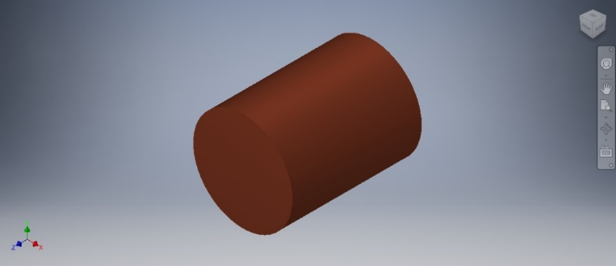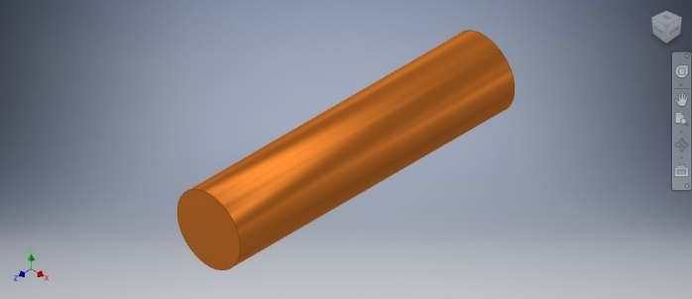
Fig 1. End Cap Fig 2. Center Cap
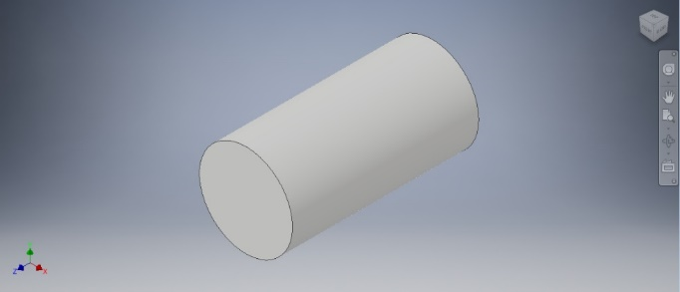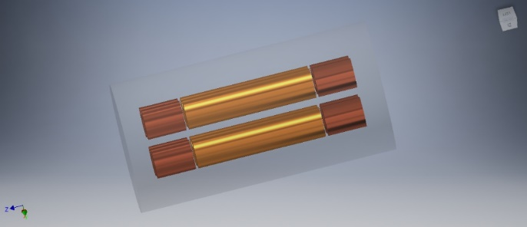
Fig 3. Enclosing Cylinder Fig 4. Paul Trap Assembly

2) COMSOL
The assembly created in the Autodesk inventor in the previous step was imported into COMSOL 5.3a. Electric Current (ec) and Charged Particles Tracing (cpt) physics modules with time dependent study were chosen. Using the ec module, end cap potentials were set to DC voltage 700V and diagonal center cap potentials were set to AC voltage V_{AC}*sin(2* π*f*t) and V_{AC}*sin(2* π*f*t + π). AC frequency f and AC voltage V_{AC} were variated to observe the trapping of particles under different values. Ten protons were released from a 1 cm diameter inlet which was placed at the center of the trap. Energy of the particles was thermal set to 12000 Kelvin.

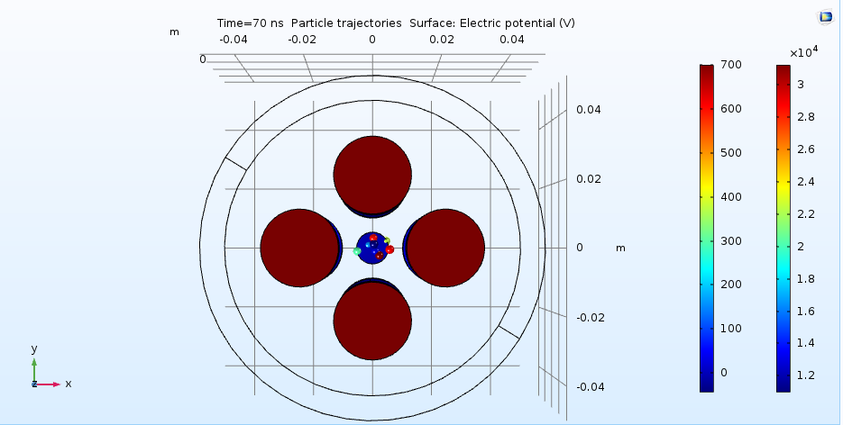
Fig 5. Particles in trap (front)

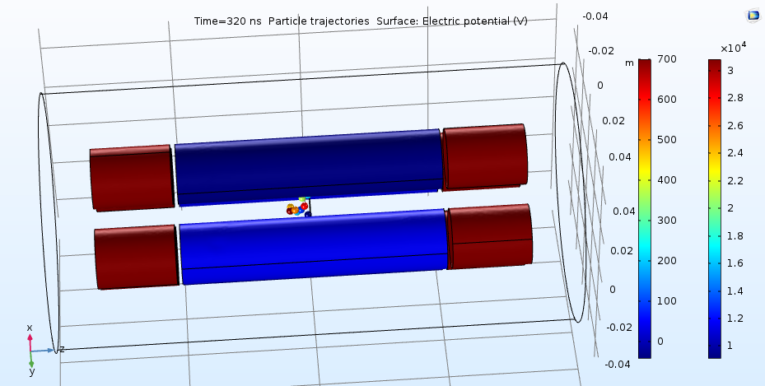
Fig 6. Particles in trap (horizontal side)

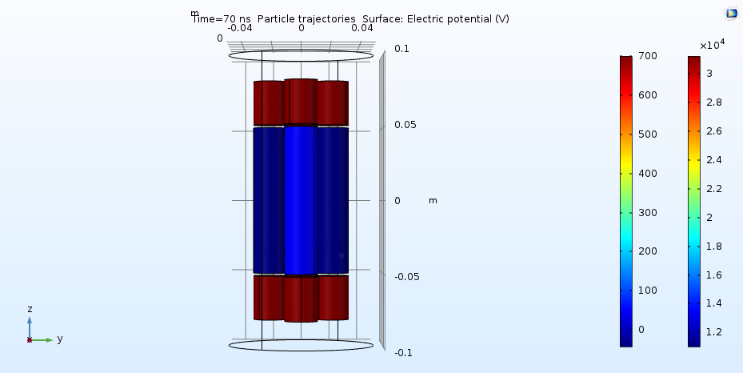
Fig 7. Particles in trap (vertical side)
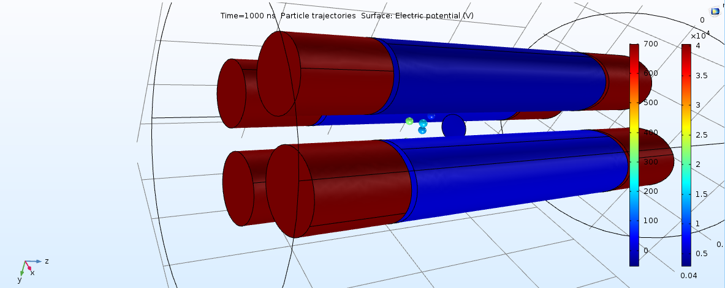
Fig 8. Particles in trap (corner)

Results
The simulation was tested using different values of AV voltage and frequency. The results show that the ratio of AC voltage and frequency should be approximately equal in order to maintain a pseudopotential that can store the protons. The heat map has Y axis representing AC Voltage and X axis representing Frequency.
 | 1 | 5 | 10 | 50 | 100 | 500
10 | 0 | 0 | 0 | 0 | 0 | 0
50 | 0 | 3 | 4 | 0 | 0 | 0
100 | 0 | 0 | 7 | 0 | 0 | 0
500 | 0 | 0 | 0 | 5 | 1 | 0
1000 | 0 | 0 | 0 | 0 | 5 | 0
5000 | 0 | 0 | 0 | 0 | 0 | 5
Fig. 9 Table for protons trapped under changing frequency (vertical) and voltage (horizontal)
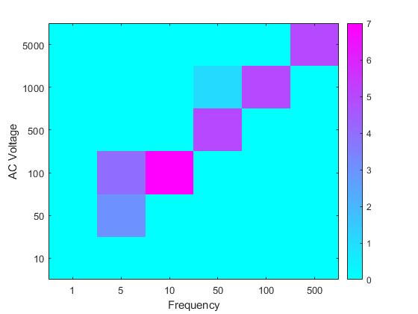
Fig 10. Heat map of the table shown in Fig. 9

Conclusion:
The results of our simulations complement well with the theory that the ratio of the frequency and voltage should be the same. There were some challenges that were faced when running the simulations such as loss of memory, slower processors, expiration of license of simulation software, and this may have led to lesser simulation runs, but the graph still depicts the nature of the trap. Future work may be to test the trap on square waves to see how effectively particles are being trapped. With square waves, we can get much higher frequency and amplitude.

References
[1] A cryogenic radio-frequency ion trap for quantum logic spectroscopy of highly charged ions T Leopold1 , S A King1 , P Micke1,2 , A Bautista-Salvador1 , J C Heip1 , C Ospelkaus1,3 , J R Crespo López-Urrutia2 and P O Schmidt1,3 1Physikalisch-Technische Bundesanstalt, Bundesallee 100, 38116 Braunschweig, Germany 2Max-Planck-Institut für Kernphysik, Saupfercheckweg 1, 69117 Heidelberg, Germany 3 Institut für Quantenoptik, Leibniz Universität Hannover, Welfengarten 1, 30167 Hannover, Germany E-mail: piet.schmidt@quantummetrology.de
[2] Stabilization and Control In a Linear Ion Trap John-Patrick Stacey Trinity Term 2003 Wadham College Oxford
[3] An ion trap for laser spectroscopy on lithium ions
[4] Building A Magnesium Ion Trap For Quantum Computation By Jiajia Zhou, B.Sc. A Thesis Submitted to the School of Graduate Studies in Partial Fulfilment of the Requirements for the Degree Master of Science
[5] A Linear Paul Trap for Ytterbium Ions A thesis submitted in partial fulfillment of the requirements for the degree of Master of Science by Phillip Wieburg
[6] https://en.wikipedia.org/wiki/Wolfgang_Paul
[7] Positioning of the rf potential minimum line of a linear Paul trap with micrometer precision P F Herskind1, A Dantan, M Albert, J P Marler and M Drewsen QUANTOP, Danish National Research Foundation
[8] https://en.wikipedia.org/wiki/Quadrupole_ion_trap
[9] A Combined Linear Ion Trap for Mass Spectrometry Yulin Huang and Guo-Zhong Li
Center for Interdisciplinary Magnetic Resonance, National High Magnetic Field Laboratory,
Florida State University, Tallahassee, Florida, USA Shenheng Guan and Alan G. Marshall
Department of Chemistry, Florida State University, Tallahassee, Florida, USA

Project Two: Creating a web interface for displaying ALPHA Spill Log data.

Project Description:
I used AJAX, DJANGO, JSON, HTML, CSS and JavaScript to create a web interface for the ALPHA Spill Log. Data from the ALPHA experiment is inserted into the database. Django extracts data from the database which is displayed on a table in the web interface. AJAX refreshes the table every second. With each AJAX refresh, data is extracted from the database. SO, if new data is inserted into the database, within a second’s interval, that data will be visible on the web interface table. There is also a search option to search previous data.
