Summer Student Report
Solene Delran
FE structural analyses for the EN/MME group at CERN

Abstract

This report gives an overview of a three-month internship within the EN/MME group, focusing on Finite Elements simulations for structural analysis of different equipment of the accelerators complex.
DOCUMENT PREPARED BY: | DOCUMENT CHECKED BY: | DOCUMENT APPROVED BY:
S. Delran EN/MME | F. Carra EN/MME | F. Carra EN/MME

Introduction
The following report presents the three-month internship as a summer student in the EN/MME-EDS section. Several structures were analysed, mostly with the finite elements technique, to optimize their design prior to construction and installation. Recommendations were given to the design colleagues, based on the simulations results. This report will present all the covered projects.

Covered projects
All the simulations were performed with ANSYS, and some analytical calculations were carried out using RDM7 opensource software.

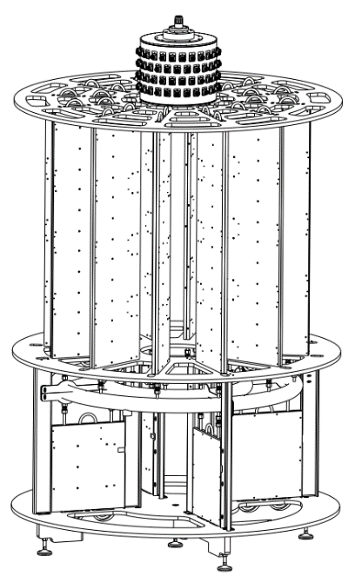
Design of the ELISA amplifier supporting system, to be exposed in the Science Gateway
ELISA is a miniature accelerator that will soon be exposed in CERN’s Science Gateway, a new building that will be inaugurated in October for CERN visitors. The identified problem was that its radiofrequency amplifier is too heavy to lean directly on the ground and exceeds the permissible surface load limit.
The solution was to design a metal plate which will be placed between the amplifier and the floor to better distribute the weight. The thickness, the bearing surfaces and different materials were studied through simulations. The transportability and the ease of assembly were also considered to dive a complete recommendation.

Sizing of metal supports for HL-LHC warm powering DC cables
The HL-LHC is an upgrade to the actual LHC accelerator. Heavy direct current cables will need to be supported in the caverns. Consequently, metal supports have to be dimensioned according to a space envelop provided by the EN/EL group.
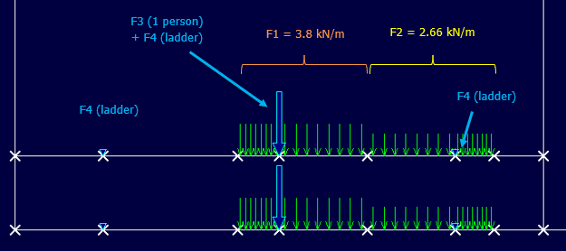
To provide a structural validation of the structure, stresses and deformations were calculated with the RDM7 software. Different cooling methods were studied between water-cooled cables (WCC) and air-cooled cables (ACC). The most disadvantageous case in terms of cable weight was kept for the calculations. Standard EN 1993-1-8 was used to assess the bolts of the structure.

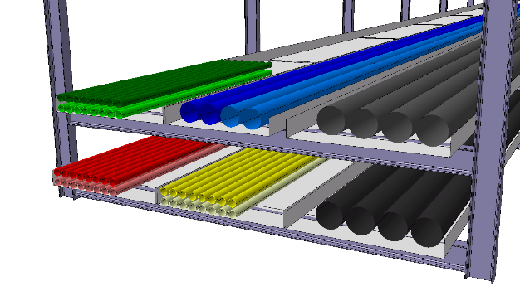

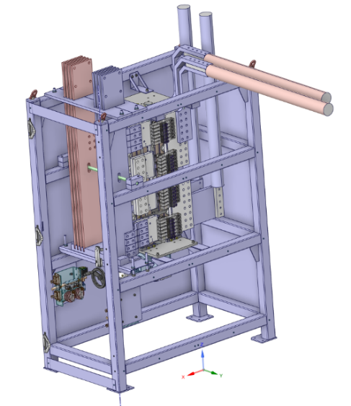
CDB supporting structure for HL-LHC
The external structure of a CDB support needed to be evaluated under a load case of 1.25 times its own weight before to be installed in SM18, where equipment is tested before to be installed in the caverns.
The structure was simplified with SpaceClaim to facilitate the finite elements evaluation. Both main masses were represented through mass points since the structure is not symmetric.
The mechanical behaviour was checked. The welds of the most stressed areas were assessed, as the bolts between the feet and the floor.

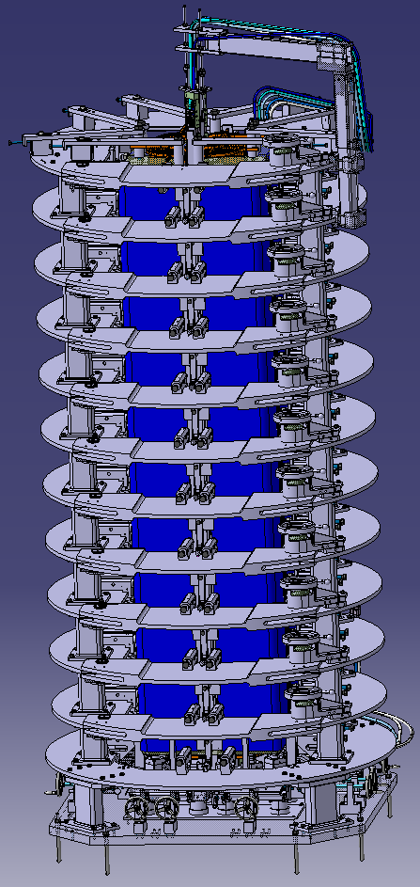
Opening system for large magnets
The TE/MSC group worked on a structure that must accommodate a magnet during its assembly phase. To do this, they have developed an opening system for inserting large magnets. The aim of this study is to evaluate the behaviour of the part that enables large magnets insertion. All the doors can be opened with a maximum opening of 90⁰. While the door is opening, it is only held on one side.
The first step was to assess the deformation of the door under its own weight while opening. Despite its deformation, the door should still be able to return to its initial position. Secondly, the effect of the torque exerted by the door on the stressed part of the ring supporting it must be studied and not exceed the yield strength.
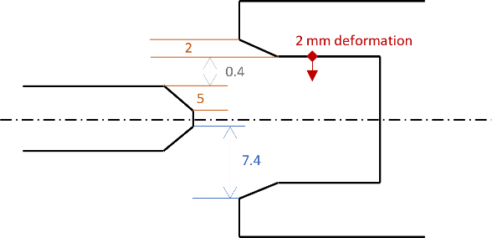

Weld and bolt assessment for MME laboratory’s traction machine
Clamps of the MME measurement laboratory’s traction machine had to be assessed. The welds were checked, as well as the bolts fixing the clamp to the rest of the structure.

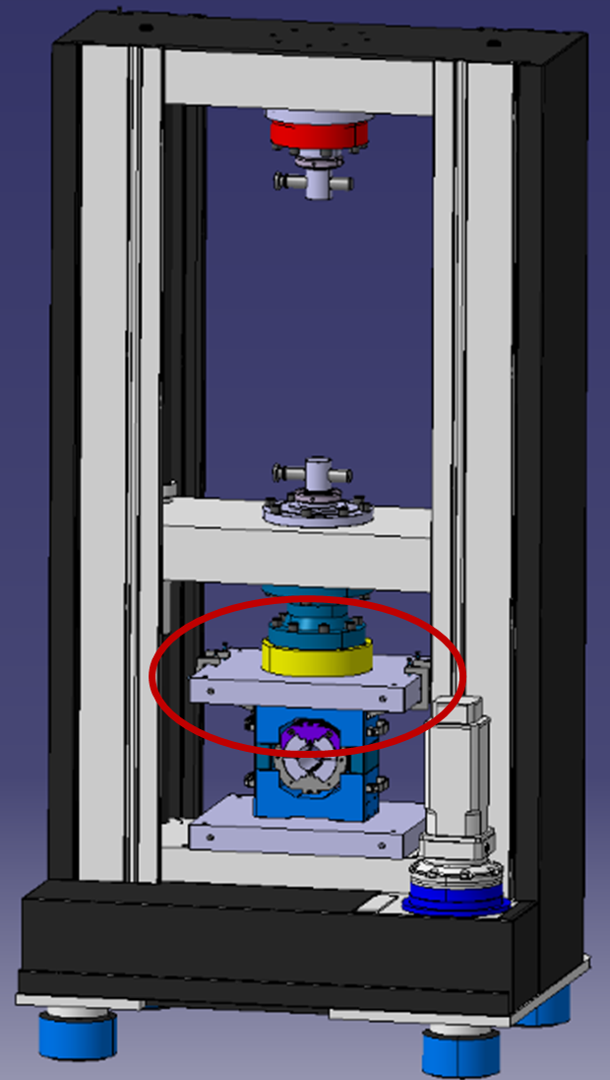
To prevent isolated maximum stress from appearing, “Elemental Mean” stress was studied to better represent the stress distribution. The weld assessment validated the use of 4 M6 bolts of class 8.8. Likewise, a 1 mm weld throat led to a safety factor superior to 10.
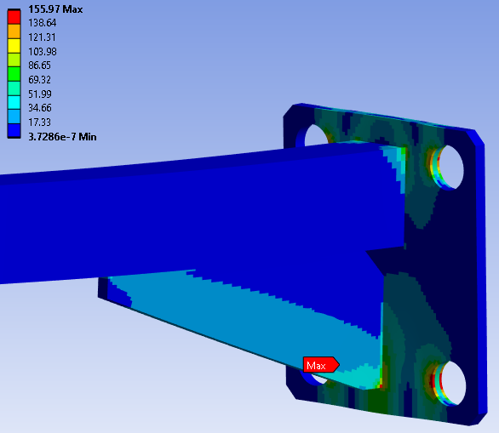
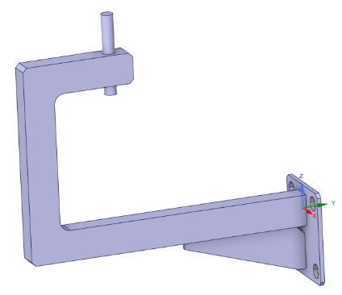

FCC half arc cell girder analysis
The FCC study is about the next generation accelerator that is proposed to be constructed in the next years. The EN/MME group is responsible for building a half arc cell mock up in order to optimize and test aspects related to fabrication, integration, assembly, transport, installation, alignment, stability and maintenance.
During this study, the use of girders, supporting quadrupoles and sextupoles, is planned to simplify their pre-assembling and alignment of to save time and costs. However, the design must be optimized to limit vibrations in order to maintain the alignment required by the beam. To do so, a modal analysis had to be performed.
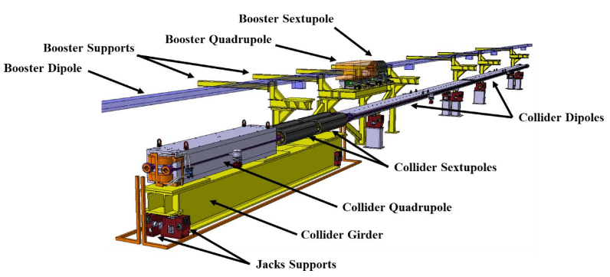
Different girder configurations were compared by changing the number of feet, jacks and their position. The objective is to maximize the excitation modes frequencies by making the girder compact.

Tanks filled with chemical mixtures
EN/MME group is designing tanks filled with chemical mixtures and their supports for a new building to be used for surface treatment of superconducting cavities, cryomodule assemblies, etc. The design team needed to be supported by calculations to optimize some structures.
The used materials are particular and have involved advanced research into their mechanical characteristics. The chemical mixtures were represented by hydrostatic pressures. The structural analysis led to some design recommendations.
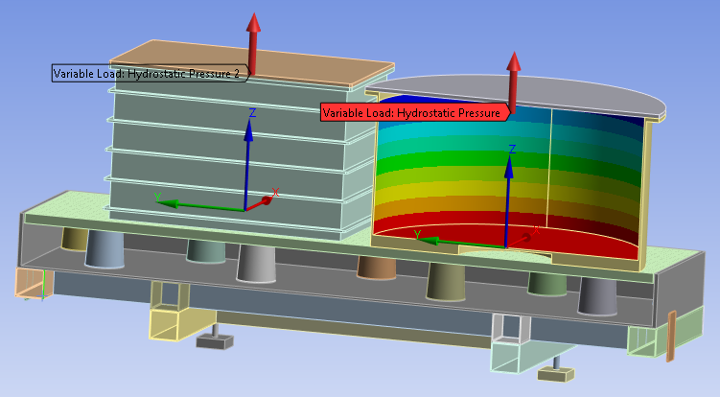

Coil compression test tool
As part of the muon collider project, coils will have to withstand pressures of up to 600 MPa. To ensure that the system is robust, test tools have been created. In this case, a manual compression tool is being considered.
The simulations considered the worst case given by the tolerances and explored the results for various coefficients of friction in order to choose the appropriate surface treatment. Materials were chosen according to the behaviour of each part. Later, a bolt assessment will have to be carried out.
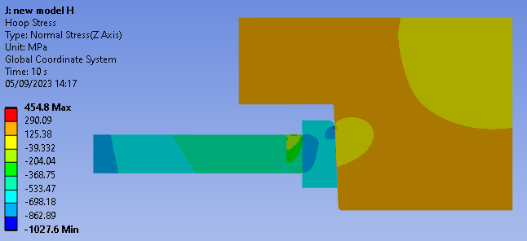

Conclusions
This 3-month work placement in the EN/MME department gave me the opportunity to work on a wide range of projects, which gave me an insight into the job of a calculation engineer. Thanks in particular to my status as a Summer Student, I had the chance to visit many of CERN's facilities and attend a series of lectures, which gave me a better understanding of the scientific and technological issues facing CERN.

Experimental LInear accelerator for Surface Analysis
High Luminosity Large Hadron Collider
Circuit Disconnector Box
Magnet, Superconductors and Cryostats group
Future Circular Collider

