Measuring the pseudorapidity distribution of charged particles in proton-proton collisions at√s=13 TeV with the ALICE Experiment at the LHC
Xiaoyu Liu (lxiaoyu1122@gmail.com)
Supervisor: Paolo Bartalini, Prabhakar Palni

During this summer, I worked in the ALICE HMTF (High Multiplicity Task Force) group, participating in the work of measuring the pseudorapidity distribution of charged particles in high multiplicity pp collisions at √s=13TeV.

Background and introduction
One of the main issues affecting the study of the minimum bias events is the possible presence of pile-up, i.e. the statistical effect related to the operation with a large number of protons in the crossing bunches. β is defined to be the average number of pp interactions per beam-crossing. Since the RUN II operations are specifically planned to reach high integrated-luminosities, the high level of pile-up may represent a serious problem to isolate the single interactions. In this respect ALICE represents an exception, as it will always run at β<<1. Indeed the ALICE detector has a unique opportunity to collect a large sample of low pile-up High Multiplicity pp data in RUN II.

Figure 3 [Phys.Lett. B 753, 319 (2016)] is the pseudorapidity distribution measured by ALICE for pp interactions at√s=13 TeV for the two event classes INEL and INEL>0 compared with the predictions of the Pythia 8 and the Pythia 6 Monte Carlo generators. My work as a summer student in the ALICE HMTF is to contribute to the extension of this measurement in High Multiplicity Final States, i.e. on events that have charged multiplicity one order of magnitude larger than the average one:
.
The presented ALICE dNch/dƞ measurement has been performed using just one run of pp events at 13 TeV. In order to have a significant statistics of High Multiplicity events, we need to use all the available data from both the Minimum Bias and the High Multiplicity triggers.

During this summer, I focused on the quality assurance of the pp Minimum Bias and High Multiplicity data collected in 2015. The main strategy to achieve such goal was to repeated the pseudorapidity measurement on Minimum Bias data collected in different periods, x-checking also the agreement of the basic distributions between the data and the simulation, and investigating various effects like the trigger conditions, the change in the LHC beam structure and the response of the inner Tracking System to these changes.
Basic physics concepts

We are interested to study the general features of the pp collisions. In most of the cases the colliding protons give rise to hard interactions. Actually these interactions take place between their constituents (the partons, i.e. the quarks and the gluons). The interactions between the partons and the subsequent showering are well described by perturbative QCD (Quantum Chromo Dynamics). Although the transition of the final state partons to the observable hadrons (which are color-less) is not calculable perturbatively, QCD-based models and conservation principles can still drive the interpretation of our data. The final state of these pp collisions is typically made of tenths to hundreds particles which may or may not show collimated flow of particles (jets). In general the particles come out in all directions with different θ (figure 1).

The transverse momentum (p_{T}) of these particles is a particularly useful observable as it is relativistically invariant. Typically it spans between few hundreds of MeV to few GeV. The innermost tracking detectors are particularly effective to measure the long-lived charged particles that can be directly counted: we refer to N_{ch} as the number of charged tracks in the event.

We define rapidity as
Differences in rapidity are conserved under Lorentz boosts in the z-direction.
Then we define the pseudorapidity (ƞ) as
In the massless approximation the pseudorapidity intervals also turn out to be relativistic invariant. Hence the pseudorapidity density distribution of charged tracks (dN_{ch}/dƞ) is a well defined observable in any reference frame.
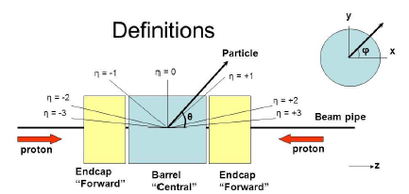
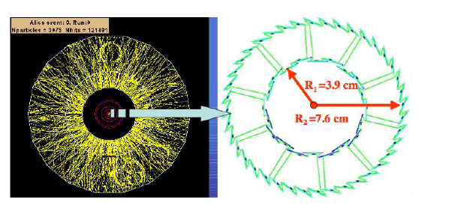
figure1: The definition of pseudorapidity figure 2: The SPD detector
Detector and Trigger used
In our analysis, we mainly rely on two ALICE sub-systems: one is the tracker detector including the TPC (Time Projection Chamber) and the SPD (Silicon Pixel Detector). The other one is the Minimum Bias trigger considering information from the V0 scintillators VOA (2.8<ƞ<5.1) and VOC (-3.7<ƞ<-1.7) as well as from other forward (ADA, ADC, etc.) or central (SPD) detectors.

The SPD consists of two layers: the inner and the outer layer. As showed in figure 2, these two layers of SPD are very close to the beam pipe, where the pp interactions take place.

Charged particles crossing the SPD detector ionize the detector producing electrons and holes and giving rise measurable hits that are read-out by the front-end electronics. The SPD tracklets are tracks reconstructed using the position of the primary vertex and one hit each on the inner and the outer SPD layers. Using the information on the multiplicity of reconstructed SPD tracklets, we can calculate the charged-particle pseudorapidity density distribution by the following relationship:
where α is the acceptance times the efficiency for a primary charged-particle to produce a tracklet, and β is the contamination of reconstructed tracklets from any background source (in particular from the combinatorial one).

When we select events, there are two normalization classes. One is the inelastic events (INEL), On top of that, there is inelastic event with at least one charged particle within the region |ƞ|<1.0 (INEL>0). The pseudorapidity distribution of charged particles is measured for both INEL and INEL >0 normalization classes.

The events are selected with a Minimum Bias trigger with logic V0A||V0C||ADA||ADC (referred to as CINT10) or with logic V0A||V0C||SPD (referred to as CINT1 or simply MB). CINT10 is more inclusive that CINT1 although none of these two logics correspond to the event classes defined above (INEL, INEL>0) and corresponding corrections accounting for the trigger selection have to be taken into account.
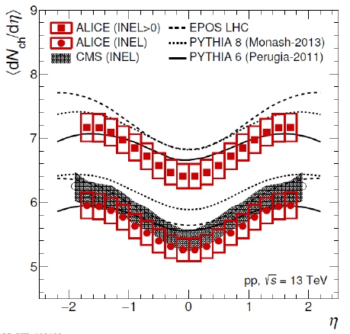
figure 3

Software Framework and Analysis Codes

This analysis uses the standard codes developed for Pb-Pb and pp vs Multiplicity analyses. The software framework used is based on the AliPhysics/AliRoot/ROOT triplet versions reported in Table 1.
AliPhysics | vAN-20160801-1
AliRoot | v5-08-12-1
ROOT | v5-34-30-alice-24

Table 1: Software used
The analysis code is located in the following directories of the Aliphysics GIT repository [?]:
$ALICE PHYSICS/PWGLF/ppVsMult/dNdEtaPP13/task
$ALICE PHYSICS/PWGLF/ppVsMult/dNdEtaPP13/macros

Results
The Effect of the beam structure
The SPD clock frequency is 10 MHz (100 ns clock period), so there are 4 possible 25 ns slots in our 100 ns clock period where the collisions may happen. The different slots are selected by a parameter called bcmod4. In total, there are 4 values of bcmod4, i.e 0,1,2,3. Each event is characterized by a given bcmod4.
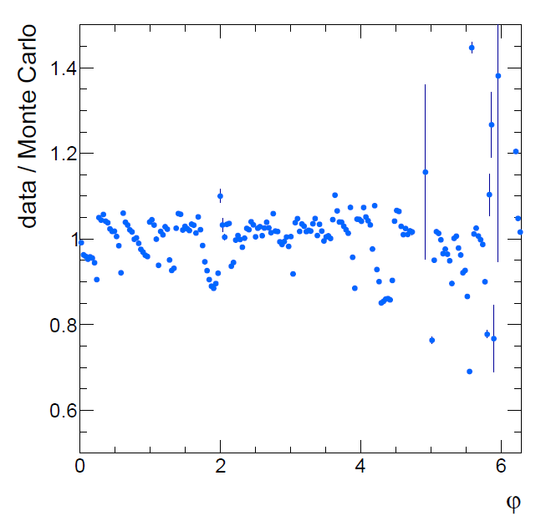
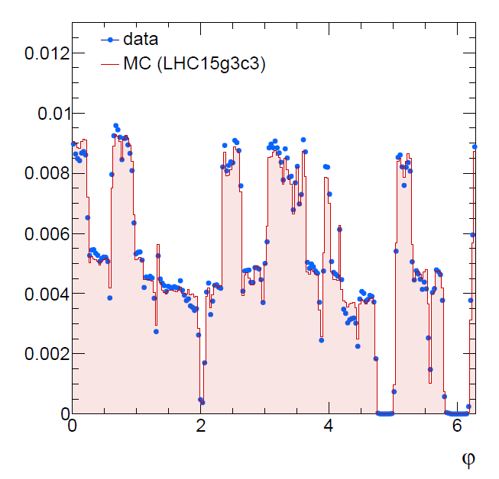
Figure 4: Azimuthal (φ) distribution of tracklets for Data and Monte Carlo. Run 225315

As is showed in figure 4, there are discrepancies between Data and Monte Carlo (MC) for φ ~ 1.8 and φ ~ 4.25. This is a common case in LHC15f period until run 225768. (I analyzed three runs: 225315, 225322 and 225717 on top of the golden run 226062 which was used for the reported publication.)

In the LHC15f period the beam crossing rate was 50 ns therefore only two bcmod4 values are defined: bcmod4=0 and bcmod4=2. My work is to investigate the pseudorapidity distribution setting bcmod4=2 and to see if there will be any improvement in the correspondence between real data and MC simulation.

It turned out that selecting events with bcmod4=2 does indeed fix few problems dealing with the data vs. MC discrepancies in the φ distribution. First, deeps are no longer observed in the Data/MC ratio for φ ~ 1.8 and φ ~ 4.25. Second, weird triangular shapes at low φ disappear. Also, the tracklets rate per event does increase of about 4-5% with a corresponding huge improvement in the dN_{ch}/dη shape that finally looks much more symmetric with respect to the one quoted for all the events (bcmod4=0 + bcmod4=2). From a quantitative point of view the last statement is corroborated by quoting the skewness of the dN_{ch}/dη distributions. 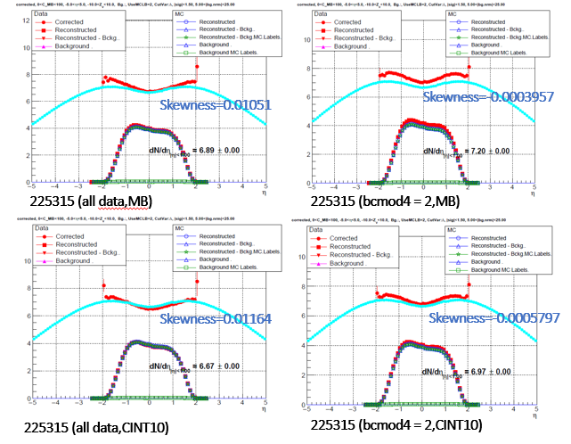
Figure 5: Corrected dN_{ch}/dη distributions(236159)

Then I further investigated the runs in LHC15i,j,l periods as well. Since the interaction rate for these period is 25 ns, all the four bcmod4 values are defined for them. I compared the pseudorapidity distribution for all the bcmod4 values. No major beam structure effects are detected in this case, although the shape of the dN_{ch}/dη distribution for the LHC15l period does certainly look more symmetric with respect to the ones measured in the LHC15i and LHC15j ones. The source of these asymmetries has still to be understood.

The Effect of the Minimum Bias trigger
In my analysis, I used two triggers. CINT10 and CINT1. Both of them are minimum bias triggers. But their logic is different. The logic of CINT10 is VOA||V0C||ADA||ADC, while the logic of CINT1 is V0A||V0C||SPD. 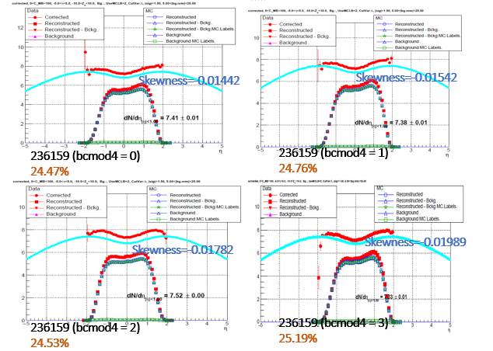Figure 6: Corrected dN_{ch}/dη distributions(236159)
It turned out that in the LHC15f period, the difference between the average dN_{ch}/dƞ value for the CINT1 and the CINT10 trigger is ~ 3.5%.

Comparison between LHC15f period and LHC15i,j,l periods
In the runs selected from the LHC15i,j and l periods, the average dN_{ch}/dƞ figures turn out to be slightly higher with respect to thos obtained running on the LHC15f period with the same trigger(CINT10) and vertex cuts (the z coordinate of the vertex, along the beam direction, is requested to be within the interval [-10 cm,10 cm]).

Conclusions and Future work
My summer student project was very useful to ALICE and more specifically to the HMTF. It allowed confirming and better understanding some weird features of the SPD response to the beam structure in the early 2015f period. It also confirmed that such feature is not present in subsequent periods, in particular it does not affect the golden run used in the publication [Phys.Lett, B 753, 319 (2016)].
The study of dN_{ch}/dη across different periods allowed to get a first feeling of the corresponding systematic in particular for what concerns the variations of < dN_{ch}/dη > and the skewness (quantifying the symmetry). No candidate source for the the asymmetries observed in the LHC15i and LHC15j periods was identified, in particular I did demonstrate that it is not due to the beam structure effects.

There are still some problems in my analysis, for example. The fraction of the 4 different bcmod4 values should does not sum up to 1, however this is understood to depend on the possibility of having failing jobs on the GRID.

Also, I should mention that during my summer student project at CERN, I started to develop a Rivet [] plug-in for Phys.Lett, B 753, 319 (2016) and for the future publication reporting dN_{ch}/dη for different multiplicity classes.

I am looking forward to finalize these studies and to contribute even more to this research line. Indeed I just registered as student in ALICE affiliated to my home institution and I will have the opportunity to continue the work once I will be back at CCNU in Wuhan.

I wish to thank all the people involved in the organization of the wonderful Summer Student programme that I had the opportunity to join in 2016.

