CERN Summer Student Programme

Simulations of LEIR Injection Line
Beam Position Monitors

BE-BI-PI group

Mariya Maltseva
maltsevamarie@gmail.com

Supervisors:
Michele Bozzolan
Lars Soby

August, 2016

Abstract
In this paper sensitivity characteristics of a beam position monitor are described. Characteristics are obtained during the simulations in CST Studio, the results are compared with the calculated values. The results for a low-beta beam and with a wire are compared.

- Introduction
Linear accelerator 3 (Linac 3) is the starting point for the ions used in experiments at CERN. After Linac 3 the lead ions are multi-turn injected to the Low Energy Ion Ring (LEIR), from which they get to the Proton Synchrotron (PS), Super Proton Synchrotron (SPS) and, finally, to the Large Hadron Collider (LHC). Moreover, Linac 3 provides too lead ions for fixed-target experiments. Researchers have requested that it produce other ions in the future, including argon and xenon.
In Fig. 2 the part of CERN accelerator complex is presented with LEIR injection line indicated.
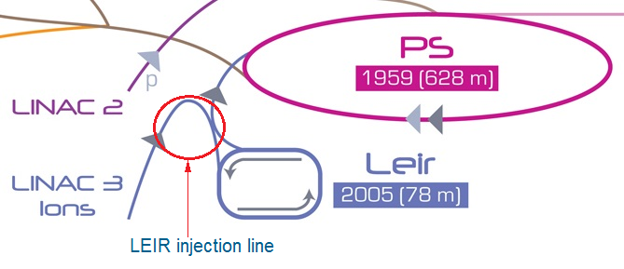
Fig. 1. Part of CERN accelerator complex
The designed injection efficiency is 70%, however, the real efficiency is typically around 50% (the meaning varies within one cycle). Position diagnostics in the form f beam position monitors (BPMs)in thetransfer line is needed in order to improve the LEIR injection efficiency.

- Pickup sensitivity characteristics
In this paper characteristics of a segmented ring-shaped pickup are studied. Angular width of electrodes is 75°, length of the pickup electrodes is equal to 210 mm, electrode thickness is 1.5 mm and other pickup dimensions are presented in Fig. 2.
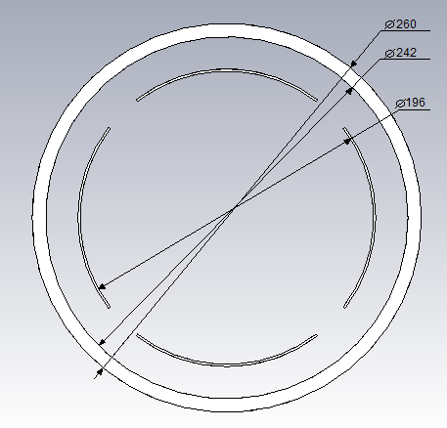
Fig. 2. Pickup dimensions
Let U be the upper electrode voltage signal, D is the bottom electrode voltage signal. From [1], the difference-over-sum ratio for a displacement in vertical direction y is
$\frac{U-D}{U+D}=yS_{y}^{'}=\frac{4\sin\left(φ/2\right)y}{φ b}+higher‐order terms.$ (1)
A more linear (in y) approximation in cylindrical geometry is to write the ratio of U/D in decibels:
$20 \log_{10}\left(\frac{U}{D}\right)=yS_{y}=\frac{160\sin\left(φ/2\right)y}{\ln\left(10\right)φ b}+higher‐order terms ,$(2)
where S_{y} and S_{y}’ are the pickup sensitivity characteristics in vertical direction, b is the electrode radius. In theory, electrical responses given by (1) and (2) should be the linear functions of displacement, i.e. calculated values S_{y} and S_{y}’ from (1) and (2) do not depend on y. The actual electrical responses of the pickup is a nonlinear function of displacement.
In actuality, the electrodes are neither grounded nor at the same radius as the beam pipe. In practice, the best empirical results with calculated S_{y} and S_{y}’ are obtained if the radius used in Eqs. (1)and (2) is the average of the electrode radius and the beam pipe radius.

- Simulations results
By means of simulations in CST Studio, electrode sensitivity characteristics were obtained. Simulations were ran with a wire as well as with particle beams of different betas: low-beta(0.1) and high-beta(0.99999). After manufacturing, the pickup will be tested with a wire. So, it is important to compare results of the present work with a wire and with a low-beta beam.
Simulations were ran in case of different beam and wire radii (from 0.1mm to 10mm) with a relevant meshing. However, for a beam/wire displacement not more than 80 mm, the electrical response were identical.
For the centred horizontal position, the electrical response $\frac{U-D}{U+D}$ was obtained as well as $S_{y}^{'}$. The results are presented in Figs. 3 and 4. Calculated curves for different radii (electrode radius as well as average of beam pipe radius and electrode radius) are also shown.

Fig.3. Difference-over-sum of signals vs vertical displacement

Fig.4. Sensitivity characteristic S’ vs vertical displacement.
The amplitude ratio of U/D in decibels was also obtained, from which sensitivity characteristic S_{y} was obtained. The results as well as calculated curves are presented in Figs. 5 and 6.

Fig. 5. Signal amplitude ratio vs vertical displacement

Fig. 6. Sensitivity characteristic S vs vertical displacement

- Conclusions
- From [2], BPM position sensitivity increases al low energies. So, higher beta beam curve should be closer to the wire curve than the smaller one. This statement agrees very well with the simulations results.
- Simulation sensitivity characteristics are closer to the calculated characteristics with a radius of the average of electrode radius and beam pipe radius than to the calculated values with the electrode radius.
- Comparison of sensitivity characteristics in simulations with a wire and with a low-beta (0.1) beam. S_{y} characteristics differ for not more than 10%, S_{y}’ characteristics differ for not more than 7%.

- References
- R. E. Shafer. “Beam Position Monitoring”, AIP Conference Proceedings 249 (1992),pp. 601-636.
- R. E. Shafer. “Beam Position Monitor Sensitivity for Low-β Beams”, Proceedings of the 1994 International Linac Conference, pp. 303-307.
- P. Strehl. “Beam Instrumentation and Diagnostics”, Springer, Berlin/Heidelberg/New York, 2006, pp. 173-176.

