Development of Low-Cost High Precision Interferometry Equipment for Use in Schools

Matthew Graham
Supervisors: Fabian Bernstein and Julia Woithe
October 10th 2019

Introduction
Currently, there is no means of purchasing interferometry equipment without spending a substantial amount of money. (1) (2) This limits the ability of schools to physically demonstrate key elements of optics, relativity, quatum light effects, and gravity waves – all of which are course content in many secondary education curricula around the world (3) – which in turn reduces the understanding and interest in the subject for pupils.
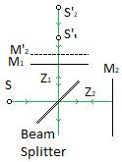
This issue could be resolved if an easy-to-use low-cost experiment kit would be available. The development and testing of such a set up has been the major objective of the internship. With the advent of accessible additive manufacturing facilities, it was designed with 3D-printed optical mounts that can utilise common optics and laser components in the interferometer. This has reduced the cost of the entire experiment to under €50. In order to make this project engaging and to demonstrate the usefulness of the device, they were designed to be used with a specific experiment: a Michelson interferometer with a laser microphone experiment. This set up not only demonstrates the physics principles and versatility of the tools but also gives knowledge on electronics and data logging, further adding to their classroom use.

Background
Figure 1 shows the setup of the Michelson interferometer. It projects a collimated laser light source, S, onto a 45° angled beam splitter that splits the beam equally onto two perpendicular mirrors, M₁ and M₂. This light gets reflected along the same path and is collimated again on the far side of the beam splitter. However, due to differences in the lengths z₁ and z₂, resulting in differences of the optical path length a phase shift between the partial beams is introduced and thus causes an interference pattern to appear on the observation plane. (4)
Figure 1: Top down view of a Michelson interferometer setup
The phase difference, d, between the two beams is described in Equation 1, with λ being the wavelength of the laser light and θ being the angle between the system axis and the angle of beam observation. This should ideally be 0º at the centre of the observation plane. (5)
$$d=2π\frac{2\left(z_{1}-z_{2}\right)cosθ}{λ} Eq 1$$
This phase difference creates concentric fringes of light, known as Haidinger fringes (6), centred around the projected normal of M₁ on the observation plane. If the mirrors are not perpendicular to the system axis, θ being non-zero, then the interference would not show up as concentric rings. This is because the virtual sources S’₁ and S’₂ (the point where the source would be if the beam is recreated with no reflection) would not be in line with the normal of the optical plane, which means the phase differences would not be the same at every distance from the centre of the optical plane, creating a different interference pattern. This effect is useful as it gives a visual aid to optimise the experimental setup. (7)
The intensity, I, of the Haidinger fringe at each point on the observational plane is described in Equation 2. It is composed from the beam amplitudes, E₁ and E₂, creating the background intensity and the phase difference at the point of observation. If the beam is observed further away from the normal, the phase difference of the beam increases. This mechanism creates the varying intensity Haidinger fringes. Constructive interference is maximum while the length between M₁ and M₂ is observed at a multiple of half λ. Destructive interference is maximum when they are observed a multiple of quarter and three quarters λ. This can be show mathematically in Equation 4 and 5. (8)
$$I=E_{1}^{2}+E_{2}^{2}+2E_{1}E_{2}cos({d)} Eq 2$$
$$m= \frac{2∆z cosθ}{λ} Eq 3$$
$$Constructive: d=2mπ where m=0, ±1,±2,±3… Eq 4$$
$$Destructive: d=π\left(2m+1\right) where m=0, ±1,±2,±3… Eq 5$$
When the mirrors M₁ and M₂ are moved relative to each other, this also changes the global phase difference on the observation plane, creating an illusion of expanding fringes appearing from the centre. Precise measurements of the relative movement between the mirrors can be made by counting the number of new constructive interference fringes that are produced through the duration of the movement. As seen in Equation 4, the distance, z, between each new full fringe created on the observation plane is equal to half the laser wavelength. (9)

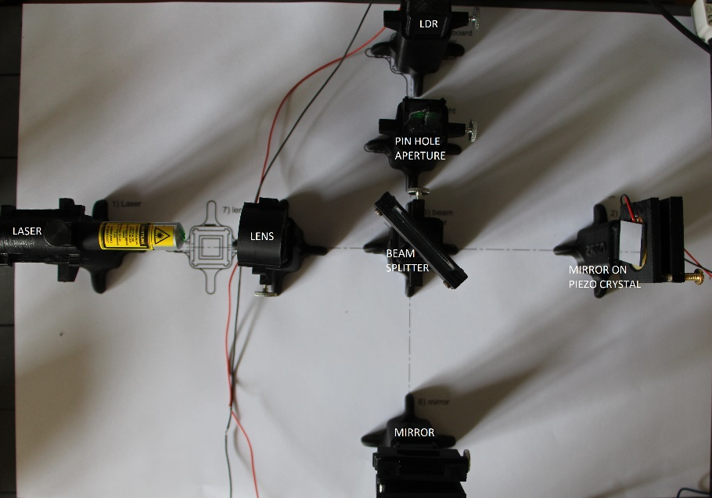
Experiment
The Michelson interferometer was set up as shown in Figure 2, utilising 3D printed mounts, 2” mirrors, a half-silvered beam splitter, a laser diode pen with a wavelength of 532nm, and a small focusing lens with a 20mm focal length to expand the interference pattern. The technique for setting up the device is detailed in the setup document on S’Cool LAB. Because only the movement of mirrors relative to each other is measured, and because the beam splitter angle only affects the intensity ratio of the beams, the set up does not need precision. The angle of the mirror can vary by approximately ±0.05º from axis perpendicularity in order to produce Haidinger fringes. However, this is relatively easy to achieve as there are many ways to locate the laser angles, as explained by the S’Cool LAB setup documents.
Figure 2: Michelson interferometer set up
A light-dependent resistor is used at the observation plane in order to measure the movement of the interference fringes. A piezo-electric crystal is placed on the back face of mirror M₁ and is connected to a wave generator that could provide a variable voltage through it. This causes a deformation in the crystal and the mirror attached to it, changing the phase difference and therefore causing the fringe pattern to expand. The number of these fringes, m, that pass over the LDR would be the distance the crystal has been displaced, l, through Equation 6. This enables, from just counting wave crossings, 216 nm precision.
$$l= m\frac{λ}{2} Eq 6$$
The aim of the experiment is to log the displacement of the piezoelectric crystal at different voltages in order to find the nanometre per volt movement of the crystal. This was recorded by using a signal generator to supply the crystal on a sawtooth wave from 0V to the test voltages 1-10V over a 5 second interval each. Then using the LDR to find out the number of fringes that had passed to calculate the displacement at each voltage. This was done by finding the product of the frequency, f, of the fringes and the 5 second load cycle, τ, in Equation 7 to find the distance.
$$l= τf\frac{λ}{2} Eq 7$$
If a device for faster data logging was used the experiment could be improved further by recording higher frequency movements from the crystal. If the frequency of the data collection was increased to 500Hz and the voltage applied was tuned to only move one fringe this set up could be used to record and play back simple tunes at creating a laser recording device.
The LDR was in a potential divider with a 120KΩ resister in order to increase the sensitivity of the reading. The equipment was shrouded to prevent entrance of any outside light. The resolution of the LDR was ±140 of data values. This is a range of only 13.7% of the total analogue values that could be utilised on the Arduino board. Although this relatively small percentage of the total resolution was used the results do not suffer from any resolution issues and the full wave form can be analysed.

Results

Figure 3: Intensity of the observation plane of 5 consecutive 5 second ramps from 0-10V
Figure 3 shows the changes in light intensity observed by the LDR during a ramp from 0-10V, the largest ramp cycle attempted. It is dimensionless as it is a raw 10-bit value converted from the voltage input of the Arduino created by the varying resistance of the LDR. It was measured over 25 seconds of 5 consecutive 5 second cycles in order to check the repeatability of the experiment and to assure the measurement of fringe movement was in phase with the start of the ramp.
The first and last oscillation are incomplete, with a high variance with date spread throughout the entire dynamic range. This error is caused by the quick drop of voltage releasing the crystal back to its original position, making the fringes contract equal to the number of oscillations they moved in the duty cycle and also from the hysteresis in the crystal. However, it is also important to note that the gradient shape of the curves are congruent with each other.
The maximum error of the defined amplitude oscillation was ±12.5, or 17.9% of the total resolution with an average error of 9.6%. This error between amplitude values has three potential causes. Firstly, the hysteresis from the load cycle in the piezo-electric crystal, due to the high frequency loading of the crystal, deforms in a minutely different form to the next load. Second, inaccuracy of light projection on the LDR; the pinhole camera method is very crude in focusing only the centre of the interference on the LDR and small inaccuracies in this could lead to non-central projections of the interference leading to slight differences in the profile of interference fringes that pass the LDR. Finally, there were other minute frequencies that could affect the local amplitude of the wave, the causes for these even with damping are almost impossible to remove with the equipment available.
A high accuracy measurement of the overall luminosity and amplitude of the fringes is not necessary for precise measurement of the displacement. The frequency and wavelength are the only variables that needs to stay constant in order to get precise measurements. The superimposed wave form’s phase error in Figure 3 is smaller than the resolution of the measurement, ±0.05 seconds. This could be improved by increasing the load cycle time or using a data logger faster than 10Hz, however, for the purposes of this experiment to be available at a school this precision is acceptable.
The precision from counting the fringes manually is a quarter of a laser wavelength. Furthermore, there would be inaccuracies from the error at the start and end of the measurements attempting to quantise non integer waves and due to the hysteresis affecting the waveform. A Fourier transform was used to measure the frequency of the oscillation instead, due to the linear five-second ramp function and linear deformation rate of the crystal. Using Equation 7 this frequency would give a fringe count to the precision of the signal generator used.
$$x\left(t\right)= \sum_{n=0}^{n<N/2}{\left[a_{n}cos\left(\frac{2πnt}{NΔt}\right)+b_{n}\sin\left(\frac{2πnt}{NΔt}\right)\right] Eq 8}$$
The waveform is expressed as a Fourier series via a discrete Fourier transform using the Bluestein chirp z-transform algorithm. This method finds a periodic Fourier transform function, x(t), for the intensity, N, at the index n. Due to the noise of the raw data it was passed through a high pass filter allowing only frequencies higher than 0.1Hz, removing a perceived 0Hz noise.
Figure 5: Deformation of Piezoelectric crystal at different voltages
Figure 4: Frequency of fringe oscillations 0-10V ramp

The power spectrum S_{xx} was then calculated at every frequency interval to obtain the power spectral density of the function using Equation 9 utilizing Fourier coefficients a_{n} and b_{n}. Figure 4 shows an example of this graph for the 0-10V ramp. The peak is clearly at 1.68Hz of with a S_{xx} of 557.8. The frequency noise produced in the form of additional peaks are also created for the following reasons. Firstly, due to the low sampling rate, the calculated wave form could have minor deviations in frequency from interpolation estimation. Secondly, the smaller peaks with higher variance from the true frequency are caused by the errors from interpolating the interrupted wave forms at the start and end of the duty cycle; at moments featuring the quick deformation of the crystal moving to its original position.
However, in all tested cases the peak S_{xx} value used was more than double that of any other peaks. From this it can be deduced with relative certainty that the frequency of the fringe expansion was at 1.68Hz.
$$S_{xx}= a_{n}^{2}+b_{n}^{2} Eq 9$$

Because there is only one clear peak in Figure 4 the frequency of the fringe movement is constant for the entire cycle. This firstly proves that the deformation of the piezo is linear and directly proportional to the applied voltage, and secondly confirms that the signal generator’s saw tooth wave is linear and reliable. Using Equation 7 the total deformation of the piezo under a 10V load can be calculated as 2.247μm. This is a similar value to that found from other sources measuring similar piezocrystals. (10)
In order to test the repeatability of the measurements, this same experiment was done on all integer ramp voltages from 1-10V. These results are presented in Figure 5. The deformation from all voltages was measured with a minimum accuracy of ±50nm; accurate to over a tenth of the wavelength of laser light. The average error from the regression line was only ±23nm. This confirms the linear nature of the piezo deformation through a second means. The gradient of the regression line can also be used to give the deformation per volt: 224nm/V ±6nm. This accuracy is calculated from the maximum variance in the deformation per volt calculated from each voltage experiment. It is so small due to the high correlation of the data to the line, R = 0.9991, this disallows any large deviations in the calculation for the gradient.

Conclusion
It is possible to build an interferometer precise to 0.05μm for under €50; despite being manufactured with the precision of only 0.1mm. It’s simple to set up and use in a designed experiment using tools on the S’Cool LAB website. With the proliferation of additive manufacture the components are more and more readily available, this experimental set up can be used in schools in a variety of countries that would not have the capability to purchase the equipment currently on the market. This makes it now possible to physically demonstrate the principles behind cutting edge areas of physics, such as the gravity waves experiment, as well as perform interesting experiments such as measuring distances the diameter of a virus. Furthermore, the repeatability, reliability and resilience to non-ideal working conditions make it a great target for a school classroom.

Works Cited
1. Haupt katalog. Naturwissenschaftliche Technische Lehrmittel. P1410, Wien : s.n., 2019.
2. Thor Labs. Physics Lab Experiments Store. Thor Labs. [Online] [Cited: 8 10 2019.] https://www.thorlabs.com/newgrouppage9.cfm?objectgroup_id=10107.
3. OCR (Oxford, Cambridge and RSA). OCR AS/A Level Physics Specification. Cambridge : OCR, 2018.
4. Michelson, Albert and Morley, Edward. On the Relative Motion of the Earth and the Luminiferous Ether. s.l. : American Journal of Science, 1887.
5. Ready, John. Industrial Applications of Lasers. s.l. : Elsevier, 1997. 2nd edition.
6. Vishwa Vidyapeetham. Michelson's Interferometer- Wavelength of laser beam. Vartual Amrita Labratories . [Online] Vishwa Vidyapeetham, 2011. [Cited: 9 10 2019.] https://vlab.amrita.edu/?sub=1&brch=189&sim=1106&cnt=1.
7. Hariharan, P. Basics of Interferometry, Second Edition. s.l. : Elsevier, 2007.
8. IITM. Experimental handbook.
9. D, Jones. The Michelson Interferometer. s.l. : University of British Columbia, 2015.
10. Lloyd, S. Characterization of a Piezoelectric Buzzer Using a Michelson Interferometer. Kamloops : The Physics Teachers, 2010.
11. Lucki, Michal. Fiber Optic and Free Space Michelson Interferometer - Principle and Practice. s.l. : intech, 2013.

