Title of the Project: Resistive Plate Chamber Construction and Performance
A Work By: Aleena Rafique
Supervised by: Dr. Pierluigi Paolucci
Introduction:
The Resistive Plate Chambers (RPC) are gaseous parallel-plate detectors having a good time resolution. They are therefore well suited for fast time tracking information as required for the muon trigger at the CMS experiment. Advantages compared to other technologies are the robustness, simplicity of construction and cost. They are also well adapted for inexpensive industrial production. The RPCs determine precisely the time of passage of the muons as well as an estimate of their transverse momentum.
In order to improve Level-1 trigger efficiency, rapidity coverage up to |η|=2.1 and thereby completing the full implementation of the Technical Design Report (TDR), the fourth endcap (RE4) consisting of Resistive Plate Chambers (RPCs) for the CMS muon endcap system are now being installed. For this upgrade, several modifications in the new construction and test procedures are being implemented.
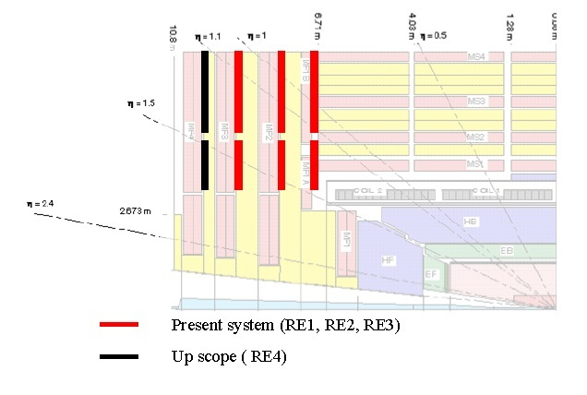
The TDR for muon trigger for the CMS experiment envisages to have four layers of RPCs in forward region. The present CMS experiment has only three layers of RPCs in the endcaps. The present RPC trigger logic, from the endcap, requires hits in at least three layers which causes an observed drop in efficiency being close to 80%. Adding the fourth layer of RPC in the endcaps and enabling three out of four trigger logic, will bring the RPC endcap performance to 95%.
Objective:
The goal is to achieve good quality assurance of the RE4 RPC chambers for the upgrade of CMS detector. These tests are performed on Bakelite panels, gaps, electronic components and chambers.
Five test are being performed for this purpose which are briefly described in the upcoming sections :
1. Quality Control 1
2. Quality Control 2
3. Quality Control 3
4. Quality Control 4
5. Quality Control 5
Quality Control 1 (QC1):
QC1 is the first level of quality certification which is performed for RPC chamber components. For example BAKELITE (the HPL panels) and the electronic components such as Front-End Boards (FEB), Distribution Boards (DB) and Adaptor boards (AB). A lot of measurements of these components are to be stored in the database. The main parameters are the resistivity measurements of the HPL panels with their respective color code as well as the CMS barcodes for all electronic equipment.
Quality Control 2 (QC2):
QC2 is the second level of quality certification which is performed for the gaps themselves. Four tests are being performed for this purpose – Visual Test, Gas Leakage Test, Pop-Spacer Test and Dark Current Test. Finally the global results after all the tests are stored into the database.
Visual test: In this test, the gaps are tested by visual inspection. The information regarding the bending of gap, bubbles on the surface, neatness and shape of the corners of the gap etc. are sent to database. Certainly there are some limits on every parameter value for visual inspection above which the gap has to be discarded.
Gas Leakage Test: After passing visual test, the gap is now sent for the gas leakage test. The gas tightness is controlled by measuring the stability of applied overpressure of 15 mbar in a fixed time of 600 sec using a pressure sensor. The maximum pressure drop of 0.5 mbar is allowed. The gap having larger pressure drop is rejected.
An additional measurement of the leak rate is carried out at 5 mbar, to be used as a reference value of the final commissioning phase at P5. This test is meant only for recording the leak value at these conditions similar to what the gaps will have in the CMS detector.
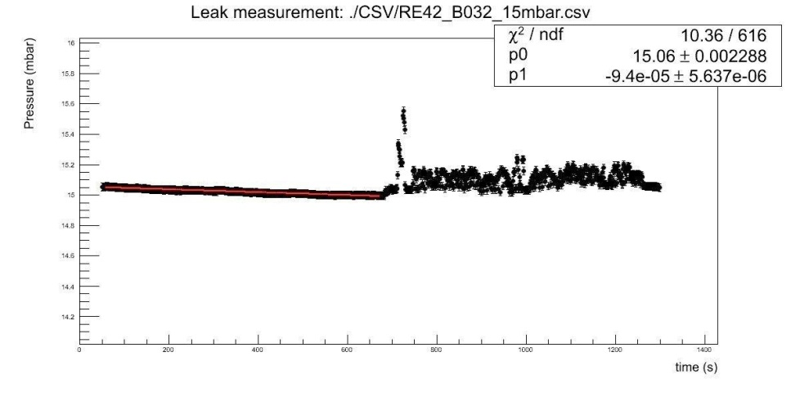
Pop-Spacer test: After gas leakage test, the gaps are subjected to an overpressure of 15 mbar to check the spacer fixation. A mask made of 0.2 mm thick PET (polyethylene terephthalate) film, where the shape of the spacers and the positions are properly drawn, is positioned on the gap. A 15 mbar pressure is applied to the gap. Each spacer is pressed and the variation of the pressure is recorded. The gas gap is qualified when no spacer causes an overpressure peak larger than 1 mbar. All the data is recorded in the data base as defined by CMS.
Dark Current Test: There are two types of high voltage tests called Dark Current I and Dark Current II. The Dark Current test I is the HV scan of gaps between 100 Volts and 10000 Volts. The plots between HV effective and the current through gap (in micro amperes) are stored to database. The value of Dark Current should be less but it increases with the increase in HV. The Dark Current test II is the long term stability test which aims to monitor the stability of the current in time at a fixed voltage. This test is important since most of the problems of increasing currents of gaps due to some gap imperfections are caught by the long term current monitoring.
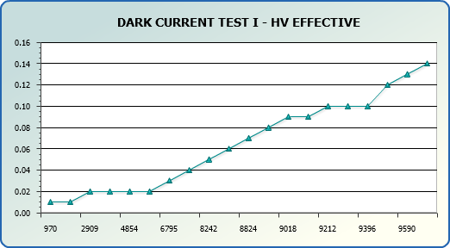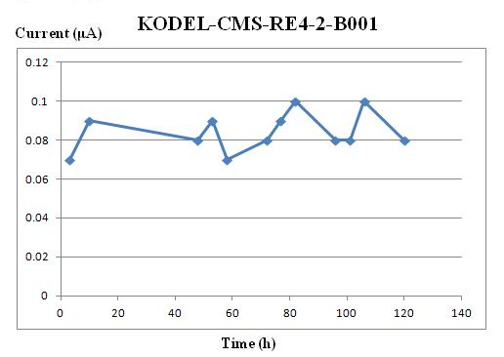
Quality Control 3 (QC3):
QC3 is the third and most probably the most sophisticated level of quality certification because it is performed for the newly constructed chambers. QC3 is divided in 2 main parts – QC3.1 and QC3.2. In QC3.1 the chamber assembly, its registration and first assembly tests are included. After any chamber has been assembled and successfully passed all the initial mechanical, electrical and HV tests the chamber is placed inside a muon telescope and the first physical data triggered by cosmic muons is being taken . On the basis of the cosmic data it is later decided whether the chamber is accepted to be prepared for installation in the CMS detector or is being rejected. After all kind of tests at any levels there are criteria for acceptation/rejection to be fulfilled, but the ones in QC3.2 are the most important because they are the only really physical parameters such as chamber efficiency, chamber mean cluster size, chamber noise rate, chamber strip profile and chamber noise profile.
Chamber Efficiency Distribution: Chamber efficiency is obtained with the ‘‘coincidence’’ method by evaluating the ratio between the number of events in which RPC has at least one fired strip in the trigger window (100 ns) and the total number of recorded events. A correction for spurious hits is also applied.
The distributions of the maximum double-gap efficiency are plotted for the three sites. The difference is due to a different geometrical acceptance of various chambers with respect to trigger area cross section. The mean value of the distribution is 97.2%. Chambers with efficiency less than 90% are not accepted.
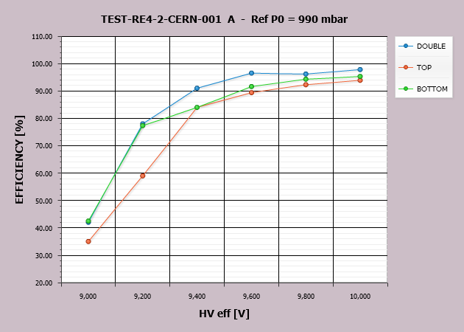
Noise Rate: The noise rate is defined as the number of fired strips per second outside the trigger window, normalized to the surface of the strips. Threshold control on front-end electronic discriminators gives the possibility to set efficiency and noise rate in the proper limits. A noise rate up to 10 Hz=cm² is considered acceptable.
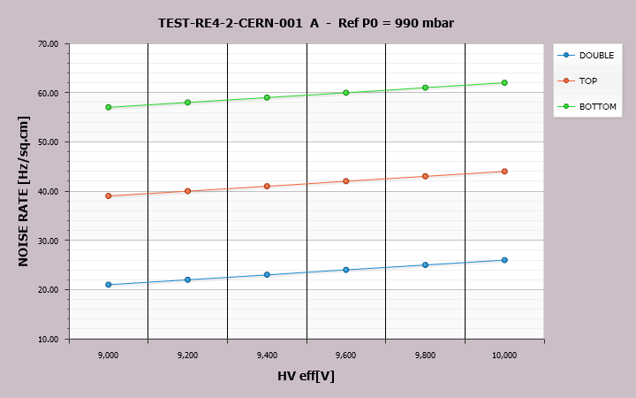
Cluster Size: All simultaneously fired adjacent strips form a cluster. The dimension of the cluster is called
cluster size. The cluster size of a chamber is defined as the average value of the cluster size distribution sampled in the first 25 ns of the trigger window (100 ns).
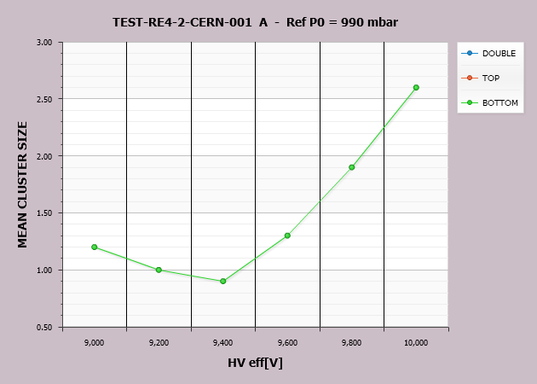
Quality Control 4 (QC4):
QC4 is the forth quality certification level performed for super modules. One super module consists of 2 already QC3.2 accepted RPC chambers – one of type RE4-2 and the other of type RE4-3. Series of tests are to be performed to the super modules before finally being approved for installation in the CMS detector.
Quality Control 5 (QC5):
QC5 is the final quality certification level which is performed for the super modules already installed in the CMS detector.
Conclusion:
About 50 CMS gaps (in two months) are tested and chambers are assembled and tested with cosmic muons. Dedicated test procedure is established and trajectory reconstruction software is developed. During the tests dark current is monitored and efficiency, cluster size and noise rate are measured. Less than 5% of the chambers are rejected for low efficiency and high current. All accepted chambers show high efficiency (>95%), acceptable clusters size (average value 2.5 strips) and low noise (<5Hz=cm²).
___________________________________________________________________

