

CERN Summer Student Program 2016
Final Report

By
Mansour Abu Siam

Supervised by
Gert-Jan Coelingh

At
European Organization for Nuclear Research (CERN)
Geneva, Switzerland
Summer, 2016
Contents
List of Figures 2
List of Tables 2
Introduction 3
Part 1: LHC 600A Energy Extracting Systems Switch Failure Diagnostic and Switch Change 4
Part 2: Possible faults simulation of a 30kA energy extraction system 5
Analysis performed 5
Conditions and parameters of the circuit (unless specified otherwise) 5
Simulation results 5
1. Ground fault Analysis 5
2. $R_{EE}$ mid-point tolerance 6
3. Delays 7
Conclusions 9

List of Figures
Figure 1: 30kA quench protection system. 3
Figure 2: 600A system schematic. 4
Figure 3: Circuit breakers of the 600A energy extracting system. 4
Figure 4: 30kA Circuit schematic 5
Figure 5: System response for a ground fault (without a fuse). 6
Figure 6: System response for a ground fault (with a 1A fuse) 6
Figure 7: Simplified representation of the switch in figures 1 and 4. 8
Figure 8: Currents and voltages for a $14μs$ – one IGBT delay. 8

List of Tables
Table 1: $R_{EE}$ mid-point tolerance results 7
Table 2: Maximum delay allowed for a safe operation. 8

Introduction
The magnet system in the LHC (Large Hadron Collider) include 1232 dipole magnets and 392 quadrupole magnets. The electromagnets are built of special cables that operate in superconducting state by cooling them to 1.9K ($-271.3℃$); the superconducting magnets of the LHC are powered in about 1700 electrical circuits.
A phenomenon called quench can spontaneously occur in superconducting magnets, which means that the superconductivity is lost in part of their windings. The energy stored within the magnet, up to 1.3 GJ, can cause severe damage. In order to protect the superconducting elements after a resistive transition, the energy is dissipated into a dump resistor installed in series with the magnet chain that is switched into the circuit by opening circuit breakers.
The system described above is utilized for magnets installed in the LHC that operate under currents ranging from 600A up to 13kA. For the next LHC upgrade (High Luminosity) there is a need for circuit breakers capable of interrupting high DC currents in a solely inductive circuit within one millisecond and under development of very high voltage across it, therefore specially designed DC- breakers are developed at CERN. Mechanical circuit breakers can withstand a DC current up to 600A, by splitting it in 3 parallel branches with 200A each, but for higher currents (7.5 – 30 kA), another approach was developed using solid state switches to ensure an ultra-fast energy extraction system that prevents overheating of the magnet during quench process.
The energy extraction system of the 600A concept is based on three, series connected, fast, mechanical 3-phase AC breakers, specifically equipped with a DC arc chutes. The three, simultaneously operated poles are connected in parallel to carry the 600A DC.
For the 30kA system illustrated in figure 1, 16 IGBTs are used, each 8 IGBTs are grouped together in parallel with a 15kA current that is supplied by a power converter, and each 4 IGBTs are mounted within one rack that takes 7.5kA (with $\sim 1.9 kA/IGBT$). The total current (30kA) will be fed to the superconducting magnets in order to bend or focus the beams. The present system will be used on a stand where magnets for a future upgrade of LHC will be tested.
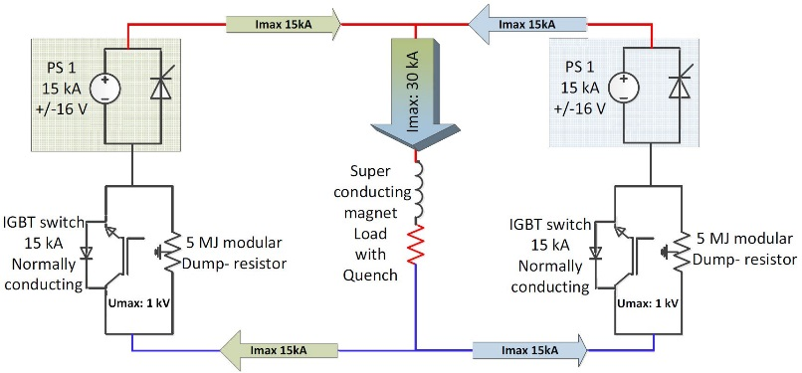
Figure 1: 30kA quench protection system.

Part 1: LHC 600A Energy Extracting Systems Switch Failure Diagnostic and Switch Change
In the first weeks, the focus was on introducing the 600A energy extracting system used in the Large Hadron Collider (LHC), as well as the under development solid state system. Practice in unmounting, mounting and testing of the circuit breakers used in the 600A system, as well as reviewing the procedure document to do the task were the main responsibilities of the student.
Figure 2 below shows the schematic diagram of the 600A system. In case of a quench, the circuit breakers must trip and the energy is extracted/dissipated by the dump resistor.
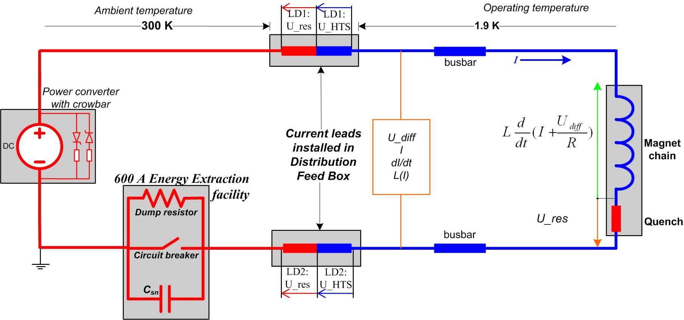
Figure 2: 600A system schematic.
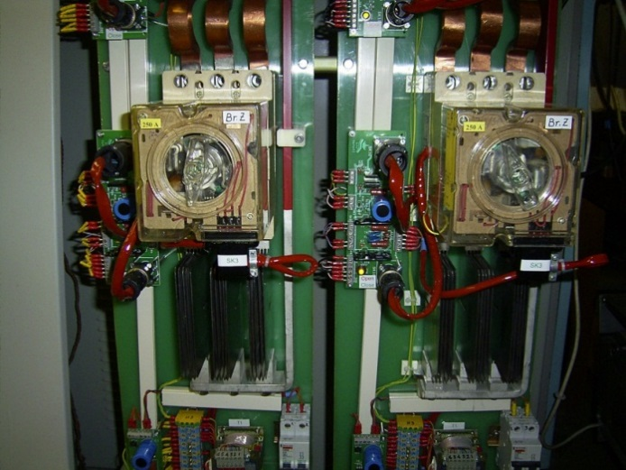
Figure 3 shows the circuit breakers (CB) and other components connected to it, mainly 3 circuit breakers are connected in series in order to increase the reliability of our system, 2 of them open together while the 3rd CB trips only if the first two fail to trip.
Figure 3: Circuit breakers of the 600A energy extracting system.

Part 2: Possible faults simulation of a 30kA energy extraction system
An IGBT based 30kA system is currently under development at CERN and will be installed in a dedicated test area in the CERN superconducting test facility. In the near future, CERN will need fast DC switches, not only for 30kA powering, but for 10kA and 20kA circuits, therefore the same topology with fewer racks in parallel can be used and no further development is needed to cover these demands.
Several fault scenarios could lead to severe damage of superconducting parts of the circuit in case of quenches or to the energy extracting system itself. Several fault scenarios were tested and analysed in order to check system’s operation in case something goes wrong. The use of multiple IGBTs in parallel can be the culprit to some of these fault scenarios.
Each switch in figure 4 represents 8 IGBTs connected in parallel, with a total of 16 IGBTs for the 30kA system. The switch contains 2 racks with 4 IGBTs and a total current capacity of 7.5kA/rack.

Analysis performed
- Ground Fault analysis (a fault from the magnet to the ground).
- $R_{EE}$ mid-point tolerance analysis.
- IGBT delay analysis.

Conditions and parameters of the circuit (unless specified otherwise)
- 30kA topology is used (8 IGBTs/switch divided in 2 racks, with 4 IGBTs per rack).
- Delays are introduced in micro-seconds.
- $L_{m}=100mH$
- $R_{EE}=60Ω$
- $R_{GND1}=R_{GND2}=40Ω ;R_{Ground}=10Ω$
- $1A$ fuse.

Simulation results
Figure 4 illustrates the circuit to be analysed along with the ground fault location using PSPICE software.

Ground fault Analysis
A fault was introduced from the magnet to the ground (see figure 4), Figure 5 illustrates the current going through the fault without a fuse in the system, the conditions mentioned in the previous section were kept the same for this simulation.
This fault location specified in figure 4 was observed to have the highest current to ground, other locations were tested but the corresponding currents in case of the fault were insignificant.
Figure 4: 30kA Circuit schematic
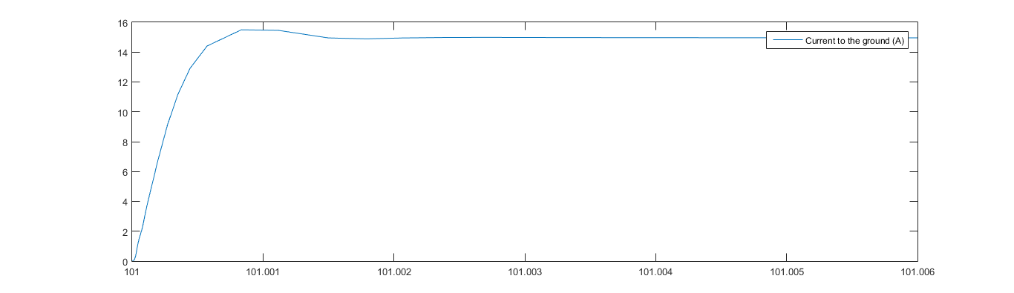
Current (A)
Time (s)
Figure 5: System response for a ground fault (without a fuse).
After adding a 1A fuse in parallel with a $10kΩ$ resistor to ensure that the system is never floating (see figure 4), figure 6 shows the response of our system.
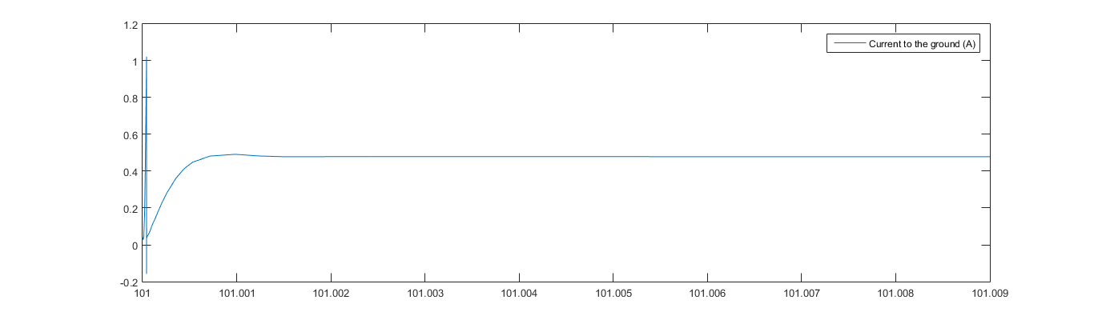
Current (A)
Time (s)
- System response from 101 to 101.009s
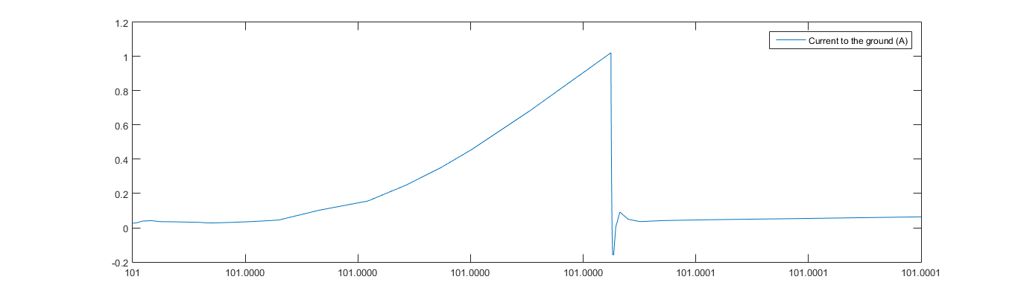
Time (s)
Current (A)
- System response from 101 to 101.0001s
Figure 6: System response for a ground fault (with a 1A fuse)
In case of a fault on the other side of the magnet, the results obtained were slightly smaller than the ones in figure 6, with the same response shape. The protective fuse installed in the system will trip in case of any ground fault and will disconnect the branch, which makes the resistor to ground $10kΩ$ therefore limits the current significantly.

$R_{EE}$ mid-point tolerance
The midpoint is added between two resistors, each of a value $R_{EE}/2$, although it might have a small tolerance due to manufacturer. The simulation is aimed to observe the effect of such tolerance on the normal operation of the system. Table 1 summarizes the values obtained for different mid-point tolerances for different $R_{EE}$ values to see the effect of changing the midpoint resistance and its tolerance on the ground current. The current going to the ground should never reach 1A during normal operation, as far as it might trigger the fuse, therefore giving a false alarm of a ground fault.
Considering the worst case in terms of current through the two middle point resistors, $R_{EE}$ was configured in the following order for each value:
$$R_{EEa1}=R_{EEb2}={(1+R}_{EE tolerance})R_{EE}$$
$$R_{EEa2}=R_{EEb1}={(1-R}_{EE tolerance})R_{EE}$$
Table 1: $R_{EE}$ mid-point tolerance results
 |  | $R_{EE}$ Tolerance | 10% |  | 20%
 |  | $R_{EE}$ = | $$6.6667mΩ$$ | $$60mΩ$$ | $$6.6mΩ$$ | $$60mΩ$$
Currents | Current to the ground | $I_{Rground}$ (mA) | 13.8 | 13.67 | 13.8 | 13.62
Currents | Current in mid-point resistor 1 | $I_{Rgnd1}$ (mA) | -215.12 | -1153.7 | -433.17 | -2297.5
Currents | current to the mid-point resistor 2 | $I_{Rgnd2}$ (mA) | 214.3 | 1153.6 | 432.37 | 2297.5
Currents | Current in the energy extraction resistor 1 | $I_{Ree1}$ (kA) | 25.77 | 15.39 | 25.97 | 15.33
Currents | Current in the energy extraction resistor 2 | $I_{Ree2}$ (kA) | 25.77 | 15.39 | 25.97 | 15.33
Voltages | Voltage across the magnet | $V_{magnet}$ (V) | -376.62 | -926.5 | -378.05 | -921.97
Voltages | Total voltage across energy extraction resistor 1 | $V_{Reetot1}$ (V) | 371.58 | 921.67 | 373.02 | 916.79
Voltages | Total voltage across energy extraction resistor 2 | $V_{reetot2}$(V) | 371.58 | 921.81 | 373.02 | 916.89
Voltages | Voltage across half of the energy extraction resistor 1 | $V_{Ree_{midpoint1}}$ (V) | 191.84 | 507.04 | 196.78 | 550.32
Voltages | Voltage across half of the energy extraction resistor 2 | ${V_{Ree}}_{midpoint2}$ (V) | 180.87 | 414.74 | 176.24 | 366.52
Voltages | Voltage across the midpoint resistor 1 | $V_{Midpoint1}$ (V) | -8.61 | -46.15 | -17.33 | -91.9
Voltages | Voltage across the midpoint resistor 2 | $V_{Midpoint2}$ (V) | 8.57 | 46.15 | 17.3 | 91.9
The current flowing to the ground is around 13-14 mA, which is insignificant and doesn’t affect our system, as far as the protection system has a fuse of 1A in series with the grounding resistor. Therefore, even if the tolerance is 20% (which is an impossible case), our system will operate without a problem.

Delays
Three types of delays were applied while keeping $R_{EE}$ fixed at $60mΩ$, with a 0% mid-point tolerance. Figure 7 illustrates a simplified representation of the switch (which is represented by an IGBT in figure 1 and a switch in figure 4), the delays introduced to the system are applied to the IGBTs in each branch (i.e within the same rack). Table 2 summarizes the results obtained from the simulation.
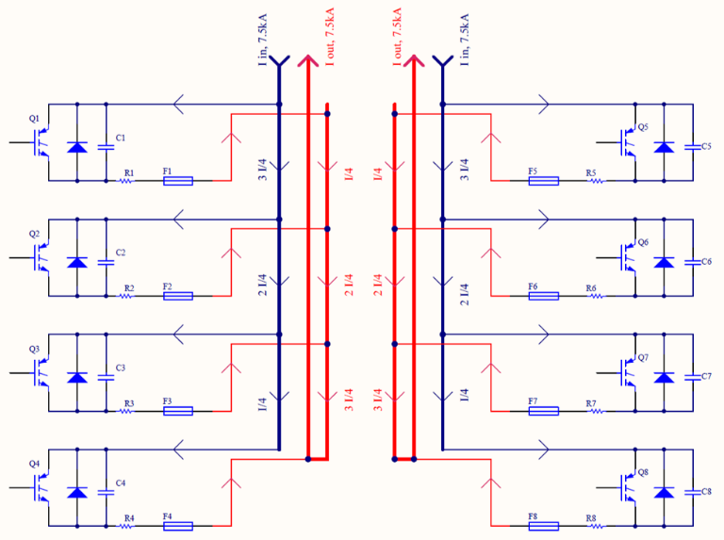
Table 2: Maximum delay allowed for a safe operation.
Type of delay | Delay ($μs$)
One IGBT delay | 14
two IGBT Delay | 20
Three IGBT Delay | 200
The delay mentioned in the table is the required delay for the given number of IGBTs in order for a 3.6kA current to flow in each of them. Other cases were not taken into consideration because the delay gets too large and the probability of having such a delay is very low.
Figure 7: Simplified representation of the switch in figures 1 and 4.
The graph below shows the currents and voltage in our system when a delay of one IGBT occurs. The duration of the high current is very short (around $5μs$) but it is high enough to damage our system if the IGBT was delayed more than the previously mentioned value.

Figure 8: Currents and voltages for a $14μs$ – one IGBT delay.
The delays we obtained are acceptable as far as the IGBT used in designing the system can withstand 7.2kA for 1ms. A safety factor of 2 was taken for the rated current of the IGBTs as well as the current doesn’t stay long and drops once it reaches the peak in a duration much less than 1ms ($\sim 10μs$), that’s why an IGBT delay isn’t a threat to the system.

Conclusions
- The simulations on the 30kA system shown that it is well protected against the faults that might occur during its operation and robust in case of any tolerance or delays that might occur, these faults include:
1. Magnet – Ground fault
2. $R_{EE}$ mid-point tolerance
3. IGBT delays.
- System’s currents and voltages were within the normal range and below their maximum limit of operation in all the simulations, and most importantly magnet’s reverse voltage did not rise above 1kV.
- As long as no ground fault occurs to the system, a significant current to the ground cannot occur.

Technology Department - Machine Protection and Electrical Integrity Group (TE - MPE) http://te-dep.web.cern.ch/content/machine-protection-and-electrical-integrity-group-mpe

