Soldering on silicon for microfluidic channels for cooling the high-energy physics detectors

Prepared for
Paolo Petagna

Prepared by
Kaltham Tahnon Al Ali

August 26, 2013
Table of Contents

Abstract 3
Metal/Semiconductor Interface 4
Soldering on Si 4
Sn-Ag Solders with RE Elements 5
Chemical Flux 5
Soldering Environment 5
Brazing 6
Example on Brazing 6
Conclusion 7
References 8

Abstract

Micro-channel cooling has been introduced as an important technique for cooling the electronics in the high-energy physics particle detectors. The silicon-etched microchannels containing the cooling fluids are connected to tubes that are made of metals at the ports. Those connections are made by soldering different metal components on the silicon. This report starts with a brief introduction of the metal semiconductor interface. It then discusses the problems that encounter soldering on silicon and the solutions that are present along with some examples. The importance of not using chemical flux in soldering and the preferred environment for soldering process is also examined. Moreover, the difference between soldering and brazing in addition to a recent example of brazing is provided.

Metal/Semiconductor Interface
The huge advance in microelectronics technology required a better understanding and improvement of metal/semiconductor contacts. The study of metal/semiconductor interface includes properties such as atomic structure, composition, electronic structure and chemical reactivity, all of which are referred to as “interface chemistry”. To understand those characteristics, transition-metal/Si interface in particular is studied. The existence of well-defined lattice structure of this interface makes it easy to identify the interaction reaction products. Moreover, silicide formation results in clear compositional states that indicate the characteristic chemical bonding state. By investigating the chemical behaviour of the contact, it has been noticed that the chemical reactivity of the transition-metal/Si interface leads to the formation of silicide compounds. This process can be summarized as follows: After depositing the metal on the Si substrate, it is annealed to promote interfacial reaction and a thin layer of silicide is formed. Further annealing produces more silicide and a thicker layer grows. This growth involves mass transport of metal and/or Si atoms through the silicide converting the entire metal layer into silicide eventually. The interface, thus, changes from metal/Si to silicide/Si interface. Interfacial reaction is uncommon at room temperature only for refractory metals such as Ti and V as initial reaction stage proceeds for near noble and mid-transition metals at this temperature [1].
The importance of the growth of metal silicides on silicon comes from the potential of these systems in providing contacts to silicon devices that combine stability with satisfactory electrical character. The precise analysis of the interface can be done by the use of the Time-of-Flight atom probe [2].

Soldering on Si
Regarding soldering of metal components on silicon, the main issue is that silicon is an inorganic material. Inorganic materials such as nitrides, carbides, oxides, sulphides, silicon and GaAs are very difficult to bond with low-melting point solders. The standard approach in solving this issue was to deposit multiple layers of metal on top of the silicon to coat it before proceeding with the standard soldering, as shown in Figure 1. However, this approach had several disadvantages related to reliability issues, poor chemical bond at the interface, and complexity and cost of this procedure. A better solution, thus, is one that can omit the multilayer metallization step. This approach has been obtained by adding rare earth (RE) elements to the solders. The low-temperature solders containing RE alloying elements can provide a powerful bonding on silicon surfaces based on chemical reactions at the interface. The synthesis of these solders is done by melting the component metals inside a quartz tube in a vacuum. Desirably, the RE atoms are trapped in the solder as fine, micron-sized islands, which provides a safe storage of the reactive RE within the solder matrix before use. Upon heating to a temperature typically 50-80°C above the solder melting point, the RE elements diffuse toward the interface and chemical reaction with the surface occurs resulting in a strong bonding. It is worth mentioning that the melting temperature of soldering ternary alloys containing RE elements are close to those of binary alloys without them. In terms of strength, Sn-Ag and Au-Sn solders, for example, containing the RE element Lu exhibit interfacial bond strengths in the range of 6.9-13.8 MPa [3].

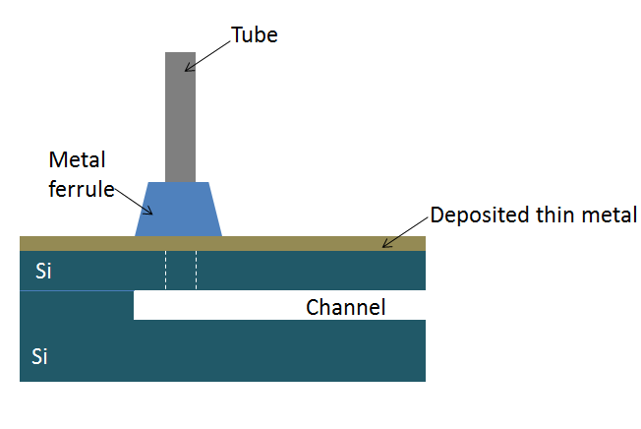
Figure 1, “Current approach by metal deposition”

Sn-Ag Solders with RE Elements
One application of this “Universal Solder” is obtained by the addition of RE elements: Ce and Nd to Sn-Ag solder. Si substrates are generally difficult to wet for Sn-based solders at low soldering temperatures. During the synthesis of these solders, the RE metals are again stored as island compounds in the solder matrix with little effect on the melting point. A problem that encountered the soldering process at the beginning was that there was no bonding at the interface as no wetting reaction between the solder and Si substrate occurred. The reason behind this was found to be a layer of oxide (SiO₂) that formed on the liquid solder surface when it was exposed to air preventing the wetting reaction. Nevertheless, by applying a small pressure on the liquid solder by another heated Si substrate the RE element could diffuse to the interface to react with the thin SiO₂ layers breaking it and forming intermetallic compounds (IMC). Particularly, when soldering at 300°C, the IMC layer becomes continuous and a strong bonding between the Si substrate and the solder is obtained [4].

Chemical Flux
It should be noted that all solders mentioned previously are fluxless. Chemical flux is a cleaning, flowing and purifying agent. It removes oxidation layers from the metals to be joined, allows solders to flow smoothly on the working piece and absorbs impurities into slags that can be scraped off the molten metal. However, these chemicals are quite corrosive and must be removed or neutralized before the soldered assembly is put in service. This process is time-consuming and increases the manufacturing cost. That is why developments have been made on solders to eliminate the need for chemical flux by adding reactive elements such as Titanium and rare earths to form active solders. In other words, the reactions between active solders and base materials eliminate the need for fluxing agents [5].

Soldering Environment
Another aspect that must be considered while soldering is the environment where it is conducted. Performing solder joints in atmospheric conditions is preferred because it alleviates the complications inherent to processing in an inert gas environment. The ability to join components without an inert environment allows for greater freedom in designing experiments and production processes. One such solder that is successfully reflowed in atmosphere using a thermode is the fluxless AuSn. The Au layers contacting the solder preform prevents the formation of oxides that would hinder the reflow process [6].

Brazing
Metals can also be joined by brazing. The difference between soldering and brazing, according to the American Welding Society, is that brazing involves filler metals that have melting points higher than 425°C as opposed to soldering [7].

Example on Brazing
One method of brazing that has been developed recently is the plasma brazing by silver-based or aluminium-based filler metals. The same highly ionized, intense plasma generated during physical vapour deposition can be utilized for joining small parts. Metals that require rapid heating and careful prevention of oxidation are good candidates for plasma brazing. Brazing is performed in a plasma discharge chamber. The faying surfaces are polished and assembled with filler metal preforms. Next, ion bombardment heats the parts to brazing temperature causing the filler metal between the gaps to melt. Later, the brazed parts are cooled under vacuum to obtain the joined parts. Brazing by ion bombardment has many advantages. Rapid cooling due to processing in a cold chamber results in a uniform, fine-grained microstructure of joined metals. In addition, Zn-containing filler metals can be used to braze at lower temperatures [8].

Conclusion

Silicon-made microchannels are being adapted for cooling the electronics in the future tracking devices. The ports of these channels are to be connected to different metal compounds by soldering. This report discussed the metal/semiconductor interface, soldering on Silicon by adding RE elements to the solders, drawbacks of chemical flux and the preferred soldering environment, and brazing with a recent example.

References

[1] G. Rubloff, “Microscopic Properties and Behavior of Metal/Semiconductor Interfaces,” Watson Research Center, 1983.

[2] C. Grovenor and G. Smith, “Investigations of Metal-Silicon Interface by Time-of-Flight Atom Probe,” Department of Metallurgy and Science of Materials, 1983.

[3] H. Mavoori, A. Ramirez and S. Jin, “Lead-Free Universal Solders for Optical and Electronic Devices,” Journal of Electronic Materials, vol. 31, No. 11, 2002.
[4] D. Yu, C. Wu, Y. Wong and J. Lai, “Direct Robust Bonding Between Sn-based solder and Si substrate,” Material Science: Matter Electron, 2007.
[5] S-Bond Technologies, “Mechanical Activation of Active Solders,” 2013, http://www.s-bond.com/assets/Documents/Mechanical-Activation-of-Active-Solders.pdf [Accessed August 19, 2013]
[6] I. Golosker and J. Florando, “Reflow of AuSn Solder Creates Strong Joints,” Brazing and Soldering Today, 2013.
[7] Anon. (n.d.) [Online]. Available: http://www.esabna.com/euweb/oxy_handbook/589oxy19_1.htm [Accessed August 20, 2013]
[8] M. Markovich and G. Fischer and A. Shapiro, “Brazing Titanium and Chromium Using Ion Bombardment Heating,” Brazing and Soldering Today, 2013.

