CMS experiment:

Adding the timing detector in front of the Ecal.

Name: Mohamed Hamdy Swalim

Brief introduction to CMS:

CMS (Compact Muon Solenoid) is one of the largest experiments built on the LHC, its purpose is to investigate the Higgs boson, and trying to find new physics beyond the standard model.

CMS consists of 5 layers:

1- The tracker: Responsible for reconstructing the paths of electrons, hadrons, and muons.

2-ECAL: Consists of a crystal matrix made from “PbWO4”. Responsible for measuring the energy of electrons.

3-HCAL: Responsible for measuring the energy of hadrons.

4- The magnet: Responsible for measuring the ratio of charge/mass of particles.

5- The muon detectors: Responsible for detecting muons (even though muons are charged particles just like electrons, because of their big mass they can penetrate through all the past layers and that's why they need their own detector).

The timing detector:

My project has to do with installing the new timing detector, which is a detector made from a material called “LYSO” and its main purpose is to measure the time it took the particle to travel from the interaction point to the timing detector.

Measuring this time could help us identify the exact location of the interaction point(with some uncertainty of course!). The timing detector shall be placed in front of the ECAL, and therefore the particles will actually pass by the timing detector before starting to develop the particle shower inside the ECAL, this causes the shower to actually start developing inside the timing detector, before developing inside the ECAL.
The way ECAL actually measure the energy is by measuring the energy the shower deposited in the crystal matrix, so if some of the shower develops inside the timing detector that will affect the measured energy of the particle, unless of course we take into account the energy deposit in the timing detector. The loss of energy in the ECAL depends on several things like the material of the timing detector, the thickness of the timing detector(the geometry of the timing detector in general), and the distance between the timing detector and the ECAL.

My work:

So my job as to run simulations of ECAL using different geometries for the timing detector and comparing the energy resolution for the different geometries, and that could help us determine the best geometry configuration for the timing detector.

I used GEANT4 with the already built example “composite_calorimeter” to run simulations of only the ECAL and HCAL layers of CMS, and later I would use ROOT in order to analyse the data and make graphs for the energy resolution.

So first I had to edit the code for the “composite_calorimeter” example to include the timing detector, I added a box made from “tungsten” in front of the ECAL.

Then I had to write a BASH script that would run the simulation using different geometry configurations for the timing detector, initially I was supposed to run the simulation using 5 geometry configurations, but after running the simulation, I got really bad results so I just ran it with 2 geometry configurations.

Configuration 1: No timing detector.

Configuration 2: With the timing detector 10 cm in front of the ECAL, and 3 radiation lengths of “tungsten” thick (about 1.0512 cm thick).

In both configurations I shot a beam consisting of an electron using different beam energies at the center of the timing detector, and I ran 5000 events in both times for each energy. The different energies were 10, 20, 50, 100, 200 GeV.

During the simulation I would save ROOT files containing the energy deposited in each crystal of the crystal matrix of the ECAL (in this example the ECAL consisted of a 7x7 matrix of crystals).

After the simulation I would write a ROOT script that would produce the graphs for the energy resolution and the mean energy as a function of the beam energy for the center crystal, the 3x3 crystal matrix, the 5x5 crystal matrix, the 7x7 crystal matrix, the ratio between the center crystal and the 3x3 matrix, the ratio between the 3x3 matrix and the 5x5 matrix, and the ratio between the 5x5 matrix and the 7x7 matrix.

First I would fit the energy graphs to a Crystal Ball function with different parameters for each graph, and then I would get the mean value and the Root Mean Square, and plot them against the beam energy.

Here is an example of the graphs I produced:

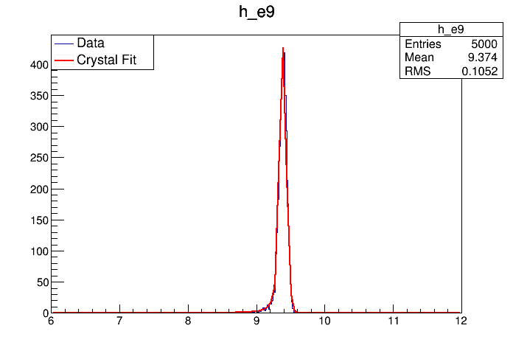
Figure 1: Fit graph for the energy deposited in the 3x3 crystal matrix for 10 GeV beam energy with no timing detector.

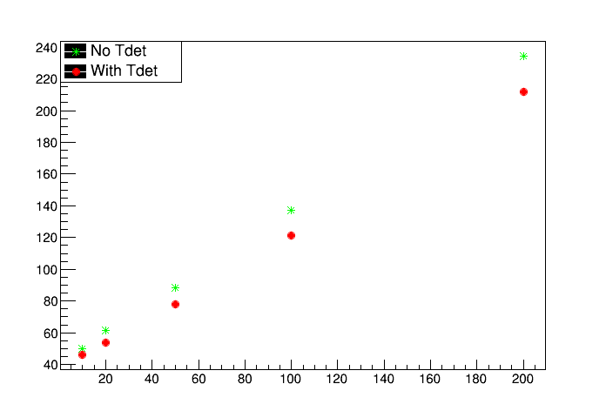

Figure 2: Graph of the mean of the energy deposited in the 5x5 crystal matrix as a function of the beam energy for both configurations.

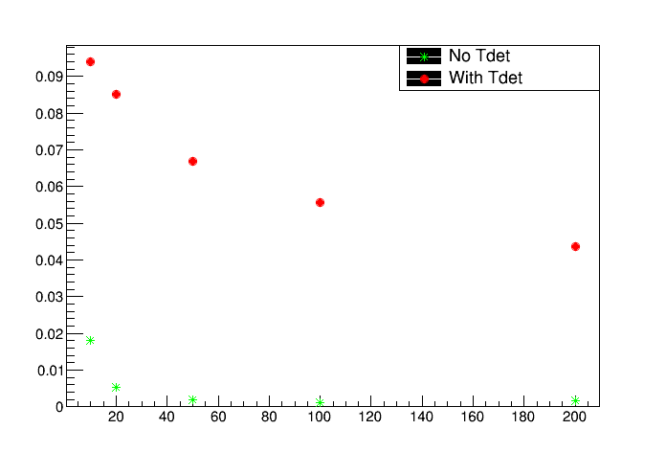

Figure 3: Graph of the energy resolution deposited in the 3x3 crystal matrix as a function of the beam energy for both configurations.

Now sadly I was not able to completely finish my task/job here. Had I enough time, I would have continued my work and tried to run the simulation using different geometry configurations, and also I would actually try to fit the graphs of the mean and RMS to certain functions with different parameters, and try to get useful information from reading the value of these parameters.

