Depletion voltage studies on n-in-n MCz silicon diodes after irradiation with 70 MeV protons

Summer student project by
William Holmkvist
Supervisor: Karola Dette
CERN, 2014

Introduction
Silicon detectors is the main component in the pixel detectors in the ATLAS experiment at CERN in order to detect the particles and recreate their tracks after a proton-proton collision. One criteria on these detectors is to be able to operate in the high radiation field close to the particle collision. The usual behavior of the silicon detectors is that they get type inverted and an increase in the depletion voltage can be seen after exposed to significant amounts of radiation.
In contrast n-type Magnetic Czochralski (MCz) silicon doesn’t follow FZ silicons pattern of getting type inverted when it comes to high energy particle irradiation, in the range of GeV. However it was observed that MCz silicon diodes that had been irradiated with 23 MeV protons followed the FZ silicon behavior and did type invert. The aim of the project is to find out how the depletion voltage of MCz silicon changes after being irradiated by 70 MeV at fluencies of 1E13, 1E14 and 5E14 n_{eq}/cm², to give a further insight of at what energies the MCz silicon begins to experience the unusual behavior of not type inverting. In addition to this, an annealing study is done to the samples in order to see how the depletion voltage changes with elevated temperatures and if this differs from the annealing of FZ silicon.

Experimental setup
Transient current technique (TCT) is a method for studying diodes where both the depletion voltage and trapping times can be measured at the same time. In this study TCT was the only experimental technique used on the sample to calculate the desired values.

Transient current technique
This method measures the signal current given from the detector vs. the time. This is done by applying a reverse biased voltage to the silicon diode and then introducing EHP. Following Shockley-Ramo’s Theorem, eq. (1), it is known that the signal current is induced by the drift of the charge carriers near the electrode, and not the collection of the charges at the electrodes (Krasel, 2004, p. 37).

$dQ=q{\vec{E}}_{R}(\vec{r})∙{\vec{v}}_{dr}(\vec{r})dt$ (1)

There are different methods of injecting EHP, however, to achieve a reproducible result a laser is used in this case. In order to distinguish between the signal produced by the electrons and the signal produced by the holes it is desirable to inject EHP only at the surface of the diode, as the electrons and holes move in different directions, one of the two will be collected at the electrode close to the injection and thus the signal seen on the oscilloscope will solely represent the carrier that drifted over the whole bulk. A red laser was used to achieve this as the wavelength is short enough not to penetrate deep into the diode.

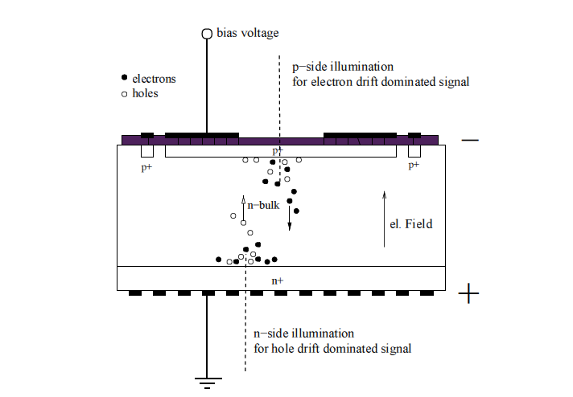
Figure 1. Cross-section view of the silicon diode being illuminated with laser. The diode is reversed bias as can be seen in the picture in order to avoid recombination of the created EHPs.
Figure 2 shows a basic TCT setup that is very similar to the setup used in this project. In addition to what is shown in the picture an ethanol/water cooling system together with a peltier plate was used to keep the sample in a constant -10º during the measurements in. The cooling is to help reduce the leakage current which is induced by the reversed bias voltage. The peltier plate was applied to a copper plate that the sample was mounted on to cool it, and the warm side of the peltier plate was cooled with the ethanol/water cooling. The copper plate which the sample was mounted to was also movable with a xyz controller with a precision of 5 μm in all three directions. The whole setup was controlled with custom written LabVIEW program.
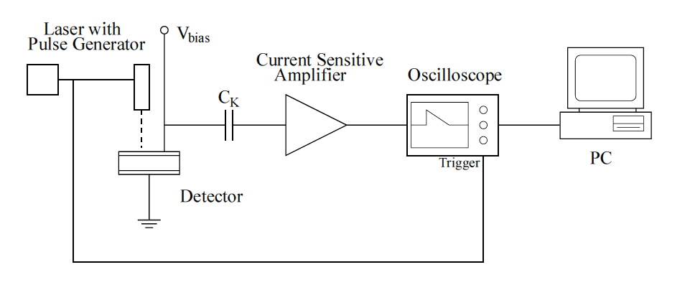
Figure 2. Basic TCT setup. The pulse generator makes the laser give light in periods and triggers the oscilloscope at the same time. The capacitor is used to filter out the signal caused by the injected charge carriers from the leakage current induced by the bias voltage. The signal is then amplified, read out on the oscilloscope and then collected by the computer.
Data analysis
The data collected with the computer is unprocessed and do not say much in itself. In order to be able to analyze this data two different program was used. Both programs had the same basic analysis but were executed in slightly different ways. The first step is to reshape the waveform created by the drift of the charge carriers that could be observed in oscilloscope. Analyzing the shape of the waveform the behavior of the drift of the charge carriers can be understood to a certain extent. However to get accurate values for full depletion from the waveform is highly limited further processing of the data is needed. It is possible to calculate the collected charge by integrating over the waveform and then acquire a graph the reveals the charge collection vs the biased voltage. From this graph it is a simple task to approximate the depletion voltage for an unirradiated sample. To calculate a reasonably accurate value of the depletion voltage two linear fits were fitted to the charge plot, one fit below the full depletion voltage and one above, and the point of intersection represents the depletion voltage, as can be seen in figure 3. All fit limits were adjusted individually to each charge collection plot to give the most accurate value of the depletion voltage.
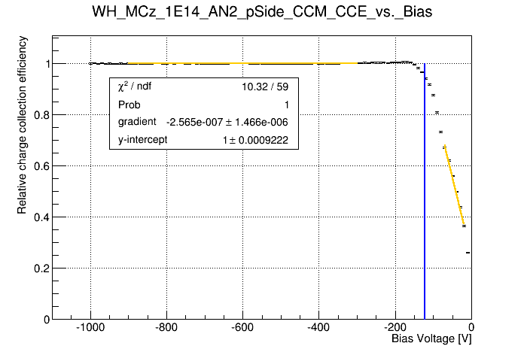
Figure 3. Depletion voltage calculated from intersection of two fits in the charge collection graph.
Charge correction method
The methods for analysis presented above works well with unirradiated or samples irradiated with low fluence. However when a silicon diode has been exposed to high fluence, the crystal defects and damage to the lattice will be high enough to be noticed in the signal. The damage give rise to trapping of the charge carriers and local electric fields which reduces the charge collection and thus makes it harder to calculate the full depletion voltage. In order to counter this effect I have used a method called charge correction method, abbreviated CCM, in this study. The CCM compensates the original signal by multiplying the exponential term exp(t/τ_{eff}) as in eq. (2), here τ_{eff} represents the effective trapping time of the charge carriers.
$i_{c}\left(t\right)=i_{0}(t)∙exp⁡(\frac{t}{τ_{eff}})$ (2)
The waveform is then integrated after being multiplied with this term and the compensated charge collection is then plotted from these values. Initially the effective trapping time is unknown and thus this technique has to be applied for different τ_{eff} until the correct value is discovered. The correct τ_{eff} is discovered through making a linear fit above the depletion region in the corrected charge correction plots and then determining for which τ_{eff} the slope of the fit is equal to 0. This is because when the correct trapping time is used the corrected charges become independent of the bias voltage above the depletion region. An example of different τ_{eff} can be seen in figure 4. This method both gives us the trapping time of diode and helps calculate a more correct depletion voltage.
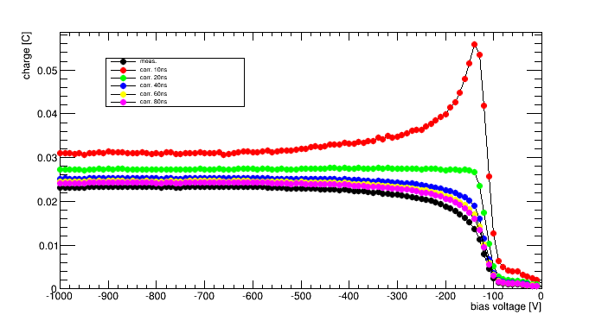
Figure 4. An example of a corrected charge plot for different trapping times.
Annealing study
The annealing of the samples were performed with an electric oven set to 60 degrees Celsius. To counter the inexact temperature inside the oven and the cooling down of the samples the temperature was recorded as a function of time and then the equivalent amount of time at exactly 60 degrees was calculated. Table 1 shows the time the samples were annealed. All samples were annealed at the same time.
Annealing step | Time in oven | Compensated time | Total annealing time
1 | 20 | 13.5 | 13.5
2 | 70 | 58 | 71.5
3 | 250 | 222 | 293.5
4 | 988 | 931.5 | 1225
Table 1. Annealing times for all samples. All time values are given in minutes.
Results
Simple calculating the depletion voltage of the samples gives a good understanding whether type inversion has occurred or not. As can be seen in figure 5, the depletion voltage increases between a fluence of 10¹⁴ n_{eq}/cm² and 5*10¹⁴ n_{eq}/cm², both for CCM corrected and uncorrected values. This is a clear sign that type inversion has occurred somewhere around the 10¹⁴ n_{eq}/cm² point.

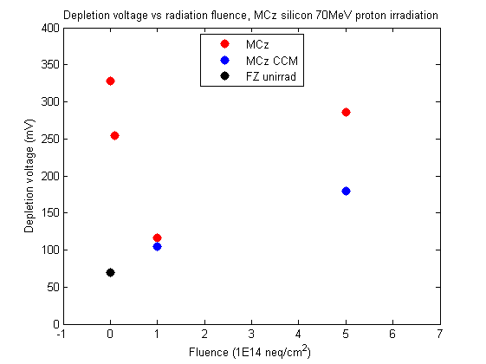
Figure 5. Depletion voltage as a function of radiation fluence. Note that only the two highest irradiated samples experience significant trapping, and thus CCM is not applied to the other samples.
To see if the sample irradiated with 10¹⁴ n_{eq}/cm² fluence has undergone type inversion or not an annealing study is necessary. The results from the annealing study of all three samples can be seen in figure 6, 7 and 8. From figure 6 it is known that the lowest irradiated sample is barely affected by the annealing. However we can determine from shape of the curve made by the data points in figure 7 that the 10¹⁴ n_{eq}/cm² sample has not type inverted. On the other hand it is very clear the 5*10¹⁴ n_{eq}/cm² has type inverted.
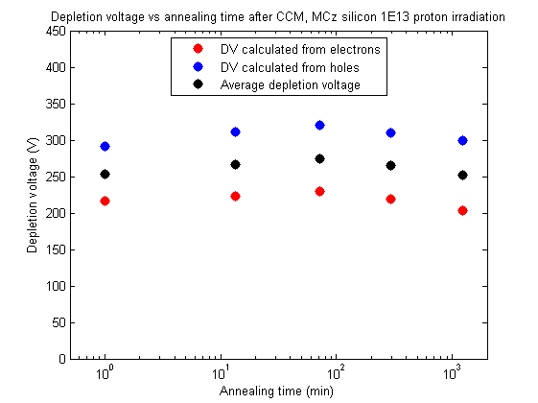
Figure 6. Depletion voltage vs annealing time for the 10¹³ n_{eq}/cm² irradiated sample.
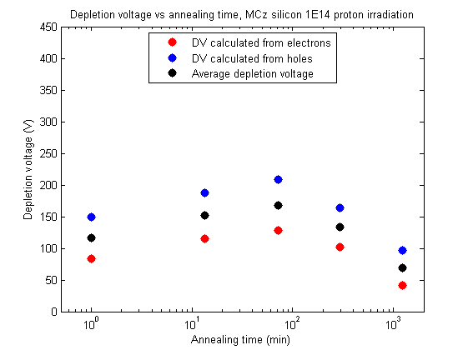
Figure 7. Depletion voltage vs annealing time for the 10¹⁴ n_{eq}/cm² irradiated sample.
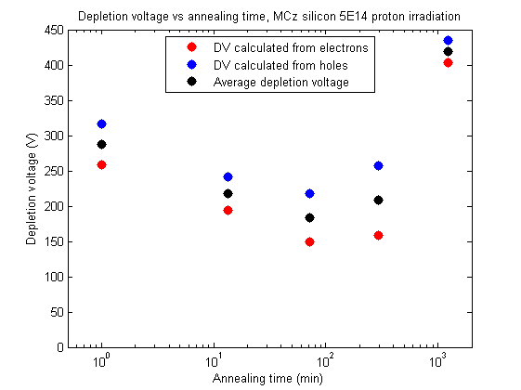
Figure 8. Depletion voltage vs annealing time for the 5*10¹⁴ n_{eq}/cm² irradiated sample.
To make sure that trapping is not playing tricks on us the depletion voltage was recalculated after CCM had been applied to the charge collection plot. The 10¹³ n_{eq}/cm² sample have sustained too little damage to have any significant trapping and is thus excluded from the CCM study. The new depletion voltage values are lower than the values calculated from the uncorrected waves, however data points hold the same curve and the highest irradiated sample can be confirmed to have type inverted.
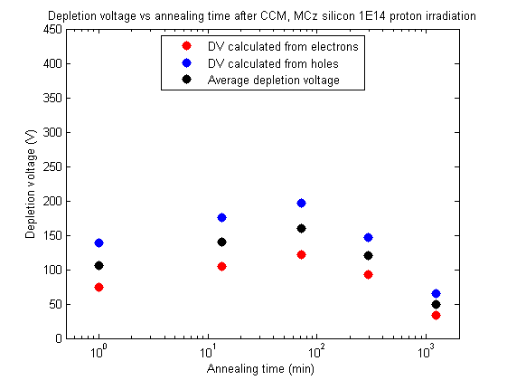
Figure 9. Depletion voltage vs annealing time for the 10¹⁴ n_{eq}/cm² irradiated sample after the CCM has been applied
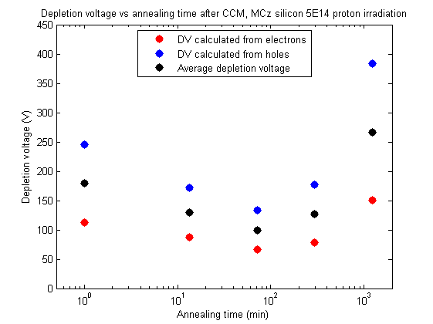
Figure 10. Depletion voltage vs annealing time for the 5*10¹⁴ n_{eq}/cm² irradiated sample after the CCM has been applied.
Figure 11, 12 and 13 below shows the results obtained from calculating the trapping times of the samples. The limits of the integration to calculate the charges for each bias voltage is determined by a threshold related to the noise of the signal, in such a way that the noise won’t trigger an integration. A trapping time equal to zero represents that there is practically no trapping occurring.
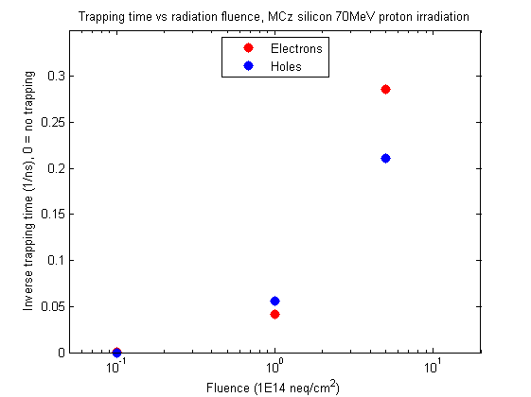
Figure 11. Trapping time vs radiation fluence. Observe that the 10¹³ n_{eq}/cm² irradiated sample do not experience any trapping worth noting.
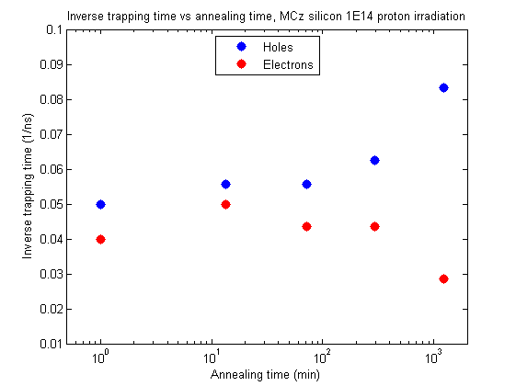
Figure 12. Inverse trapping time vs annealing time for the 10¹⁴ n_{eq}/cm² irradiated sample. Increased trapping for holes and decreased trapping for electrons can be observed.
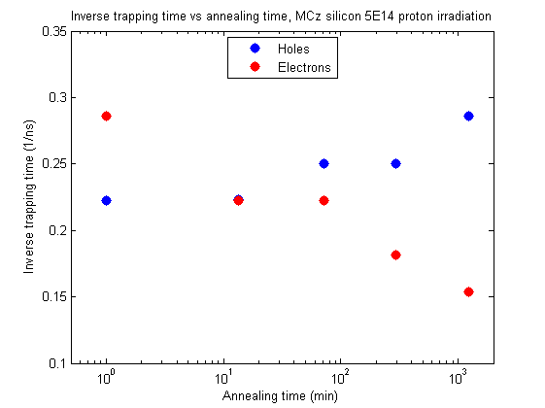
Figure 13. Inverse trapping time vs annealing time for the 10¹⁴ n_{eq}/cm² irradiated sample. Increased trapping for holes and decreased trapping for electrons can be observed.

Conclusion and Discussion
From the results section it is clear that 70 MeV proton irradiated MCz silicon diodes type invert for high enough fluence and it is possible to draw the conclusion that they behave similar to FZ silicon as well. Comparing these results to Krasel’s results (2004, p. 105), it can be seen that Krasel’s samples experienced type inversion at lower fluence than my samples. This can however be explained by MCz silicon diodes having higher initial doping concentration and thus requires greater radiation to decrease the depletion voltage and eventually type invert the material.
The annealing study also gives results that are pointing towards these samples behaving in the same way as FZ silicon diodes. Specifically this can be seen as beneficial annealing is taking place up until approximately 80 min and after that the reverse annealing starts to dominate the process, which is the same for FZ silicon.
The trapping behavior after annealing agrees with previous results of both MCz and FZ silicon, i.e. the trapping of the holes increases with annealing time and electron trapping decreases.
This project was not enough to determine at around what energy the strange behavior of MCz silicon is taken place, nor explain the origin of its cause. To gain a deeper knowledge about MCz silicon samples irradiated with higher energy beams have to be investigated.

Reference
Krasel, O (2004) Charge Collection in Irradiated Silicon-Detectors. Unpublished PhD thesis. Universität Dortmund.

