

CMS RPC performance study by using 2012 and 2015 data
Binish Batool
National Centre for Physics (Pakistan)

Abstract
Resistive Plate Chambers are the dedicated trigger muon detector for the Compact Muon Solenoid experiment at the Large Hadron Collider at CERN. HV50 is one of the parameter under study to eventually spot any aging effect. The comparative study is done for Barrel and Endcap region particularly, and as a whole too confirming the excellent behavior of RPC detector and fulfillment of requirement as per decided before the upgrade.

Introduction
The Large Hadron Colider (LHC) is the world’s largest and most powerful accelerator. It accelerates and collides the two high energy particle beams coming at speed relative to the speed of light. These beams come from the different tubes kept at ultrahigh vacuum guided by superconducting electromagnets.
The Compact Muon Solenoid (CMS) is a general purpose experiment at LHC. The physics motivation is to test and to complete the Standard Model (SM), especially for what concerns the search for the Higgs boson and the exploration of new physics beyond SM. The CMS detector consists of various sub-detector systems. The Muon system located outside of the magnetic coil is designed for Muon triggering and tracking it consists of three technologies:
the Drift Tube in barrel region, the Cathode Strip Chamber (CSC) in Endcap region,
Resistive Plate Chamber (RPC) in both regions.

CMS RPC and HV50
CMS uses double-gap Resistive Plate Chambers, operated in avalanche mode, with 2mm gas gap formed by two parallel Bakelite electrodes. A copper readout plane of strips, placed between the two gaps, collects the induced charge and front-end electronics forms signal. The avalanche production depends on the environmental pressure P, the temperature T, the gas mixture and the high voltage HV. At fixed gas-mixture, and other parameters being fixed the dependence of efficiency on HV is described by a sigmoid function. HV50 is the effective high voltage at which the chamber reaches the half of its maximum efficiency.

Where $P0 = 965mbar$ and $T0 = 293K$

The effect of HV50 on the efficiency is exponential and can be seen from the formula.

As the operational condition of the RPCs approaches the limit of its rate capability, the voltage drops occurring across the two resistive plates of the gap dominate the increase in the applied high voltage. With the more increase of voltage and current the resistivity goes on increasing which is controlled empirically by water vapors otherwise it could add more aging.

Results:

In 2012 there were no RE4 chambers installed on either side of the detector. They were added during the first long shutdown period of LHC. I have compared the HV50 parameter of RPC for the 2012 and 2015 HV scan collision data to study the performance of RPC. Following are the details for every single chamber partition, called roll in Endcap and wheel in Barrel. The comparison of the whole Endcap and Barrel was also done by plotting their HV50 including all rolls except RE+4 and RE-4 and wheels respectively.

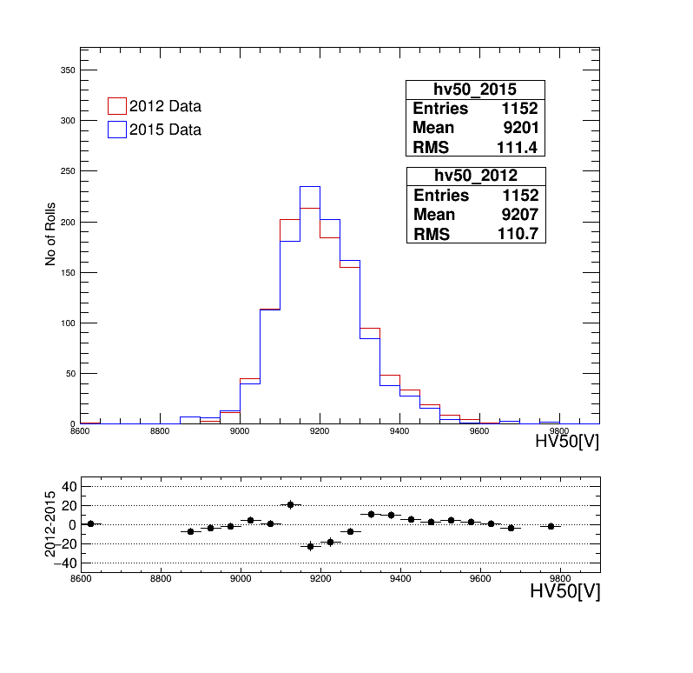
Endcap Region:

For 2015 the RE+1 becomes active at higher value of high voltage as compared to RE+1 for 2012, but it has smaller peak than that belong to 2012. For RE+2 the chamber become active more quickly and give maximum peak bit earlier than RE+1 so this give maximum efficiency at comparative smaller value of HV50. For RE+3 the HV50 becomes higher due to the construction reasons and it becomes active at larger value.

For RE-1 we can see the peak shift for 2015 towards right which means it gives maximum efficiency at higher value of HV50 here at 9150V. RE-2 plots is bit shrinked which means it becomes active for comparative shorter time and gives max at 9150V the same voltage at that for the former. The plot of HV50 for RE-3 is again the shifted towards right showing its late activeness than other chambers.

This figure shows the general plot for HV50 for the whole Endcap region excluding the RE4 as they were not installed in 2012. It shows that the value of HV50 for which maximum efficiency gives its half, has become larger than that of 2012 as the peak belonging to 2015 is higher than that of 2012. The plot at the bottom of the figure shows the HV50 differences around zero. Comparatively more of them fall on the –ve axis, which shows that HV50 values for 2015 has become bit large.

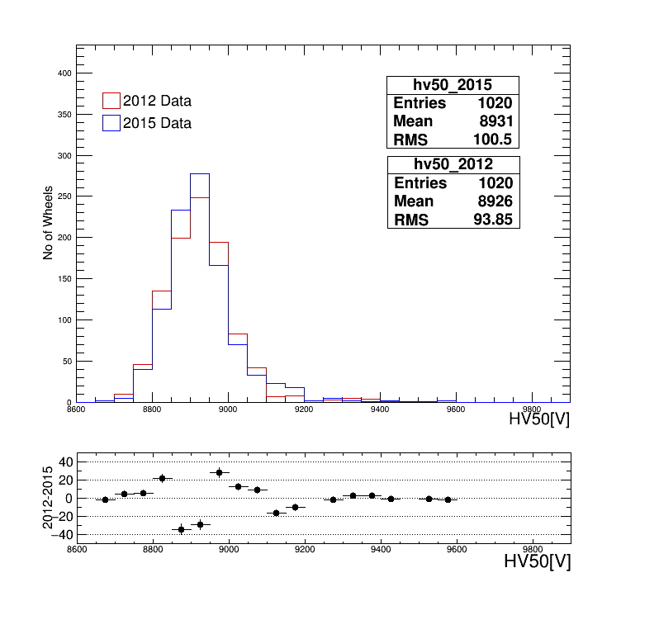
Barrel Region:

The plots for the barrel region are bit shifted towards the left showing the quick active behavior with the applied voltage. For W+0 the peak for HV50 is higher for 2015 (8900V) than that for 2012(8950). For the next chamber W+1 a large number of wheels give maximum at the value of 8900V. For W+2 the plot has enough width (8650V to 9250V) that means the wheels here are showing the same behavior as the HV50 increases on the x-axis.

The peak in W-1 is at 8850V and for the 2015 its bit higher than 2012. For W-2 the peak for 2015 is shifted towards right mean wheels are becoming active later than they have been active in 2012 and showing peak at 8850V.

The figure on the right side shows the general wheels plots. And it shows that for 2015 the value of HV50 for which efficiency is half of its maximum has increased than that for 2012 and the peak is at the same value for both of years.
The difference plot at the bottom shows comparative more falling points on the +ve axis, which shows that HV50 values for 2015 has become bit smaller.

Conclusion

After the upgrade of LHC for Run2 (2015), although the more activeness of the rolls and wheels for the Endcap and barrel region has been observed for the same HV50 values, but the RPC parameter HV50 shows the good agreement with that belonging to 2012 HV scan data. It shows the reliability of RPC detector and uniform behavior which indicates the smooth construction of the chamber all the way. As no significant increase of high voltage was observed, so there is no aging effect spotted.

