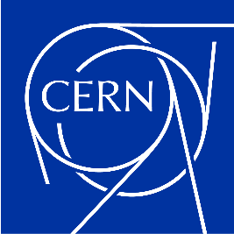
1 September 2023
delipavl@ece.auth.gr

Electrical Network Supervision system - data model consolidation
Pavlos DELIOPOULOS
CERN, CH-1211 Geneva, Switzerland

Summary,
during my nine-week tenure as a summer student at CERN in EN/EL/CBS section in Cern, Geneva, Switzerland, I had the privilege of engaging in a project that seamlessly integrated with my studies in electrical engineering. This immersive experience granted me the opportunity to gain a firsthand perspective of CERN's intricate electrical equipment and network. Witnessing the practical implementation of concepts, I had learned in the classroom was an unforgettable experience. This hands-on encounter has significantly enriched my academic journey, bridging the gap between theoretical knowledge and real-world applications, while providing valuable insights into the realm of electrical engineering operations.

Contents
1. Introduction 3
2. Employed Technologies, 3
3. Codeschema, 3
4. Data quality improvement, 4
5. Procedure, 4
6. Verification, 6
7. Visits, 6
8. Supervising work, 7

Introduction
the electrical network at CERN has exhibited a continuous state of evolution since its inception, in direct response to the escalating requirements of the laboratory, its diverse array of accelerators, and experimental endeavors. This evolutionary trajectory, extending from the late 1950s to the contemporary era, has engendered a labyrinthine architectural configuration characterized by a heterogeneous assemblage of equipment across successive generations. Concurrently, the landscape features an ancillary development in the form of the Electrical Network Supervision system (ENS), charged with the imperative task of monitoring and regulating CERN's intricate electrical network. In the context of this ever-evolving infrastructure, the salient imperative of data fidelity assumes paramount significance.
Preserving the integrity and utility of data for electrical operators poses a formidable challenge. To this end, my summer project is poised to garner a holistic comprehension of the CERN electrical network and the concomitant ENS framework. This encompasses a taxonomic delineation of diverse categories of electrical paraphernalia and Intelligent Electronic Devices (IEDs). A pivotal facet of my mandate resides in the adept utilization of data engineering tools to configure the ENS, thereby ameliorating the quality and cohesiveness of data within the system. This purview extends to judiciously effecting additions or revisions to specific data pertinent to discrete device lineages employing the extant engineering apparatus.

Employed Technologies,
ENSDM: The configuration database framework for ENS comprises RTUs, Devices, Tags and Protocols, used for retrieving and rectifying equipment data, aiming to enhance data accuracy.
PSEN: A SCADA system used to monitor and control cern’s electrical network by collecting, analyzing and registering real time data from equipment.
EXCEL: This system was utilized to monitor alterations in code schemas and their associations with devices, maintaining a computer-readable Excel file to track these chances effectively.
SQL: Programming language used to manage and interact with relational databases connected to ENSDM, used to verify the consistency of the corrections done.

Codeschema,
is a template that defines devices. It includes basic info like name, description, device family, maker, model, attached devices, and signals with all the associated configuration and communication protocols. Each codeschema has two sets of attributes: one for electrical devices and one for intelligent devices (IED). These attributes help create devices with specific features.
NAME: DeviceFamily_Maker_Protocol_Model_Code
Example: RELAY_SCHNEIDER_IEC61850_S80_T87-B

Data quality improvement,
The need to improve codeschemas arose due to inaccurate information about the associated IEDs and electrical devices created by a particular codeschema. Within the latest update to the procedure for creating codeschemas, the wizard forces the codeschema name to follow the naming convention, the wizard takes the MM + device family from the model device, the MM + device family is added to the main information tab of the codeschema browser, and the Modify option allows the FMM of electrical devices and IEDs to be changed while maintaining the naming convention. For this particular reason, most codeschemas created before these rules were applied must be corrected.

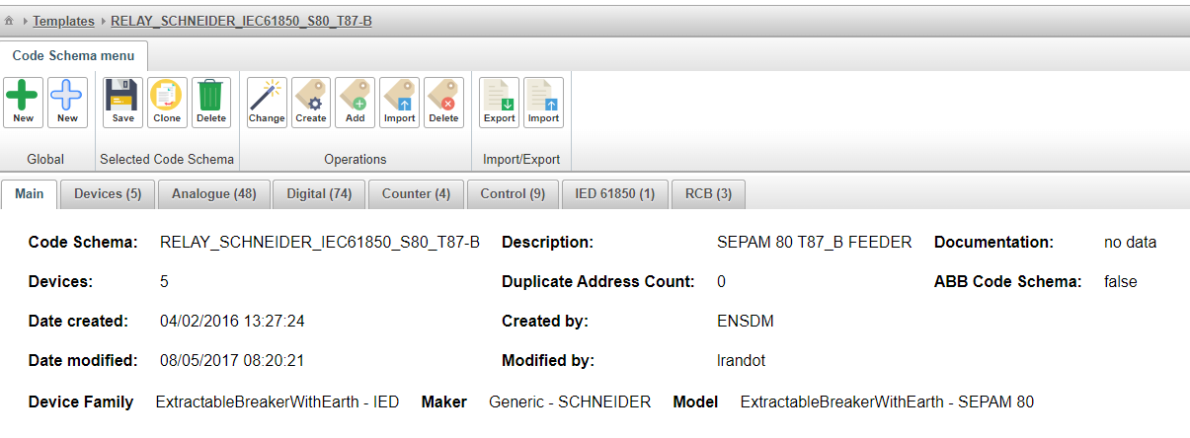
Figure 1 – Codeschema’s main information tab in ENSDM.

Procedure,
The procedure of improving the data quality involved a systematic examination of tags and signals originating from codeschemas, with a primary focus on validating the accuracy of the Maker, device family, and model. In instances where discrepancies emerged, a correction was employed, encompassing the rules of existing classifications a process reported within an Excel-based file to ensure robust documentation and ongoing oversight.

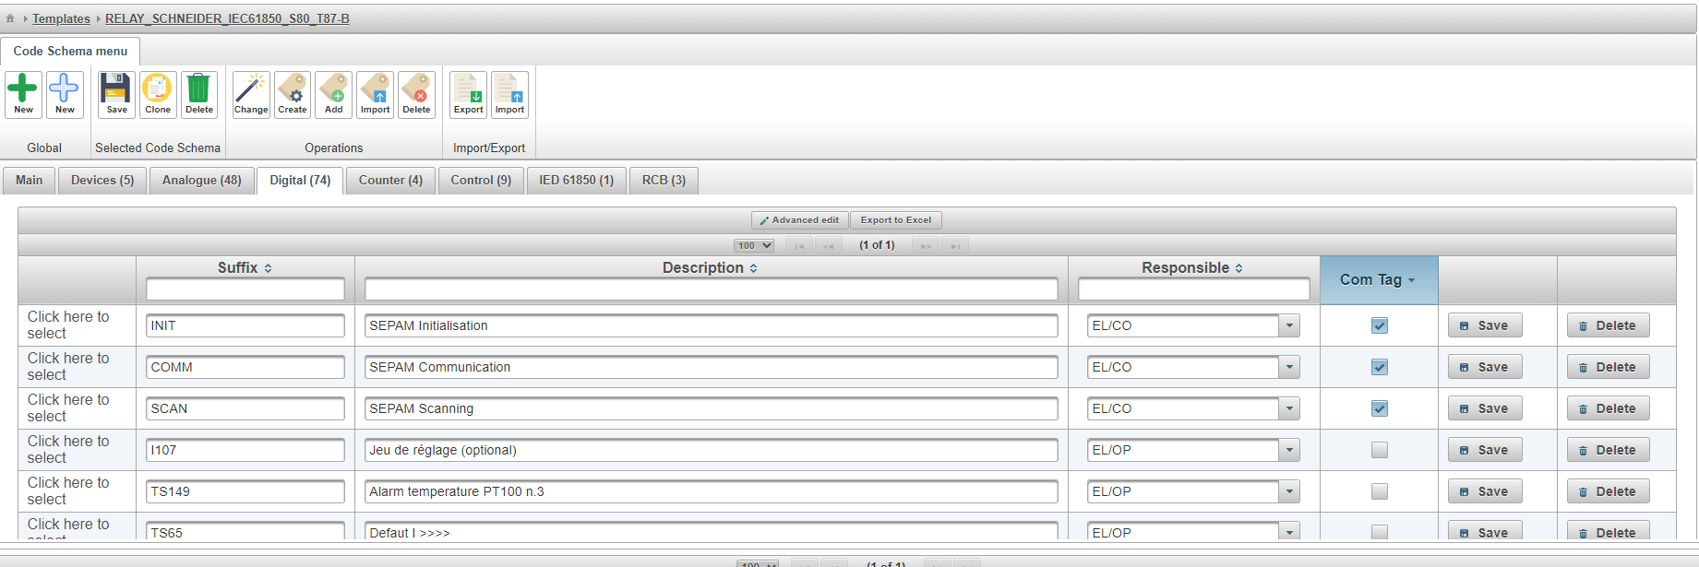
Figure 2 – Codeschema’s digital signals tab in ENSDM.

Exporting electrical devices and IEDs from each codeschema to identify necessary corrections based on previous codeschema changes, new maker, model, and device family, as well as determining which devices should be associated with the codeschema.

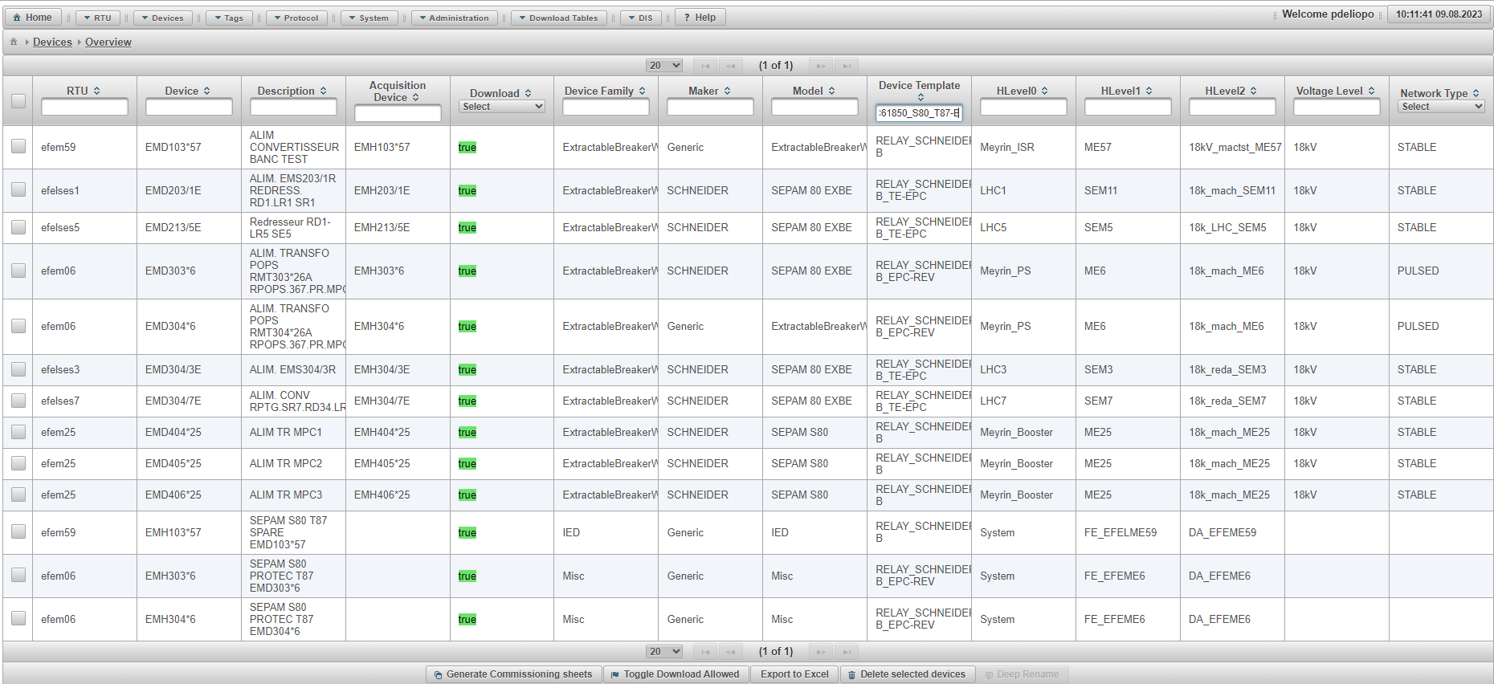
Figure 3 – Exporting codeschema’s devices through ENSDM.

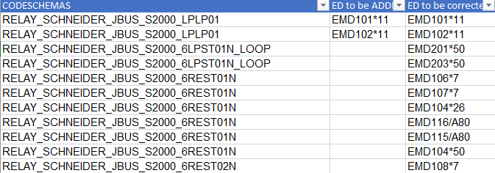
Figure 4 – Keeping track of devices associated with treated codeschemas.

The main goal of this well-organized effort was to build a strong system to ensure the accuracy of code structures, device connections, and related information. This helped make managing things smoother and guaranteed the trustworthiness of equipment data. The Excel file has been meticulously designed to ensure the utmost accuracy in recording modifications to code schemas and the associated devices. Its primary purpose is to facilitate automation for enhanced efficiency when working with this data.
The first column indicates whether the code schema is treated or not using binary. Following that, you will find the code schema's name, description, and the count of associated devices. Next, there is a code that specifies whether any modifications have been made and their respective locations, which could be either electrical devices or IEDs. Subsequently, you will find 'before' and 'after' details for electrical devices, including the maker, model, and device family, and the same for IEDs.

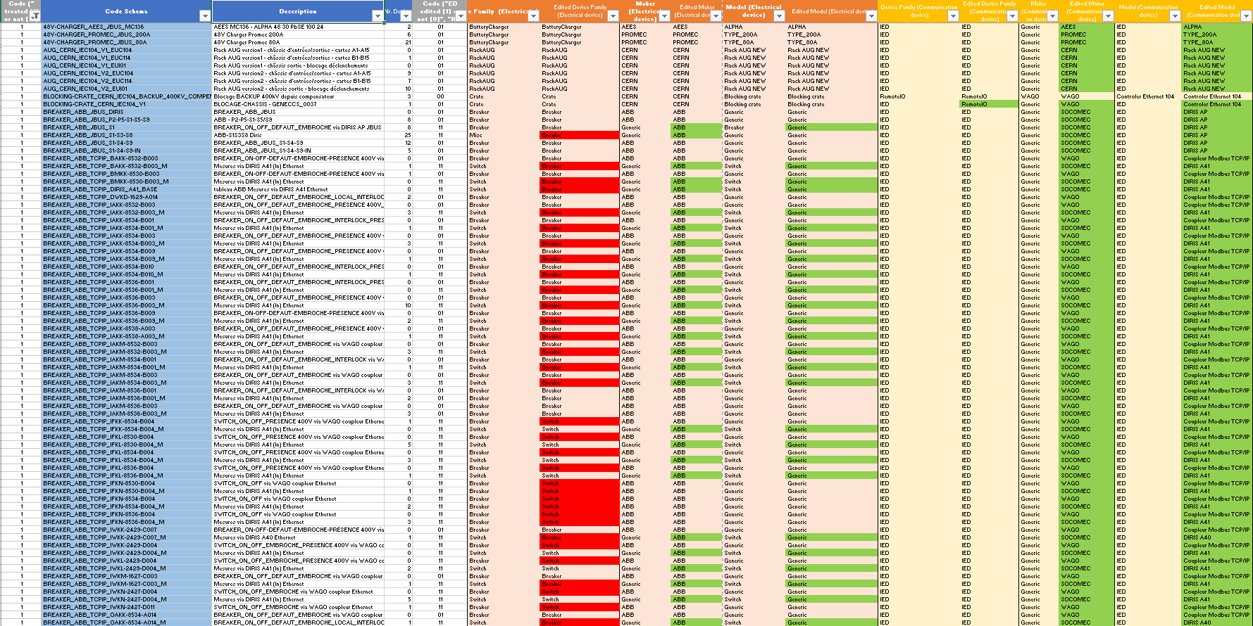
Figure 5 – Modifications tracking in Excel.

Verification,
We need to confirm the consistency between the ENSDM database and the Excel file. To achieve this, our approach involves extracting an ENSDM table containing end user information using SQL. Once extracted, we can proceed to verify each codeschema for accuracy.

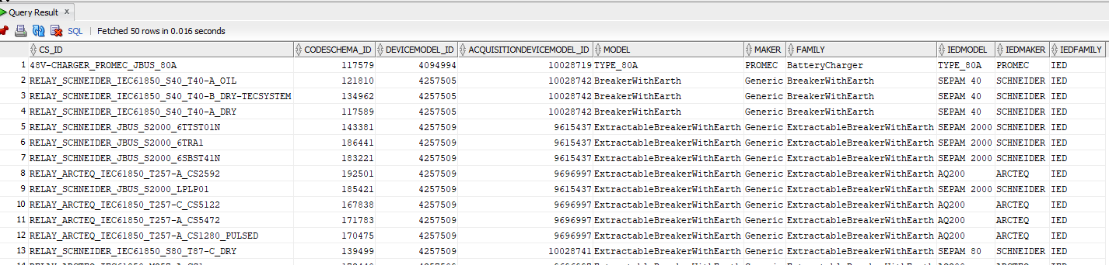
Figure 5 – SQL extracting.

Visits,
During my visits to the CERN substations, I gained valuable insights into the intricate workings of networking and safety protocols within this scientific facility. One notable highlight was the exploration of the main substation, housing a powerful transformer that draws energy from a 400 kV power line. Moreover, I delved into the change of seeing the equipment and the associated characteristics such as device family, maker and model that I was dealing with and correcting electronically from my computer.

Supervising work,
Tasked with a responsibility, the goal was to validate the correct execution of the work executed by this company at request of CERN. This involved ensuring the correct handling of alarm priorities on specific equipment and devices, contributing to enhanced operational efficiency and system reliability.



