Summer Student Report | 
 |  | Ciarán Toner

Before I begin this report about my time at CERN it seems appropriate to state my background. I studied Electrical and Electronic Engineering at the Queen’s University in Belfast where this summer, while in the summer student programme, I graduated with masters in engineering. Haven completed my university degree and previously completed 2 different internships I have a certain degree of experience in engineering and most of this experience is in hardware engineering.
As part of the ATLAS experiment my task at CERN was to work with some of the electronics hardware that provided and interface between the detectors and the computer system. The VMM1 is the pervious generation of this hardware and my first week consisted of me reading documents on the VMM1 device. I was informed that the VMM2 would come the following week and that understanding the VMM1 would greatly help when working with the VMM2. My task was never made clear, I was only told that this new hardware was yet to arrive.
The following week there was no new hardware and my supervisor was too busy to give me a new task so I filled in the time reading random documents on CERN. The week after this I was informed that the VMM2, the hardware I was supposed to work on, would not arrive before my time as a summer student was up.
I understand that this is supposed to be a work related report so now it seems best to state that after weeks of nothing happening, despite me meeting my supervisor and telling him I wanted something to do, I finally got a project in week 7.
With 2 and a half weeks left of my time as a summer student I finally had a project I could start. My project was to modify the SRS (scalable readout system) software that is used to interact with the hardware that detects the particles. The previous generation of the software could interact with only one hardware device at a time so it was my task to improve the software whereby the user could select any number of devices that the software would then control.
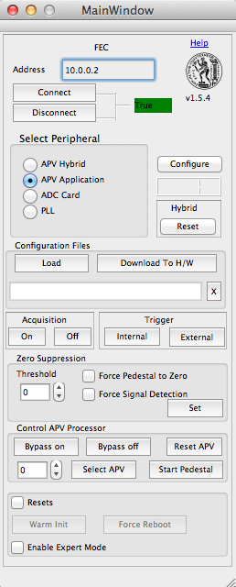
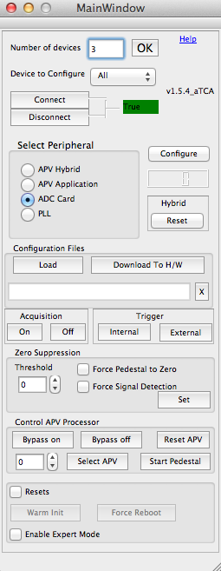
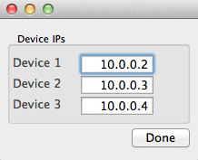

The image above shows the old version of the software next to the new version. In the new version when the user enters the number of devices the widget pops up telling the user to enter the IP address for each of the devices.
As well as this the software was modified to deal with a new FEC (front end control) card, which had 12 registers rather than 8. Increasing the number of registers resulted in an increase in the number of bytes that the application used when storing the data. This meant that the code had to be modified as configuration files were of a different size and would not correctly load.
Overall the project was a success however given the fact that I was only given this project with less than 3 weeks left I was under a huge amount of pressure to get it finished before I left. This resulted in many late nights during my last few weeks due to the fact that this project was entirely and in software and my experience is with hardware and I have limited software skills.

