Design & Development of the EDMS Service Pages
My first project-related task upon arriving at CERN was to start familiarising myself with the Engineering and Equipment Data Management System (EDMS) which is used to store all technical and engineering data about the Large Hadron Collider (LHC). During the first few days I went through some introductory material about how the system works and the features it offers. In addition to this, I started identifying the different types of users which use the system.

My supervisors, Alexandra and Tsvetelin, then started to explain to me what would be required: to migrate and re-develop the FAQ and Service pages of EDMS from SharePoint and to create a site which looks more modern and is easier to maintain. The first step was to start looking for some possible frameworks which could help with structuring and developing the site in an easy way such as Jekyll, which is a static site generator. After scouring the web looking for frameworks, it was decided to simply find a CSS template which would fit the needs of the site and start the development from there. This decision could be made due to the projected static content of the website, as there was no need for dynamic data which would have required server-side logic.

A CSS theme with numerous features was identified and after ensuring that the license under which it can be used was valid, development could be started. The first decision made was to change the colour scheme to match that of the EDMS logo. The final result was a clean, white background, complemented with elements of blue, grey and green.

The next task was to start identifying the different pages required throughout the site and the content to be represented throughout each section. The content from the old EDMS services pages was revised and parts of it which were still relevant were marked to be migrated into the new pages. New content still had to be created, involving both text and diagrams.

One of the most important elements when designing content was to keep the end-users in mind. EDMS is used by many different user groups, ranging from beginners to technically advanced users. For example, we made sure to not make many changes in the page containing the list of Frequently Asked Questions (FAQs) so as to keep the site as familiar as possible to users who had been accustomed to the old FAQ list in the past.

The concept for the new site was to have 6 main pages: the landing page, the features page, the EDMS usage, the services page, the tutorials page and the FAQ page, each of which will be explained in further detail later on. Once a draft of the site structure and content required was made, development was started.

Home
The landing page was of course developed to be able to welcome the users and to give them some general information about EDMS, what it is and what it does. Since EDMS is used to document the lifecycle of a product, it was appropriate to add a cycle diagram of product phases typical for big engineering projects such as the LHC: the design phase, the manufacturing phase, installation, commissioning, maintenance and finally their dismantling. In addition to this, some information regarding who can use EDMS and an overview of the system is given.

Further to the graphs, other statistics about EDMS are showcased through dynamic counters which count up from 0 to particular values depending on the respective statistic. These can be seen below:
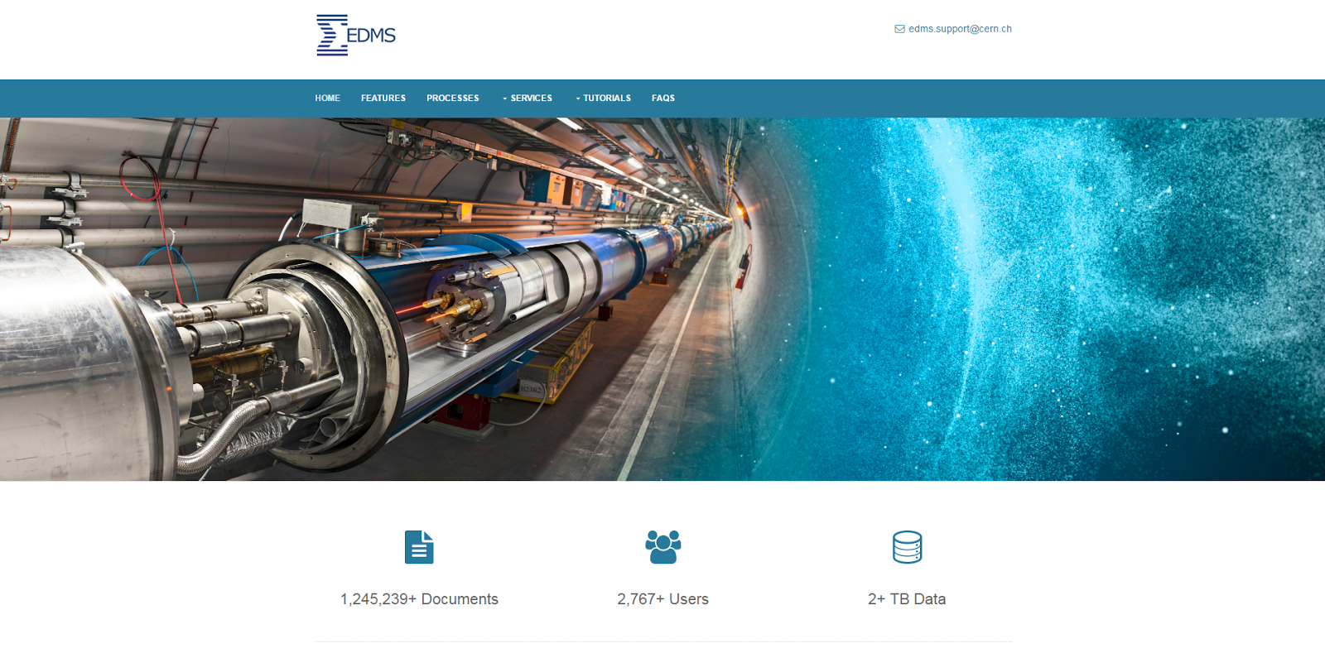

Features
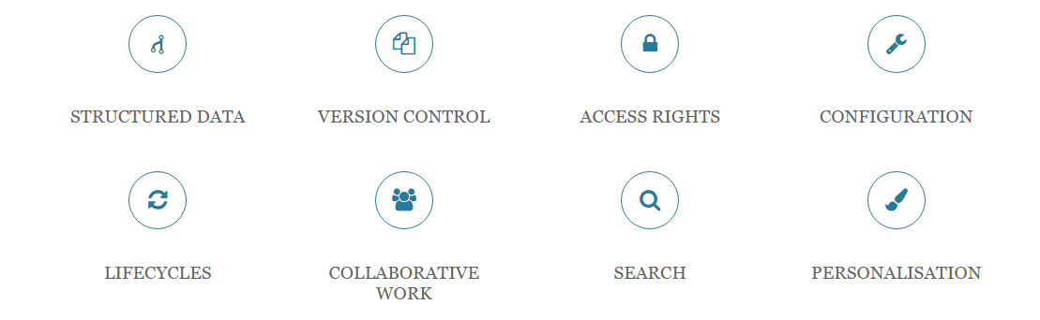
This page was conceptualised over the summer so as to be able to showcase the numerous features which EDMS offers such as structured data, version control and personalisation. The below image is a screenshot of an interactive diagram serving as navigation within the page. Depending on the section clicked, it takes the user to the respective chapter.

Usage
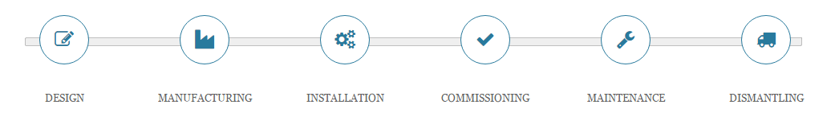
An engineering project is usually carried out in 6 distinct phases: the design of the components, manufacturing, installation, commissioning, maintenance and dismantling phases as can be seen from the image above. A page on the EDMS service pages was created so as to be able to give some information about how EDMS is used in each part of a product lifecycle. For example, starting off with the first stage of the lifecycle, the design stage, the HiLumi-LHC project team and the EDMS team worked together on ensuring that EDMS is fully integrated within the work processes of all HL-LHC work packages dealing with CAD design, equipment and/or technical documentation. In addition, the CERN Design Offices are big users of EDMS as they do mechanical designs upon request of various projects running at CERN. These designs are then of course stored in EDMS. Another example is the final stage of a lifecycle, known as the dismantling phase. An example of EDMS’ use in this phase is by CERN’s Traceability of Radioactive Equipment at CERN (TREC) application, created to track and measure the radiation levels of components in their dismantling phase which uses EDMS to store all radiation measurements.

Services
The new services page combined two pages from the old site into one: the Training page and also the Support page. This is because both pages offered quite little information when considered on their own, and given that support and user training can easily be combined, it made sense to create a new page combining them both. This page was completely rebuilt and revamped when compared to the old EDMS site. To be able to showcase all training and support by EDMS, we split the page into four main sections: training, customisation, statistics and support and consultancy.

Training
This page was dedicated to the courses which the EDMS Services team offered such as the introductory course and the Local Administrators courses. As per the previous site, the new section offers details on how to enroll for these courses. It includes as well the links to the online tutorials found on the site and details about customised training for different user groups which the team offers.

Customisation
It is important to note that EDMS is customizable; it can be adapted to meet the needs of different projects. We therefore added a section to advertise this fact, and to encourage users to contact the EDMS Service team know more about the available configuration options to get the most out of EDMS.

Support and consultancy
This section gives the details of the available support given daily by the EDMS Support team; how the team can be contacted and the hours of operation.

Statistics
A number of line graphs and bar charts were developed to showcase some statistics about EDMS such as the number of support tickets solved per year, the number of users on official EDMS training courses since 2002 and the amount of data stored within EDMS since its inception in 1998. These graphs were developed using the d3.js JavaScript library.
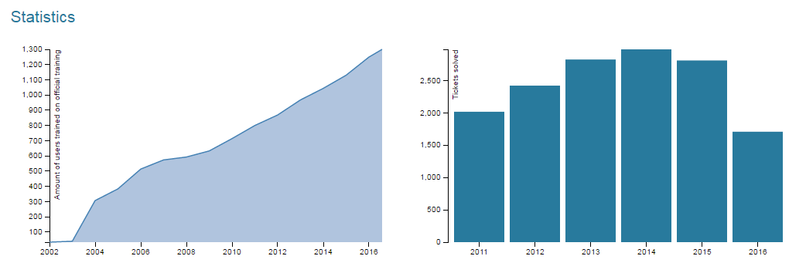

Tutorials
The previous site included a number of video tutorials which explain everyday actions within EDMS. These videos were migrated to the new site with the difference that instead of opening the videos as a link to a separate page, a JavaScript library (lity.js) was identified so as to be able to create a lightbox effect around the videos which are now popped up within the same page with the foreground shaded out.
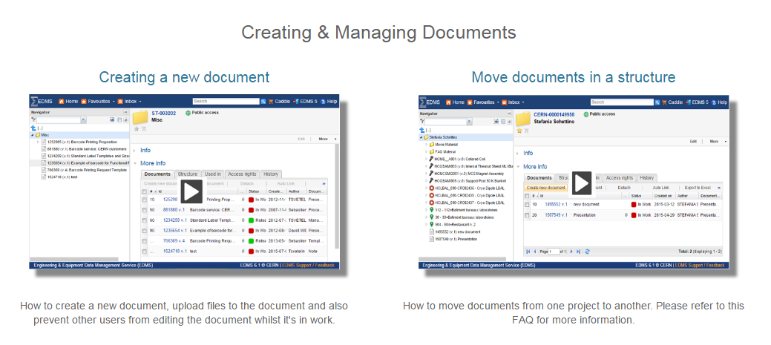

FAQs
The FAQ page was migrated only with minor changes in respect to the old EDMS service pages. This was mainly due to the primary concern of wishing to preserve the old layout which many EDMS users are accustomed to.

Responsive design & Mobile development
Since the majority of EDMS users access EDMS from desktops and laptop computers, ensuring a responsive design was not a top priority until we ensured that all other required tasks had been completed. Therefore, towards the final stages of development, once we established that time constraints were no longer an issue, we made sure that the site performed well on mobile devices. Part of this task included the use of CSS Media Queries to be able to alter the site menu depending on the current window size. For example, on smaller screens, the menu would be scaled down to look like the below:
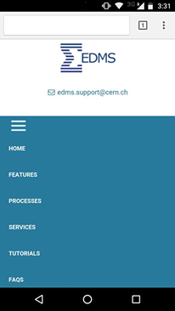

Hosting
The site will be hosted at http://edms-service.web.cern.ch.

Overall, the project aim was achieved; we managed to design and develop more modern, responsive service pages for EDMS. We hope that they will be of great use for the EDMS community!

