CERN SUMMER STUDENT REPORT 2025


MULTI-OBJECTIVE PARTICLE SWARM OPTIMIZATION (MOPSO)

Author:
Gift Oguare
Supervisors:
Felix Pantaleo
Simone Rossi Tisbeni
Affiliation:
University of Benin

Geneva, 8th August 2025.

ABSTRACT

This report presents the development of an interactive web-based visualization tool for multi-objective particle swarm optimization (MOPSO), created during a summer internship at CERN. The project involved designing and implementing a comprehensive dashboard that enables researchers to upload CSV file containing MOPSO results and visualize them through dynamic scatter matrix plots. The interface was developed using Python’s Dash framework, deployed on CERN’s OpenShift Kubernetes Distribution (OKD) Platform-as-a-Service, and tested using CERN’s SWAN (Service for Web-based Analysis) environment. The tool provides interactive filtering, pareto front identification, target point, and real-time data manipulation capabilities, significantly enhancing the analysis workflow for multi-objective optimization problems in high-energy physics applications.

- INTRODUCTION
  - BACKGROUND
Multi-objective particle swarm optimization (MOPSO) represents a critical computational technique in solving complex optimization problems where multiple, often conflicting objectives must be simultaneously optimized.
Traditional approaches to analysing MOPSO results often rely on static visualizations or require specialized software installations, creating barriers to collaborative research and limiting the accessibility of optimization insights. The need for an interactive, web-based solution that can handle the complex multi-dimensional data motivated this project.
  - Project Objectives
The primary objectives of this internship project were to:
- Develop an interactive web interface for visualizing MOPSO results.
- Implement dynamic scatter matrix plotting capabilities for multi-dimensional objective spaces.
- Create tools for Pareto front identification and analysis.
- Provide interactive filtering and data manipulation features.
- Deploy the solution on CERN’s cloud infrastructure for broader accessibility.
- Ensure scalability and usability for diverse optimization datasets.

  - Scope and Significance
This project addresses a significant gap in the available tools for MOPSO analysis in the physics research community. By offering an intuitive, browser-based interface, the tool broadens access for users across various backgrounds.

- LITERATURE REVIEW AND THEORETICAL FOUNDATION

  - Multi-Objective Particle Swarm Optimization
Particle Swarm Optimization (PSO), first introduced by Kennedy and Eberhart in 1995, simulates the social behaviour of bird flocks to solve optimization problems. The extension to multi-objective problems (MOPSO) presents unique challenges, as noted in Liu Dasheng comprehensive work on MOPSO algorithms and applications.
In muti-objective optimization, the goal is not to find a single optimal solution but rather a set of solutions representing optimal trade-offs between competing objectives. This set is known as the Pareto front, where no solution can improve one objective without degrading at least one other objective.
The mathematical formulation of a multi-objective optimization problem can be expressed as:

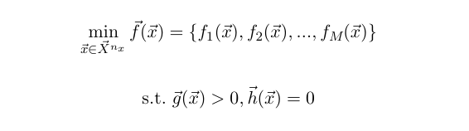

  - Visualization Challenges in Multi-Objective Optimization
Visualizing multi-objective optimization results presents several challenges:
- Dimensionality: Real-world problems often involve multiple objectives making direct visualization difficult
- Pareto Front Identification: Distinguishing optimal solutions from sub optimal ones requires computational analysis
- Interactive Analysis: Researchers need to explore different aspects of the solution space dynamically
- Data Scale: Optimization runs can generate thousands of candidate solutions.

- SYSTEM DESIGN AND ARCHITECHTURE

  - Technology Stack
The visualization interface was built using a modern web technology stack optimized for scientific computing:
- Backend Framework: Python Dash with Plotly for interactive visualizations
- Data Processing: Numpy and Pandas for efficient numerical computations
- UI Components: Dash Bootstrap Components for responsive design
- Deployment: CERN’s OKD (OpenShift) Platform-as-a-Service
- Development Enviroment: CERN SWAN (Jupyter-based analysis platform)

    - Core Libraries and Dependency
The application relies on the following Python libraries and tools:

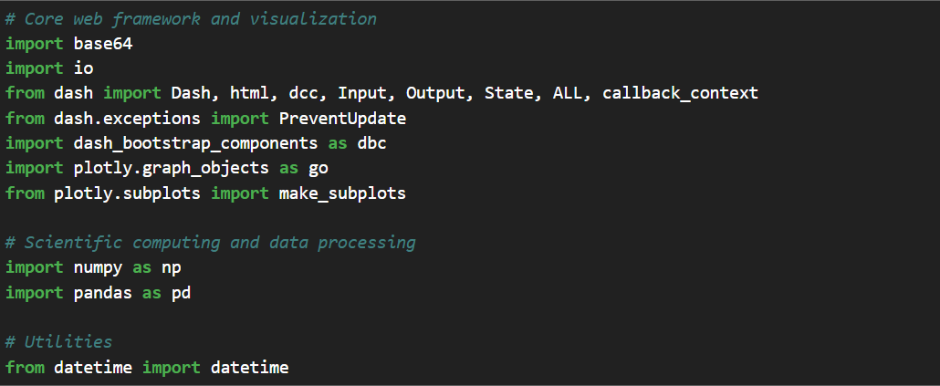

  - Architecture Overview
The system follows a client-server architecture with the following key components:
- Data Upload Module: Handles CSV file parsing and validation
- Processing Engine: Performs Pareto front calculation and data transformations
- Visualization Engine: Generates interactive scatter matrix plots
- Filter System: Provides real-time data filtering capabilities
- State Management: Maintain user selections and application state.

  - Data Structure Design
The application accomodates flexible data structures by automatically detecting:
- Parameter columns
- Objective columns
- Dynamic restructuring based on user specifications

- IMPLEMENTATION DETAILS

  - Core Functionality
    - CSV Data Processing
The system implements robust CSV parsing with automatic structure detection:
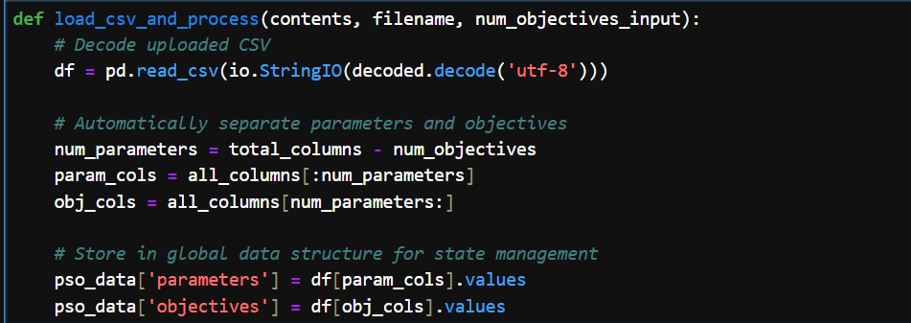

    - Pareto Front Calculation
The implementation includes an efficient algorithm for identifying Pareto-optimal solutions:
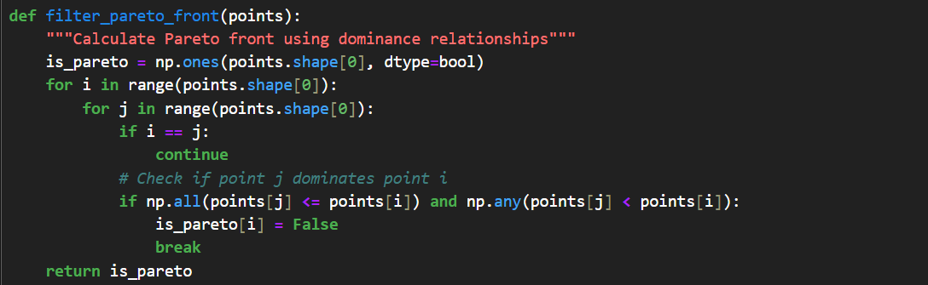

    - Interactive Scatter Matrix
The centrepiece of the visualization is the dynamic scatter matrix that displays all pairwise relationships between objectives:
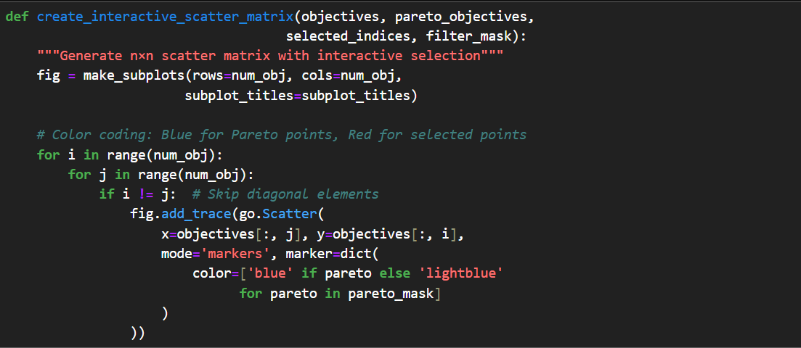

  - Advanced Features
    - Dynamic Filtering System
The interface provides real-time filtering capabilities through range sliders for both parameters and objectives:
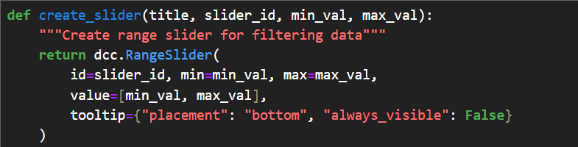

    - Interactive Point Selection
Users can select points through multiple selection modes:
- Click selection for individual points.
- Drag selection for multiple points.
- Programmatic selection through point indices.

    - Data Manipulation Tools
The interface provides tools for data exploration:
- Delete Selected: Remove selected points from analysis.
- Keep Selected: Retain only selected points.
- Reset Data: Restore original dataset.
- Clear Selection: Deselect all points.

  - State Management
The application maintains complex state information including:
- Original and modified datasets
- Current selections and filters
- Visualization parameters
- Activity logging for user actions.

- DEPLOYMENT AND INFRASTRUCTURE

CERN SWAN Integration
The development process leveraged CERN’s SWAN platform, which provides:
- Jupyter notebook environment with pre-configured scientific libraries
- Access to CERN’s computing resources
- Integration with CERN’s authentication systems
- Collaborative development capabilities

  - OKD Deployment
The production deployment utilized CERN's OpenShift Kubernetes Distribution (OKD), which is the open-source version of Red Hat OpenShift built on Kubernetes. CERN uses OKD as their primary Platform-as-a-Service solution, providing container orchestration, automated deployments, and integrated CI/CD pipelines.
The Dash application was containerized using Docker with a Python 3.9 base image, including all required scientific computing libraries (NumPy, Pandas, Plotly, Dash). It was configured to run on port 8080, following CERN's standard practices, with a stateless design where application state is maintained in memory rather than persistent storage.
The deployment process involved pushing code to CERN's GitLab, building container images in CERN's registry, and deploying through the OKD web console.
This deployment approach ensured the visualization tool was accessible to CERN researchers while maintaining security policies and providing reliable, scalable hosting infrastructure.

- RESULTS AND IMPLEMENTATION
6.1. System Overview
The MOPSO visualization tool successfully delivers all core features as specified. The web interface operates smoothly from data upload through interactive visualization. Users can upload CSV files, and the system automatically detects data structure and creates appropriate visualizations.
The workflow demonstrates intuitive design. After uploading a file, users specify how many objectives their data contains, and the system handles the rest. The scatter matrix automatically adjusts to show all relationships between objectives, with Pareto front identification highlighting optimal solutions in blue while displaying regular points in lighter colours.

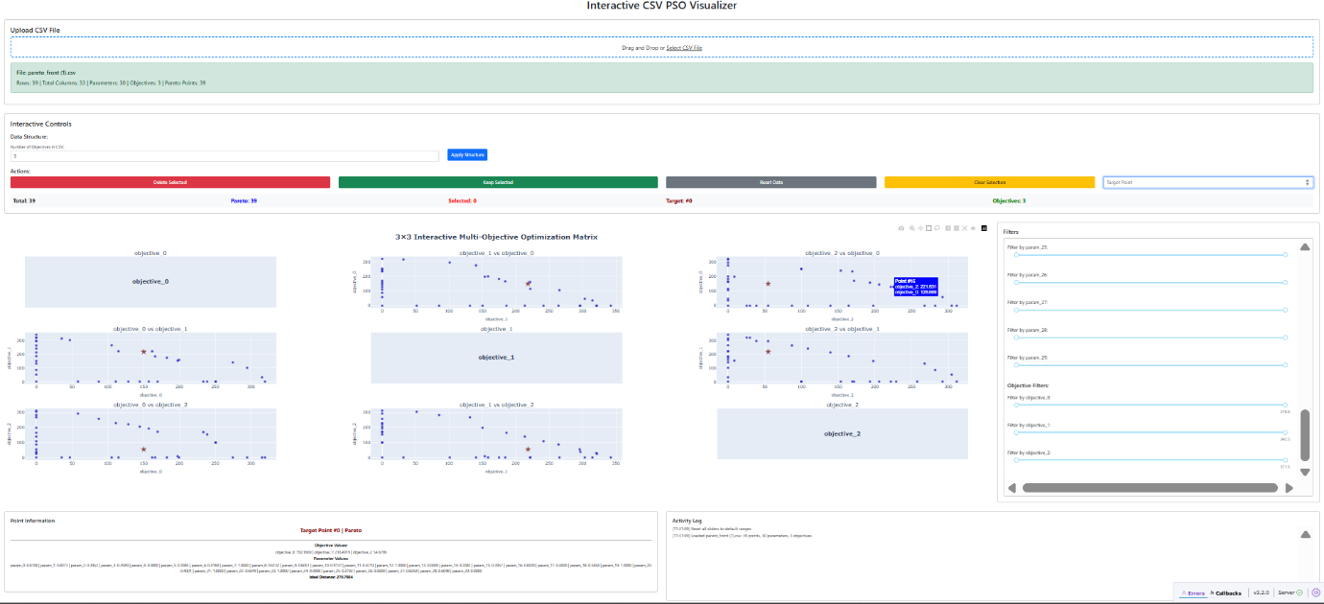

6.2. Technical Capabilities
The system handles datasets with varying complexity effectively. The automatic column detection correctly separates parameters from objectives based on user input, and the visualization adapts accordingly for different numbers of objectives and parameter dimensions.
The Pareto front calculation algorithm operates as designed, correctly identifying optimal points by checking dominance relationships. The interactive features described in Section 4.2.2 function reliably - users can select points through clicking or dragging, and the filtering system responds in real-time to range slider adjustments.
All four data manipulation tools (Delete Selected, Keep Selected, Reset Data, Clear Selection) operate without errors and maintain data integrity throughout operations.

6.3. Project Assessment
The implementation achieves all initial objectives. The tool provides an accessible method for researchers to analyse MOPSO results interactively, deploys successfully on CERN's infrastructure, and handles multi-dimensional data common in optimization problems.
The implementation demonstrates that web-based tools can effectively handle scientific computing tasks traditionally requiring desktop software. The technical foundation provides a solid base ready for research use, transforming a visualization challenge into a comprehensive data analysis tool.

- CONCLUSION
This internship project successfully developed a comprehensive web-based visualization tool for multi-objective particle swarm optimization results.

  - Key Achievements
- Technical Innovation: Created a sophisticated web interface combining advanced visualization with interactive data analysis.
- Practical Impact: Provided researchers with an accessible tool for optimization result analysis.
- Infrastructure Integration: Successfully deployed on CERN’s cloud infrastructure.

7.2 Learning Outcomes
This project provided valuable experiences in:
- Scientific software development methodologies
- Cloud deployment and containerization
- Interactive visualization design
- Multi-objective optimization theory and practice
- Collaborative development in research environments.

REFERENCES
- Liu Dasheng. (2008). Multi-objective particle swarm optimization: algorithms and applications. Doctoral thesis, National University of Singapore.

