 | Motion capture as a tool for radiation dose estimation in the decommissioning of ATLAS’s inner detector
ATLAS Project Document No: | Institute Document No. | Created: 28/08/2019 | Page: 1 of 10
 |  | Modified: | Veers. No.: 1.2

This document details the methodology and results behind utilising Phasespace motion-capture technology, to assist in estimating a radiation dose that technicians will receive during the decommissioning of the ATLAS inner detector (ID). Dose estimation was achieved by constructing a mock-up of the current ID and having a technician carry out the same work that will occur during actual decommissioning. The Phasespace motion capture system tracked the movement of the technician as they worked and from this, a human model was created within Autodesk Motionbuilder and imported into the game engine Virtalis 3-D renderer. Within Virtalis a virtual model of the mock-up with an up to date FLUKA radiation map overlaid had been drawn. The human model was imported into Virtalis and allowed to interact with the virtual radiation as it worked. Once the model animation had finished, the total dose accumulated by it was determined. The final estimated dose was determined to be 21.92 μSv.

Contents
Introduction 3
Motion capture Hardware 4
Motion capture Software 5
Results 7
Conclusion 9
Appendix 1 10

Table of Figures
Figure 1- Phasespace Master Client Interface 4
Figure 2- LED arrangement 4
Figure 3-Recap 2 interface 5
Figure 4-Motionbuilder actor 5
Figure 5-Character interface, Motionbuilder 6
Figure 6-Virtalis virtual environment with character 6
Figure 7-Radiation dose accumulated versus time 7
Figure 8-Mock-up 10
Figure 9-Virtual Mock-up 10

Introduction
The high luminosity large hadron collider experiments are the next big step in the future of the CERN supercollider’s journey. Fundamentally, the aims of high luminosity are to attempt to increase the number of protons under acceleration during active beam operation by a factor of 10. This will allow for far more frequent successful collisions, vastly increasing the LHC’s performance, allowing for more data to be taken and increasing the overall probability of rare events occurring; such as the production of the Higgs Boson. However, the ATLAS inner detector (ID), in its current form, will not be able to handle the increased number of proton-proton collisions. As such, the current ID must be decommissioned and replaced by a newer model; capable of reaching the new requirements.
However, after many years of being subject to the bi-products of various collisions, residual radiation has built up within many of the ID’s components. There is not enough radiation to cause any critical damage to personnel, such as ‘radiation sickness’, but enough to warrant concern for future health during prolonged exposure; such as technicians during decommissioning efforts. Therefore, an accurate dose had to be calculated before work commenced.
It was decided that to calculate as accurate a dose as possible, a mock-up of the inner detector would be constructed. Once constructed, the mock-up would undergo the same procedures technicians would carry out within the actual caverns and from this, a radiation dose would be calculated before any real work began. To determine the dose received, the Phasespace motion capture system was to be utilised. The motion capture system works by having high FPS cameras arranged around the workspace of the mock-up to create a capture area. Inside this capture area would be red LEDs that the cameras could accurately track the position of in 3-D space. The LEDs could then be attached to the technician carrying out the work on the mock-up and a human model be made from the LED’s data. Additionally, a virtual environment of the mock-up was created within the game engine Virtalis 3-D renderer and an up to date FLUKA radiation map applied to it. The human model from the motion capture could then be added into this environment; how much of the virtual radiation it receives during the decommissioning, is how much the technicians will receive during active operations; ultimately, providing an accurate dose estimation for decommissioning and allowing the upgrade to proceed.
One great advantage of this set-up is that it has great reusability potential. The most obvious way this could be reused, would be by carrying out the same method as this project, on some other area of ATLAS or the LHC. The system could also be used for training purposes. For example, trainees could be recorded carrying out work and their movements be accurately played back; should their dose be higher than expected, the data can be re-watched and accurate feedback could be given about avoiding unnecessary, radioactively hot areas. Another advantage of this set-up, it allows technicians to practice their duties in a safe environment before exposing themselves to the real thing; boosting both efficiency and safety.
In summary, the aim of this project is to determine an accurate dose of radiation technicians will receive during decommissioning efforts by utilising the Phasespace motion capture system and applying the data to some form of game engine; where a virtual radiation dose can be determined. This virtual radiation dose will then be used in the ALARA application process for allowing the decommissioning of the ATLAS ID to commence.

Motion capture Hardware
Before the tests on the mock-up could begin, the set-up and limits of the Phasespace system had to be tested. One of the major concerns during initial testing was in optimising camera positions. Camera positioning is critical to any motion capture system; incorrect positioning could lead to large areas of the workspace being uncovered by any camera; leading to large blind spots and subsequently occluded LED’s. As such, many tests were carried out with many different camera arrangements to determine which would provide the best results. It was decided that a camera set-up which circles the entire mock-up would be the most beneficial, leading to the final set-up below:
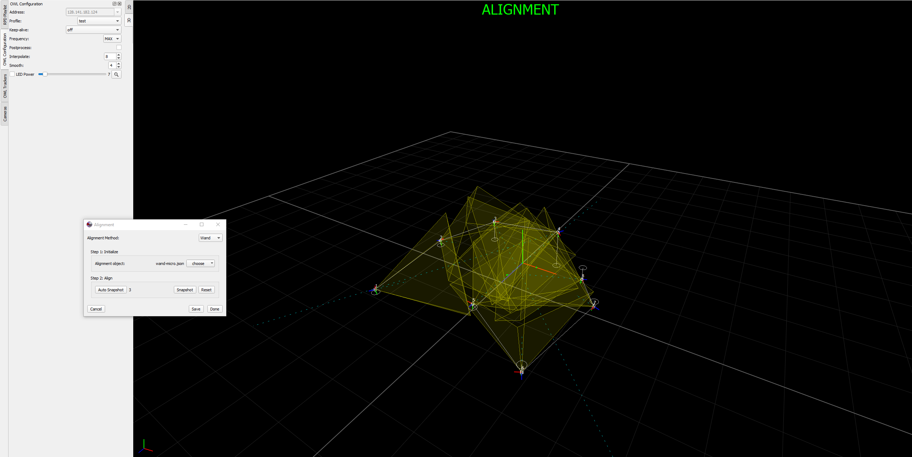
Figure 1- Phasespace Master Client Interface
The next major concern was the positioning of the LED’s on the technician’s body. Many different set-ups were tested, mainly based on trial and error, one set-up would be tested and its stability would be assessed after. After many alterations, the final set-up chosen can be seen below:
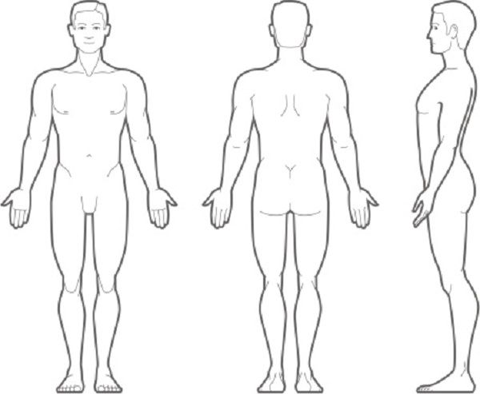
Symmetrical
LED

Symmetrical
Figure 2- LED arrangement

With both camera positions and LED arrangements deduced after initial tests, the final recordings on the mock-up could begin.

Motion capture Software
After final recordings of the mock-up had been captured, the recording had to undergo post-processing to be suitable for importing into the virtual environment. There are three main pieces of software which were used with the Phasespace set-up: the Phasespace master client, Recap 2 and Autodesk Motionbuilder.
The Phasespace master client application (PMC) is the first of the three software to be used. The PMC is used in connecting the LED’s, activating them and finally displaying and recording the LED positions in the capture area. The PMC is also used in the calibration and alignment of the system and is thus integral in camera positioning; as it also shows each cameras field of view for each calibration completed. The PMC can record data in .RPD and .C3d formats or indeed both. However, .C3d was the only format to be used, as it was the only format compatible with both Recap 2 and Autodesk Motionbuilder.
Once the PMC has been used to record initial motion captures, Recap 2 is used to cut up the recordings into smaller chunks. This was required as due to a discrepancy with the different import settings of C3d data between Phasespace’s Recap and Autodesk’s Motionbuilder, Motionbuilder would limit recordings to 65,536 frames. Recap 2 could then export these 65,536 frame chunks together, so that they could be imported into the same Motionbuilder file as ‘takes’. These takes would play one after another but with each not exceeding the max number of frames. The recap 2 interface with markers and export dialog box can be seen below:
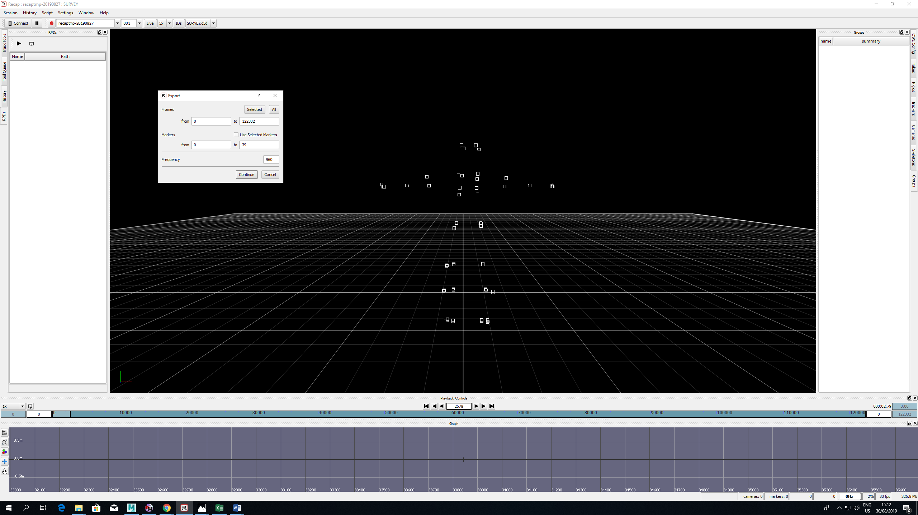
Figure 3-Recap 2 interface
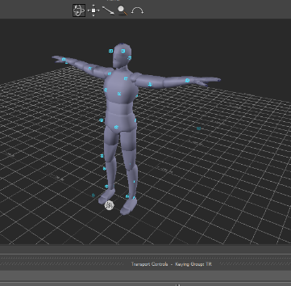
Autodesk Motionbuilder is the final piece of software that was used. Motionbuilder was used to clean up the C3d data imported into it. Whenever an LED fell from view of the cameras for whatever reason, it would drastically alter the data and ruin recordings. However, Motionbuilder has a built-in interpolation system that studies the X, Y and Z coordinates before the LED is lost, and applies an estimation of where it should be. There are multiple different forms of interpolation: linear, rigid-body, constant and Bezier; Motionbuilder also offers the control curve option to alter any of the different forms of interpolation. Once the data was cleaned, a human model know as an ‘actor’ was applied to it. The actor applied to the data can be seen below:

Figure 4-Motionbuilder actor
Once an actor was applied to the data, a skin could be added on top of the actor so that it appeared more realistic. Applying a character skin also standardised the names of bones in the actor’s skeleton, this was extremely useful when importing into the virtual environment as each different recoding had the same convention; so, no new code had to be written when applying the character to the environment. Below can be seen an actor with a character skin; within the motionbuilder environment:
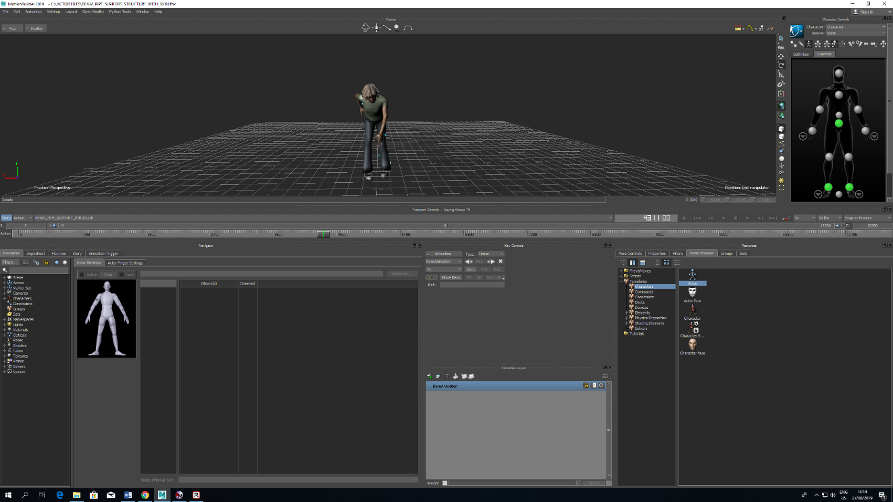
Figure 5-Character interface, Motionbuilder
Finally, with the data applied to a skinned actor, it was ready to be imported into virtalis where it could interact with the virtual environment. The virtual environment consists of a CAD drawn mock-up overlaid with an up to date FLUKA radiation map of the actual ATLAS inner detector. Once the motion capture is within Virtalis, the motion capture model interacted with the virtual radiation as the animation played; accumulating dose over time. This is what makes the use of motion capture so advantageous, the model moves through the virtual environment just as a technician would during decommissioning efforts; providing an accurate dose estimation without ever being exposed to real radiation. Below is the virtual environment created for the ATLAS inner detector; used in this project:
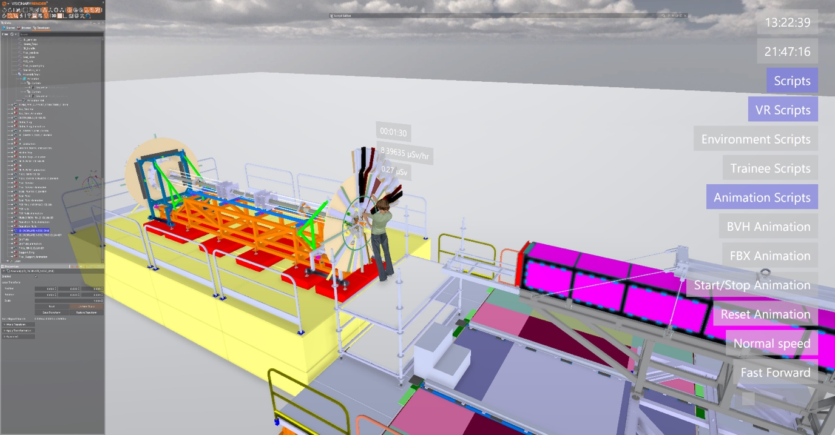
Figure 6-Virtalis virtual environment with character

Results
After each stage of decommissioning, a radiation dose was taken. All results for each stage can be seen below:
Decommission stage | Accumulated Radiation dose (μSv)
Endplate Nose | 1.02
Beam pipe support | 3.06
Outer ring | 3.39
IBL services | 4.31
Heater trays | 5.65
ER bundle | 10.03
Pixel services s8 and pixel outer services | 11.16
Seal plates | 20.15
PST rail interface | 20.53
Pixel support ring | 21.45
Transition rails | 21.55
Intermediate rails and frog | 21.92
 | Total dose: 21.92 μSv

As table 1 above shows, the total dose accumulated by the technician during mock-up operations was estimated to be 21.92 μSv. This value can now aid in determining an ALARA level by the appropriate authorities for such matters.
The time of each intervention was also monitored to make a record of the rate at which dose was accumulated; depending on the stage of decommissioning. Displayed graphically, this looks like:

Figure 7-Radiation dose accumulated versus time
Figure 5 previous, shows an initial increase of moderate gradient from the endplate nose to the Heater trays. These initial operations took place further from the centre of the beam pipe; therefore, it is to be expected that the rate of exposure should decrease. However, once work had finished on the heater trays and ended on the seal plates, all located around the beam pipe, the rate of exposure jumped up dramatically; it appears to be no coincidence that the exposure rate takes a significant increase when work begins on or near the centre of the mock-up. Finally, the rates begin to level out after the seal plates and finish on the intermediate rail stage. This work took place roughly a meter from the mock-up, thus decreasing exposure.
As to be expected, working in and around the beam pipe caused the overall accumulated dose to jump rapidly; whilst also decreasing as distance from it increased. As such, it appears that the most significant dose will arise from the beam pipe and the centre of the mock-up; when technicians carry out their duties, care should be taken whilst working around it.

Conclusion
After multiple tests and recordings, it could be stated that this project achieved all aims set at this time. The set-up worked as planned and an estimated dose through motion capture was achieved. However, there are still many future goals for this project. Whilst now, the dose estimated could have been achieved through more conventional methods, it is when high luminosity test begins that this projects full potential will be realised. High luminosity will provide much greater radioactive environments and the safest way to proceed will be by using the system laid out in this document. To conclude, this project could be deemed a success as:
- An estimated accumulated dose for working on the decommissioning of the ATLAS inner detector was achieved with motion capture, recording a physical mock-up
- The system was determined to be suitable for use in a multitude of different areas and activities; such as training.
- Results showed the most active component to be the central beam pipe and that it had significant effects on exposure rate.

Appendix 1

1.1 Real to virtual
The entire process began by constructing the mock-up on which all work and recordings would be carried out. The mock-up was made from former spare parts of the ATLAS inner detector as well as unneeded materials. Below is an image of the fully constructed mock-up:
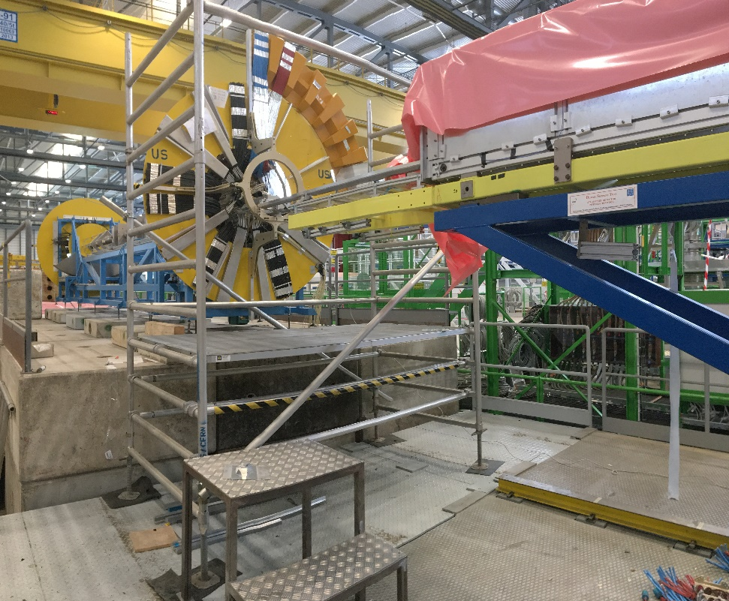
Figure 8-Mock-up
From this mock-up, the virtual model could be drawn. The model was drawn in Autodesk inventor and exported into Virtalis:
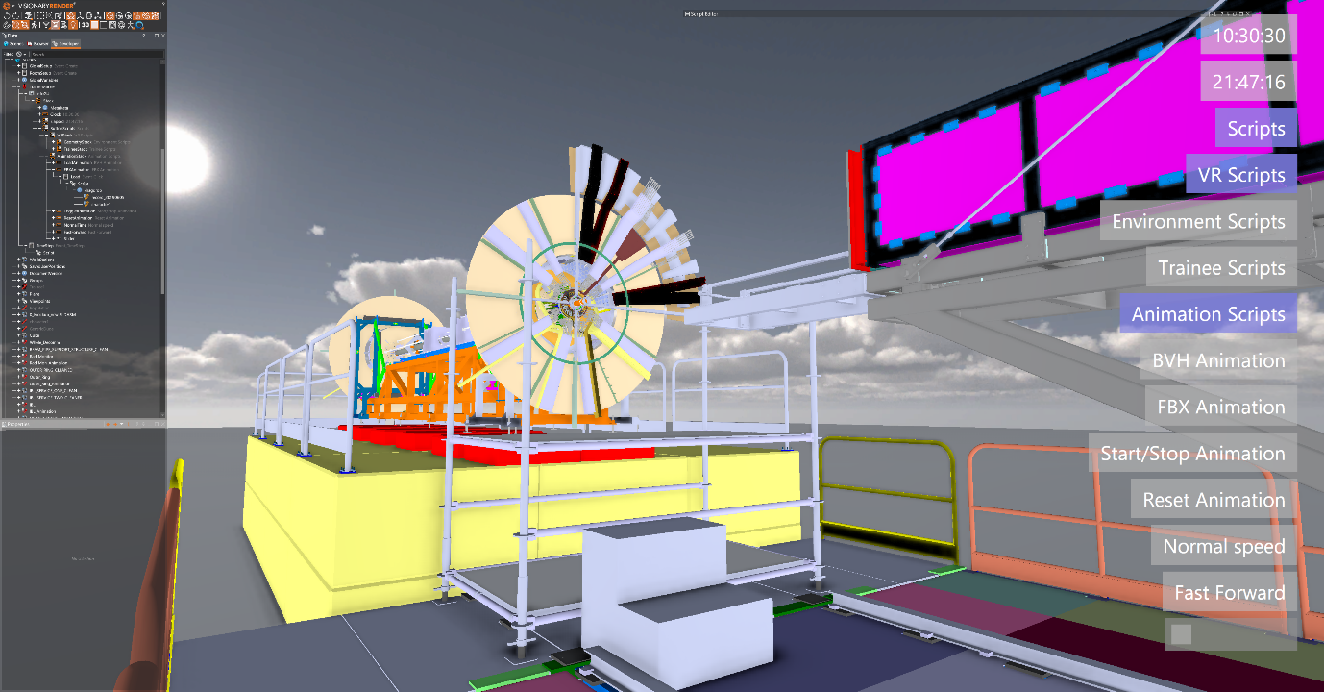
Figure 9-Virtual Mock-up

