CERN SUMMER STUDENT REPORT 2025


MULTI-OBJECTIVE PARTICLE SWARM OPTIMIZATION (MOPSO)

Author:
Gift Oguare
Supervisors:
Felice Pantaleo
Simone Rossi Tisbeni
Affiliation:
University of Benin

Geneva, 8th August 2025.

ABSTRACT

This report presents the development of an interactive web-based visualization tool for multi-objective particle swarm optimization (MOPSO), created during a summer internship at CERN. The project involved designing and implementing a comprehensive dashboard that enables researchers to upload CSV file containing MOPSO results and visualize them through dynamic scatter matrix plots. The interface was developed using Python’s Dash framework, deployed on CERN’s OpenShift Kubernetes Distribution (OKD) Platform-as-a-Service, and tested using CERN’s SWAN (Service for Web-based Analysis) environment. The tool provides interactive filtering, pareto front identification, target point, and real-time data manipulation capabilities, significantly enhancing the analysis workflow for multi-objective optimization problems in high-energy physics applications.

- INTRODUCTION
  - BACKGROUND
Multi-objective particle swarm optimization (MOPSO) represents a critical computational technique in solving complex optimization problems where multiple, often conflicting objectives must be simultaneously optimized.
Traditional approaches to analysing MOPSO results often rely on static visualizations or require specialized software installations, creating barriers to collaborative research and limiting the accessibility of optimization insights. The need for an interactive, web-based solution that can handle the complex multi-dimensional data motivated this project.
  - Project Objectives
The primary objectives of this internship project were to:
- Develop an interactive web interface for visualizing MOPSO results.
- Implement dynamic scatter matrix plotting capabilities for multi-dimensional objective spaces.
- Create tools for Pareto front identification and analysis.
- Provide interactive filtering and data manipulation features.
- Deploy the solution on CERN’s cloud infrastructure for broader accessibility.
- Ensure scalability and usability for diverse optimization datasets.

  - Scope and Significance
This project addresses a significant gap in the available tools for MOPSO analysis in the physics research community. By offering an intuitive, browser-based interface, the tool broadens access for users across various backgrounds.

- LITERATURE REVIEW AND THEORETICAL FOUNDATION

  - Multi-Objective Particle Swarm Optimization
Particle Swarm Optimization (PSO), first introduced by Kennedy and Eberhart (1995), simulates the social behaviour of bird flocks to solve optimization problems. The extension to multi-objective problems (MOPSO) presents unique challenges, as noted in Liu Dasheng's comprehensive work on MOPSO algorithms and applications (Liu, 2008).
In multi-objective optimization, the goal is to find a set of solutions representing optimal trade-offs between competing objectives rather than a single optimal solution. This set is known as the Pareto front, where no solution can improve one objective without degrading at least one other objective. A solution x₁ dominates solution x₂ if x₁ is better than or equal to x₂ in all objectives and strictly better in at least one objective.

  - Visualization Challenges in Multi-Objective Optimization
Visualizing multi-objective optimization results presents several challenges. Real-world problems often involve multiple objectives, making direct visualization difficult due to dimensionality constraints. Researchers need to explore different aspects of the solution space dynamically, examining relationships between objectives and parameters. Additionally, optimization runs can generate thousands of candidate solutions, requiring efficient methods to process and display large datasets while maintaining interactive performance.

- SYSTEM DESIGN AND ARCHITECHTURE

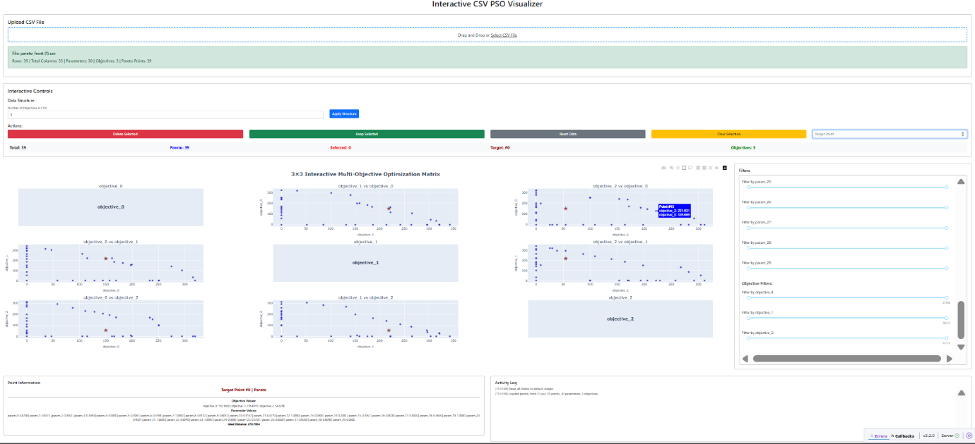
Figure 1The MOPSO visualization interface showing the scatter matrix plot with Pareto front identification and interactive filtering controls

  - Technology Stack
The visualization interface was built using a web technology stack optimized for scientific computing. Python Dash with Plotly was selected for the backend framework due to its integration with scientific Python libraries and ability to create interactive web applications. Dash provides callback mechanisms for real-time updates and integrates well with NumPy and Pandas for numerical computations. Dash Bootstrap Components were used for responsive design, ensuring the interface adapts to different screen sizes. The deployment utilized CERN's OKD (OpenShift) Platform-as-a-Service for container orchestration and scalability. Development was conducted in CERN SWAN, a Jupyter-based analysis platform that provides access to CERN's computing resources and pre-configured scientific libraries.

  - Core Libraries and Dependency
The application relies on several Python libraries: Dash and Plotly for web interface and visualization components, NumPy and Pandas for numerical computations and data manipulation, Dash Bootstrap Components for UI styling, and standard libraries including io for file handling and datetime for timestamp operations.
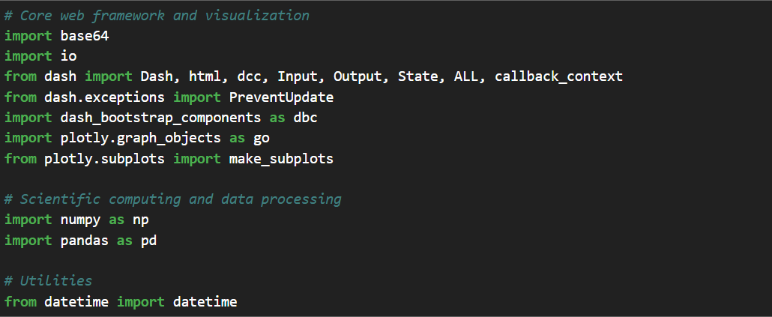

  - Architecture Overview
The system follows a client-server architecture with five key components. The data upload module handles CSV file parsing and validation, ensuring uploaded files contain the expected structure. The processing engine performs Pareto front calculations and data transformations, applying dominance relationships to identify optimal solutions. The visualization engine generates interactive scatter matrix plots that display pairwise relationships between objectives. The filter system provides real-time data filtering capabilities through range sliders. State management maintains user selections and application state throughout the session.
The application accommodates flexible data structures by allowing users to specify the number of objectives in their dataset. Based on this input, the system automatically assigns the first n columns as parameters and the remaining columns as objectives. This approach handles datasets with varying numbers of parameters and objectives without requiring specific column naming conventions.

- IMPLEMENTATION DETAILS

  - Core Functionality
    - CSV Data Processing
The system implements CSV parsing functionality that reads uploaded files and structures the data based on user specifications. Users indicate the number of objectives in their dataset, and the system separates parameters from objectives accordingly. The implementation handles standard CSV formats and converts numerical data to appropriate data types for processing.

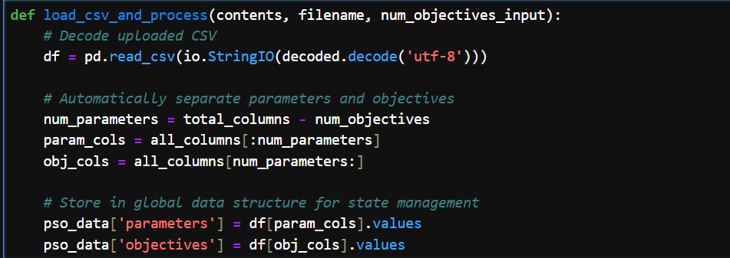

    - Pareto Front Calculation
The implementation includes an efficient algorithm for identifying Pareto-optimal solutions:
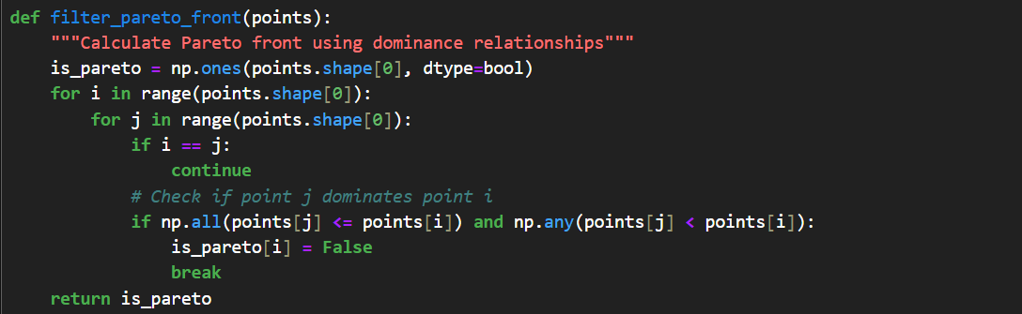

    - Interactive Scatter Matrix
The visualization component creates a scatter matrix displaying all pairwise relationships between objectives. Each subplot shows the relationship between two objectives, with Pareto-optimal solutions highlighted in blue and regular solutions in gray. The scatter matrix automatically adjusts its dimensions based on the number of objectives in the dataset, providing a comprehensive view of the objective space.

  - Advanced Features
    - Dynamic Filtering System
The interface provides real-time filtering capabilities through range sliders for both parameters and objectives. Users can adjust the ranges to focus on specific regions of the solution space, and the visualization updates immediately to reflect the filtered dataset. This functionality enables detailed exploration of particular areas of interest within the optimization results.

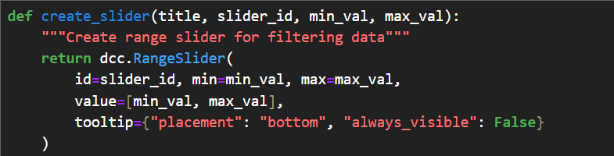

    - Interactive Point Selection
The system supports multiple selection modes for data exploration. Users can click individual points to select them or drag to select multiple points simultaneously. Selected points are highlighted across all subplots in the scatter matrix, enabling cross-dimensional analysis of specific solutions.

    - Data Manipulation Tools
The interface provides four data manipulation operations. "Delete Selected" removes selected points from the current analysis while preserving the original dataset. "Keep Selected" retains only the selected points, filtering out all others. "Reset Data" restores the original uploaded dataset, removing all filters and selections. "Clear Selection" deselects all currently selected points without modifying the displayed data.

  - Data and Interface Persistence
The application maintains several types of information to ensure consistent user experience throughout a session. The system stores both the original uploaded dataset and any modified versions created through filtering or selection operations. Current point selections and filter settings are preserved across different user interactions. The application tracks visualization parameters such as axis ranges and colour schemes to maintain consistency during updates.

- DEPLOYMENT AND INFRASTRUCTURE

CERN SWAN Integration
The development process utilized CERN's SWAN platform, a Jupyter notebook environment with pre-configured scientific libraries and access to CERN's computing resources. The platform was used for prototyping and testing the visualization components during development.

  - OKD Deployment
The production deployment used CERN's OpenShift Kubernetes Distribution (OKD), the open-source version of Red Hat OpenShift built on Kubernetes. CERN operates OKD as their Platform-as-a-Service solution for container orchestration and automated deployments.
The Dash application was containerized using Docker with a Python 3.9 base image and the required scientific computing libraries (NumPy, Pandas, Plotly, Dash). The application was configured to run on port 8080 with application state maintained in memory rather than persistent storage.
The deployment process involved pushing code to CERN's GitLab, building container images in CERN's registry, and deploying through the OKD web console. This process made the visualization tool accessible to CERN researchers through the institution's hosting infrastructure.

- RESULTS

The MOPSO visualization tool fulfilled the specified objectives. The web interface processes the workflow from data upload through interactive visualization. Users upload CSV files, specify the number of objectives in their data, and the system generates the corresponding visualizations.
The system processes datasets by separating parameters from objectives based on user input. The visualization adjusts to different numbers of objectives and parameter dimensions. The Pareto front calculation algorithm identifies optimal points by checking dominance relationships, and the interactive features operate as implemented. Users select points through clicking or dragging, and the filtering system responds to range slider adjustments.
The four data manipulation tools (Delete Selected, Keep Selected, Reset Data, Clear Selection) function as implemented and maintain data integrity during operations. The implementation shows that web-based tools can perform scientific computing tasks that typically require desktop software installations.
The deployment on CERN's infrastructure makes MOPSO analysis capabilities available to researchers. The technical implementation addresses visualization requirements for multi-objective optimization data.

- CONCLUSION

This internship project developed a web-based visualization tool for analysing multi-objective particle swarm optimization results. The tool runs in standard web browsers without requiring additional software installations, which simplifies access for researchers working in collaborative environments.
The implementation involved multiple technical areas including multi-objective optimization algorithms, web development frameworks, and cloud deployment on CERN's infrastructure. The project required understanding Pareto dominance relationships and how to identify optimal solutions from MOPSO datasets, as well as the practical considerations of developing research software within institutional computing environments.
The resulting tool allows researchers to upload CSV files containing optimization results and visualize the data through scatter matrix plots with Pareto front identification. Users can filter data, select points interactively, and manipulate datasets to focus on specific regions of the objective space.

REFERENCES
- Liu Dasheng. (2008). Multi-objective particle swarm optimization: algorithms and applications. Doctoral thesis, National University of Singapore.
- Kennedy, J., & Eberhart, R. (1995). Particle swarm optimization. Proceedings of ICNN'95 - International Conference on Neural Networks, 4, 1942-1948.

