Sep 4, 2013

CERN Summer Student Project Report

Student : KOULOURIS Aimilianos

Supervisors : VANBAVINCKHOVE Glenn, BARTMANN Wolfgang

Development of automatic knob-generation tool for the protection devices in the LHC

Introduction

This project is of significant importance. In the LHC transfer lines, the beam is extremely well controlled and confined. This is managed through a wide variety of superconducting magnets, which focus, defocus and bend the beam. As for the control part, there are numerous monitoring devices co-operating with the SCADA systems, all working for the protection of the instruments and the people.
Our work, in particular, falls under the beam transfer lines, TI2 and TI8, between the SPS and the LHC. The protection devices in the transfer lines need to be set up according to the optics of the beam, namely the trajectory inside the beam-pipe. This means that, depending on the trajectory of the beam inside the beam-pipe and the positioning of the protection devices around the beam-pipe, certain adjustments need to be made, so that the beam will not damage or even affect the monitoring devices, for example we don't want something similar to the picture happening:
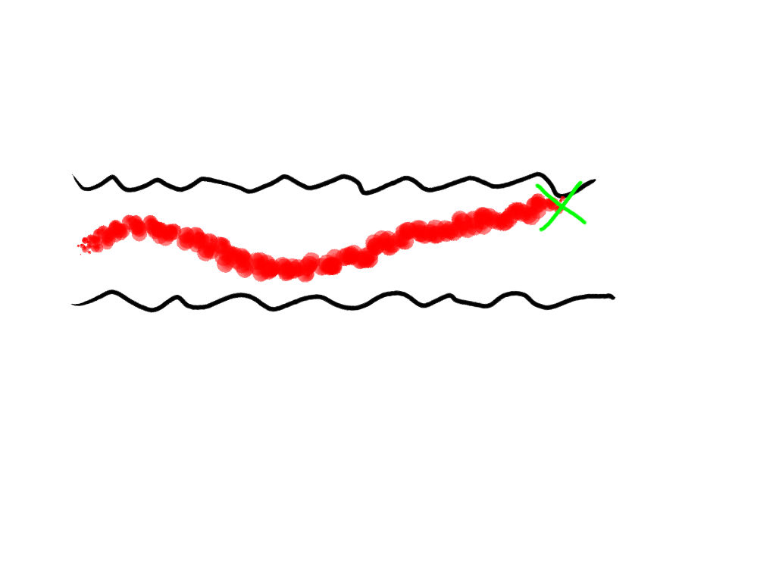Illustration 1: Beam trajectory inside the beam-pipe. Proximity between the two should be avoided.

This project is an effort to introduce some automation to the above.

The Physics

The project was more programming-oriented. In spite of that, in the beginning an introduction to beam physics and dynamics was necessary. There has to be some familiarity with terms such as alpha, beta, emittance, aperture.
In a simple approach, the square root of beta represents the beam size and alpha is its derivative. Emittance has to do with the shape and distribution of the particles in the momentum-position phase space. Aperture is the size of the pipe or the confinement of the available space by some element in a certain point in the beam line.
Namely, the definition of sigma is: 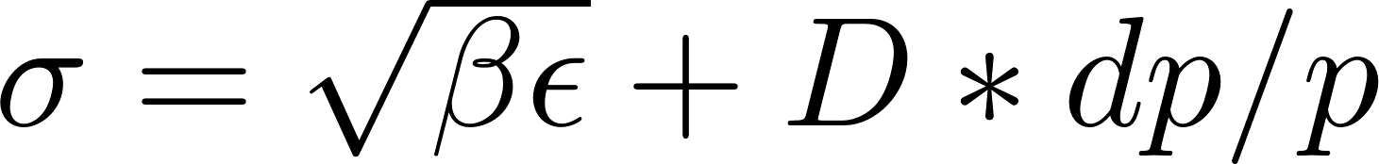, where  is the beta function,  is the normalized emittance, D is the dispersion and dp/p is the momentum off-set. In the following picture you can see an example of emittance plot:

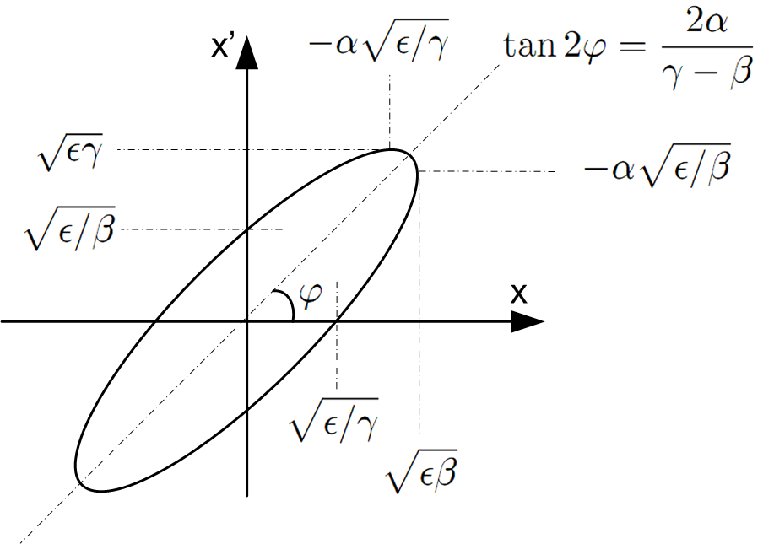

Work Outline

A. MAD-X

The first step was to get familiar with the programming language, used to simulate the accelerator, MAD, which stands for Methodical Accelerator Design.
First task: the design of a FODO cell with a phase advance of 90 degrees in both planes. Next, the creation of a 1km transfer line with the requirement to fulfill some initial and final conditions, such as certain beta of the beam.
This part of the project lasted around 4 weeks. There were few difficulties encountered during this, mostly having to do with the matching behavior and the implementation of macros for the matching. After resolving these issues we moved on to the graphical interface.
Later in the summer, there was an effort to dig into the MAD-X behavior, regarding element slicing. That is, we tried to determine what happens when we use many little elements instead of a big one. For example, in the following table you can see the results. We matched only one magnet strength (MDLH.61104) but recursively replacing it with 2,3,4,5 smaller magnets of the same total length; ergo the slicing term.

Table 1: Matched strengths of the element MDLH.610104 and ratios of the values and lengths.
The important data is in the last column, where after very simple calculations, we see that the final matching of the magnet strengths is irrelevant to the number of slices, since the ratio of the real strengths is almost 1, concertedly the final matched strengths are considered equal, which is expected and very positive.
Actually, one could suggest that slicing can lead to better results, since with ascending number of slices, there is a tendency of the final ratio value towards 1. This is currently only a speculation.

B. JMAD

After the MAD-X introduction, we move on to JMAD, a Java implementation of MAD. Parallel to that began the coding of the GUI for the project.

The interface consists of the following steps:

- Selection of SPS Transfer Line (TI2/TI8)
- Reviewing the current strengths of the magnets
- Matching a selection of magnets to a certain beam offset and phase advance
- Review the matching result, considering aperture and beam size values
- After accepting these knobs, insert them in the LSA database
- Optional: Delete knobs from the database

Also, you can refer to the following flow-chart depicting the code written for the GUI and the implementation:

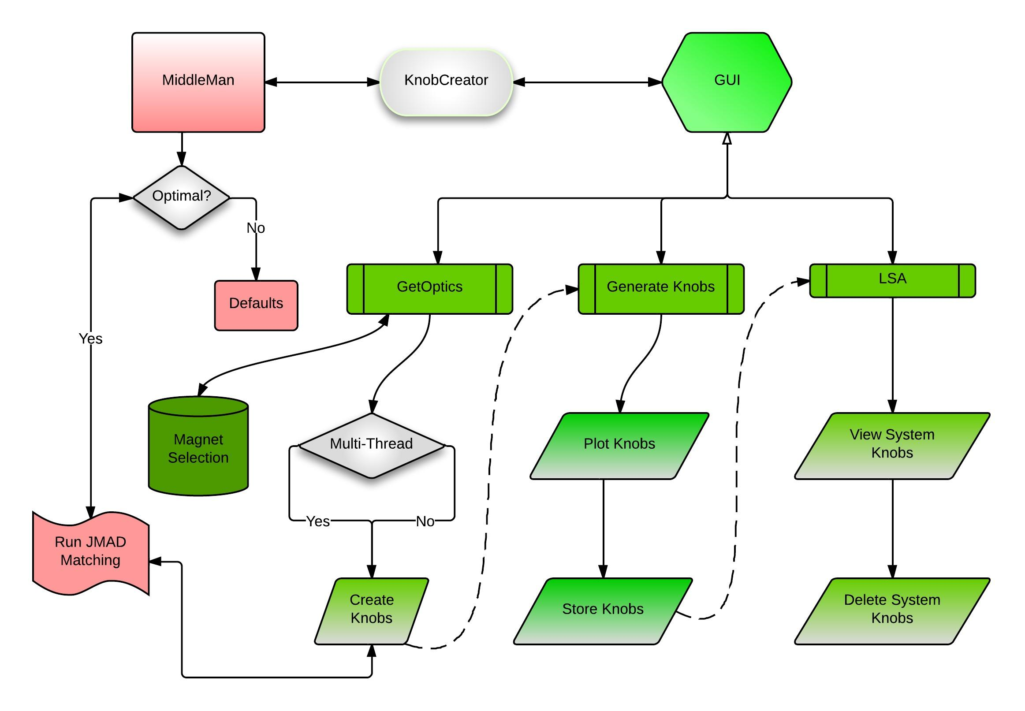Drawing 1: Project Code Flow-Chart.
KnobCreator : Main class. Calls the MiddleMan and initiates the GUI.
MiddleMan : Responsible for triggering the initial JMAD run and producing default element lists.
GetOptics : Communicating with the MagnetSelection class. Invokes JMAD run and feeds data to the GenerateKnobs class.

This can also be viewed in the following screen-shots of the program:

- Get Optics Panel

The top row-panel is for Accelerator selection. Selecting 'SPS' gives access to the next panel. There is the particle transfer and beam process selection. This software is for the TI2/TI8 lines, so only choosing LHCB1/LHCB2 triggers the next panel, which shows a list of optimal kicker elements for the knob. Defining the optimal ones is not yet implemented.

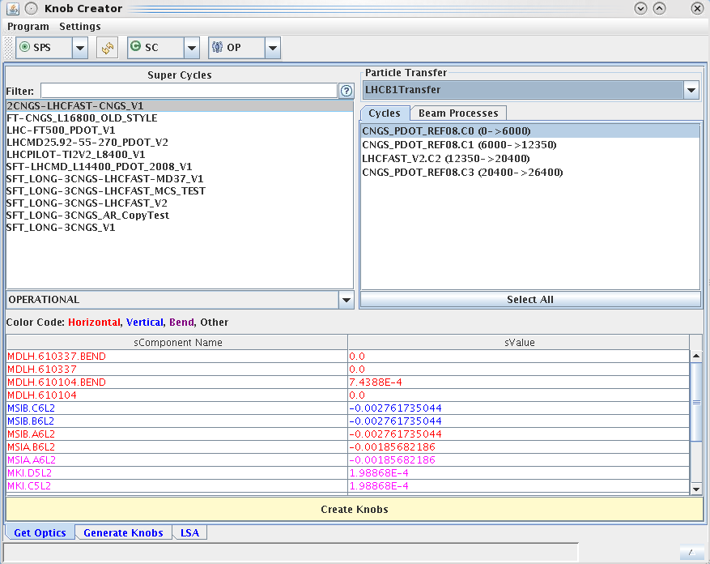Illustration 1: Particle Transfer Selection and elements for matching review.

- Magnet Selection

Before the knob creation, the user can edit the list of elements to be used in the matching, through the menu Settings > Magnet Selection:

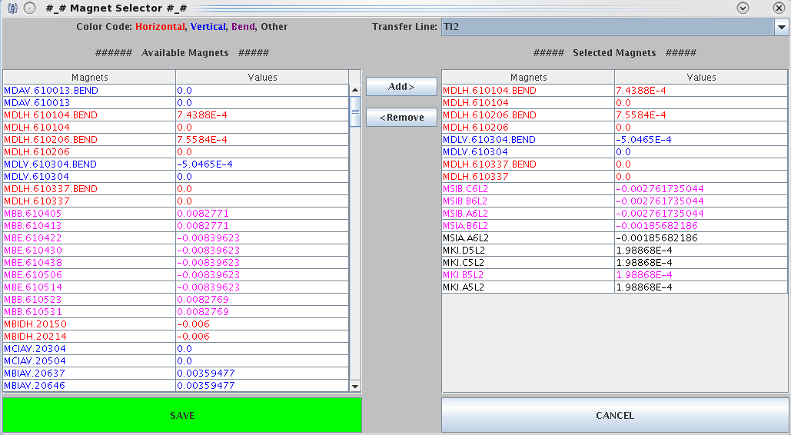Illustration 2: Magnet Selection Panel.
Left : Full list of Kick and Bend elements.
Right : List of selected elements, to be used in matching and knob generation.

After having the desired list of elements in the first tab, the user can create the knobs for various hard-coded phases. Once the matching is finished, move on to the next tab.

- Generate Knobs Panel

The following is a panel to visualize the effect of the matching. By selecting a knob, there are plotting options to view the trajectory, the beam size and the aperture. There is also an option to increase the sigma of the beam, until it is too close to the aperture. If the result seems desirable, the user may store the knobs in the LSA system.

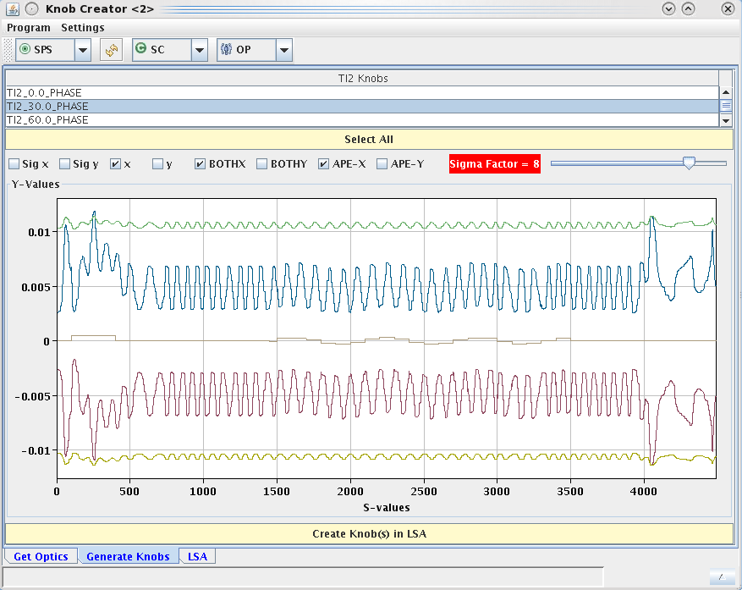Illustration 3: Second Panel in main window.
Shows the beam trajectory and warns the user in case the beam comes too close to the beam-pipe.

- LSA Panel

The last tab is a viewing panel for knobs, to check the elements in each knob inside the system and possibly have it removed:

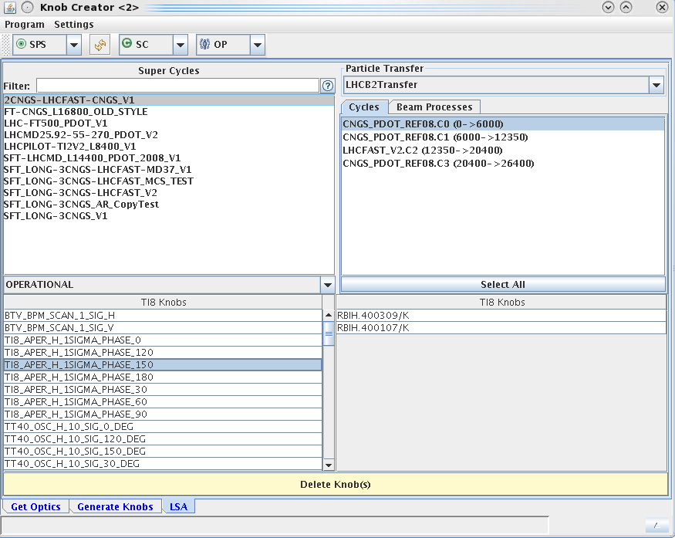Illustration 4: Final Panel of the main window.
Simple View of the LSA-System knobs and their elements.
Also, availability to select and remove knobs from the system.

Ideally, the GUI will contain options for optimizing the magnet strength values, taking into consideration the maximum values. This is something that might be applied using MICADO. Due to time constraints, this is something that may be implemented in future versions.

Moreover, there were also difficulties in the JMAD part of the project. The macro of MADX does not exist in JMAD, something that could prove very useful for this and possibly other projects. The task of implementing the macro in JMAD is something that can be done in the future.

Conclusions

In the end, we were able to test the Knob Creator and generate, create and delete knobs from the LSA System. The project, as a whole, helped me realize the magnitude of the LHC controls infrastructure, broadened my knowledge about transfer lines and most importantly for me: I learned MAD-X and greatly refreshed my Java skills.

References

  - CAS - CERN Accelerator School : 5th General Accelerator Physics Course Proceedings, vol.1, 1994
  - Particle Accelerator Physics, H. Wiedemann, 3rd edition, Springer
  - MAD – Methodical Accelerator Design Website - madx.web.cern.ch/madx/
  - JMAD – Integration of MADX into the Java World, Proceedings of IPAC'10, Kyoto, Japan, p.465-467

See: MAD-X CERN Website
See: JMAD - Integration of MADX into the Java World

