Summer student project report
Kazuki SUZUKI

Supervisors: Enrico Gamberini, Roland Sipos

Overview:
My project consisted in the creation of a WinCCOA-based panel to be used for monitoring the Data Acquistion (DAQ) system as part of the Run Control system of the ProtoDUNE Single-Phase experiment at CERN.

RunControl is the part of an experiment that coherently steers the data taking operations. It has three main building blocks:
- Mechanism to interact with all actors participating to data taking
  - Inter Process Communication
- Mechanism to abstract the specifics of the experiment’s components and describe them in a uniform way
  - Run Control Tree, Finite State Machine
- Mechanism to allow the human operator to steer data datking
  - User Interface

The project:
The software DAQ system of ProtoDUNE-SP is based on ArtDAQ, a complete framework developed by the Fermi National Laboratories in the USA. A special plugin based on CERN’s DIM has been developed and allows to connect ArtDAQ’s internal metrics regarding the status and performance of the DAQ to the fwDIM component of CERN’s Joint Controls Project (JCOP).

My goal was to develop a general, personalizable and scalable panel to show the trends of a large number of metrics.

The usability of the panel is an important requirement, since it will be used by a large number of non-expert operators during ProtoDUNE data taking.

The panel features two modes (showed as different tabs): “Show All” (Fig. 1) and “Select” (Fig.2) modes. In “Show All” mode, a complete set of trends matching a user specified filter is automatically shown.

In “Select” mode, the user can drag and drop the data point name (again a filter can be set to show a sub-set of them) on the the trending page that wishes. Multiple data points can be shown in the same trending page in order to correlate the time series of different data points. It turned out, that this particular feature will be really useful in the ongoing integration tests.
Conclusion:
I learnt the structure of Run Control systems of the experiments, and also had the opportunity to study and gain experience in one of the industrial leader SCADA system, SIMATIC WinCC Open Architecture.

The panel I developed is general and flexible enough to not be experiment-specific, and can be used with any datapoint names by setting accordingly the filter in the panel.

At the very end of the development, the project was integrated with the ProtoDUNE-SP RunControl system, and now it is used on a daily basis.
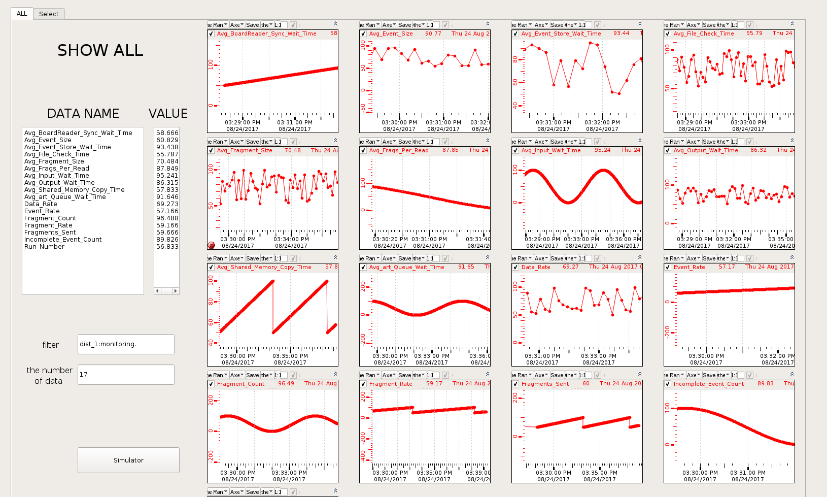
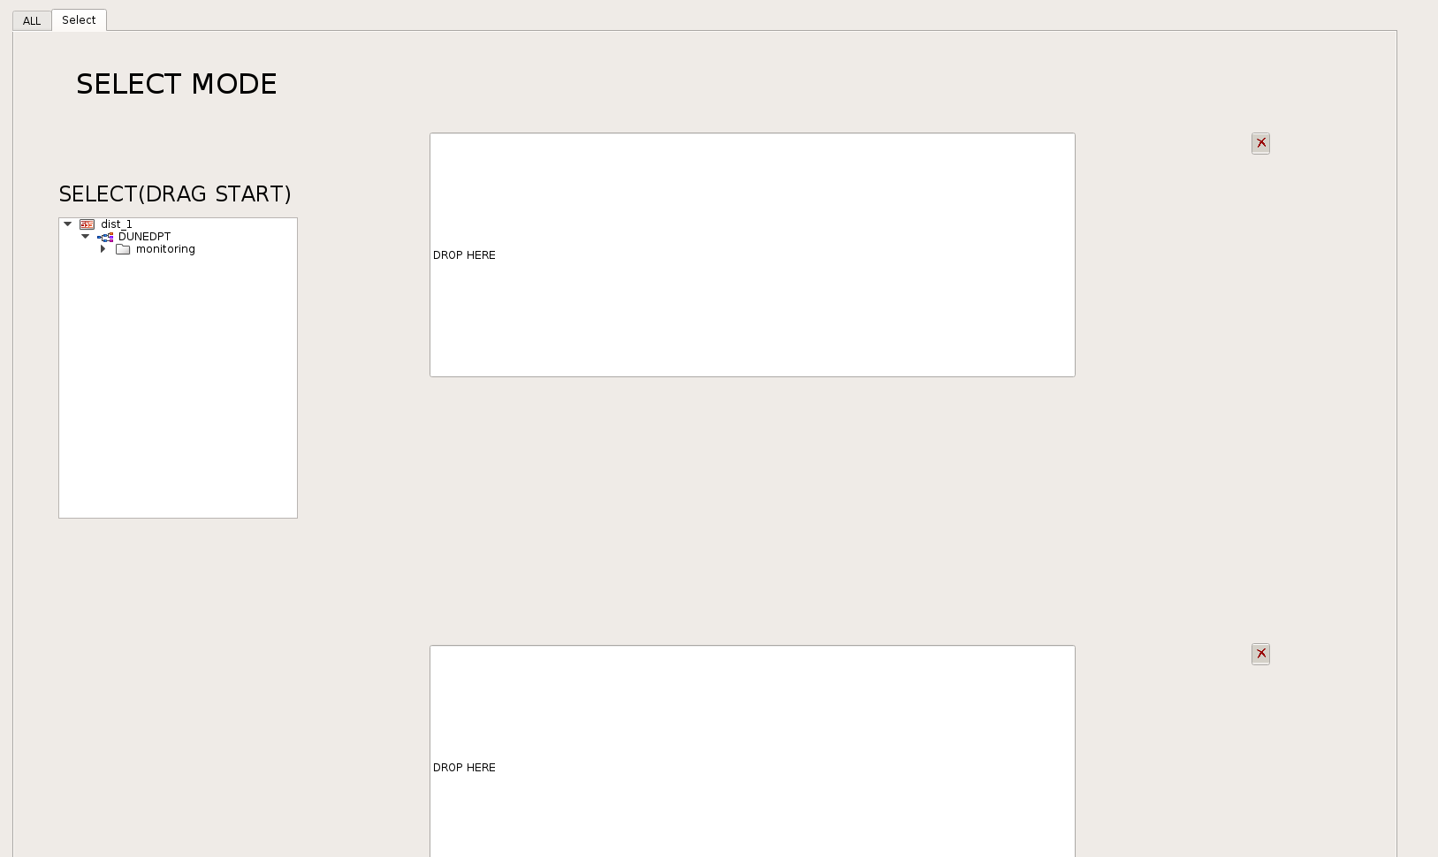
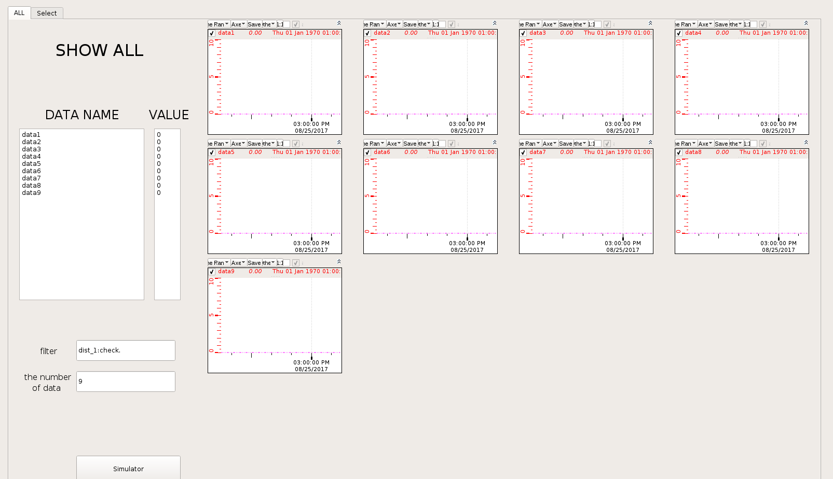
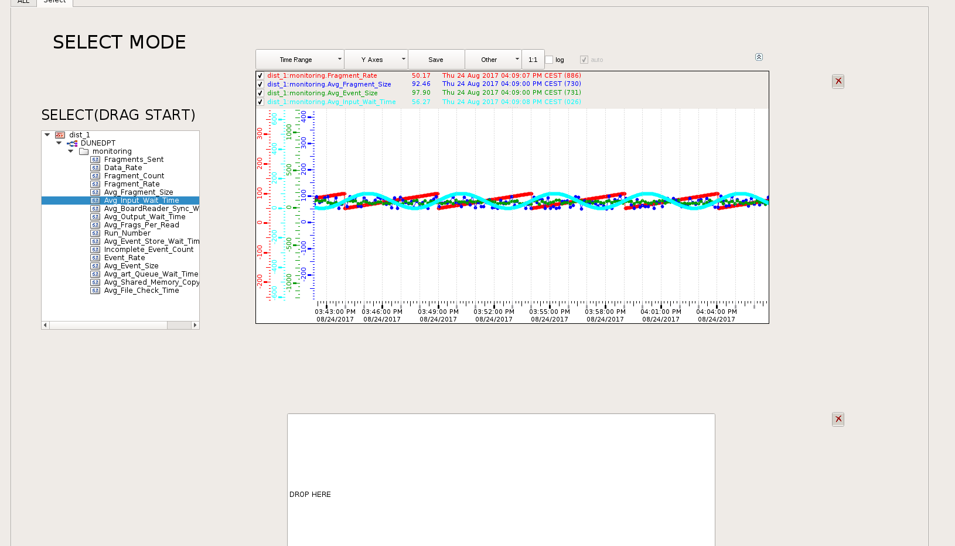
Figure 1 “Show All” mode
Figure 2 “Select” mode
Figure 3 “Show All” mode when users change filter
Figure 4 In “Select” mode, users can make multiple data in one plot.

