

Characterization of the SPS 800MHz travelling wave cavities.

Summer student:
Bazyl Dmitry, NRNU “MEPhI”

Supervisors:
Elena Shaposhnikova,
José Enrique Varela Campelo,
CERN, BE-RF department.

Geneva, Switzerland
August 2015
Content:

- Introduction
- Dispersion diagram.
- Fundamental passband.
- Longitudinal higher order modes.
- Conclusion.

- Introduction
This document describes the activities carried out during my summer internship at CERN. My task was to characterize the 800MHz Travelling Wave Cavities (TWC) of the SPS by means of full-wave simulations and Radio Frequency (RF) measurements. The task was carried out in two steps. First, the fundamental passband of the cavity was characterized. Then, the Higher Order Modes (HOMs) of the structure were studied.

It is well known that HOMs in RF cavities are a potentially dangerous source of beam impedance. Therefore, HOMs (both longitudinal and transverse) can drive the beam unstable [1]. The 800MHz cavities of the SPS were studied in the past. However, very little documentation was left behind. Currently, the performance of the SPS is limited by a longitudinal beam instability. In order to study this instability, an accurate impedance model of the whole SPS is needed. Characterizing the longitudinal beam impedance of the 800MHz cavities was one of the main goals of my internship. The Computer Aided Design (CAD) model of an 800 MHz TWC is shown on the Fig 1.

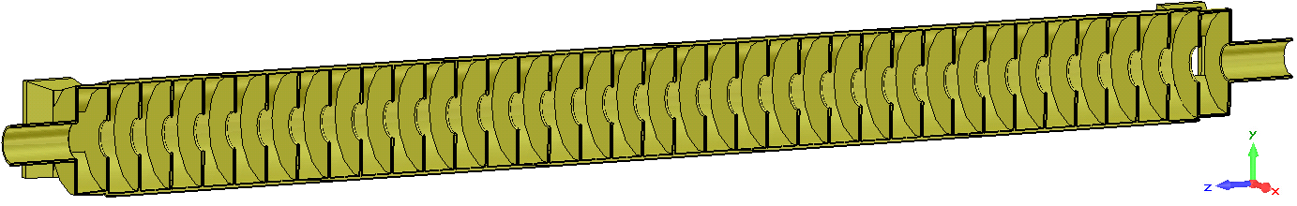

Figure 1. CAD model of an 800 MHz TWC (x-cut plane view).

- Dispersion diagram.

The first ten longitudinal modes of the TWC are shown in the dispersion diagram of Fig. 2. The dispersion diagram was computed using a single cell model and running eigenmode simulations in CST MWS [2]. The fundamental passband is highlighted in blue. The dispersion diagram shows that the cavity is designed to work at a phase advance of 90$°$ as a forward wave. The intersections between the, so called, light line (red dashed line) and the different passbands of the dispersion diagram are regions of potentially high-impedance HOMs.
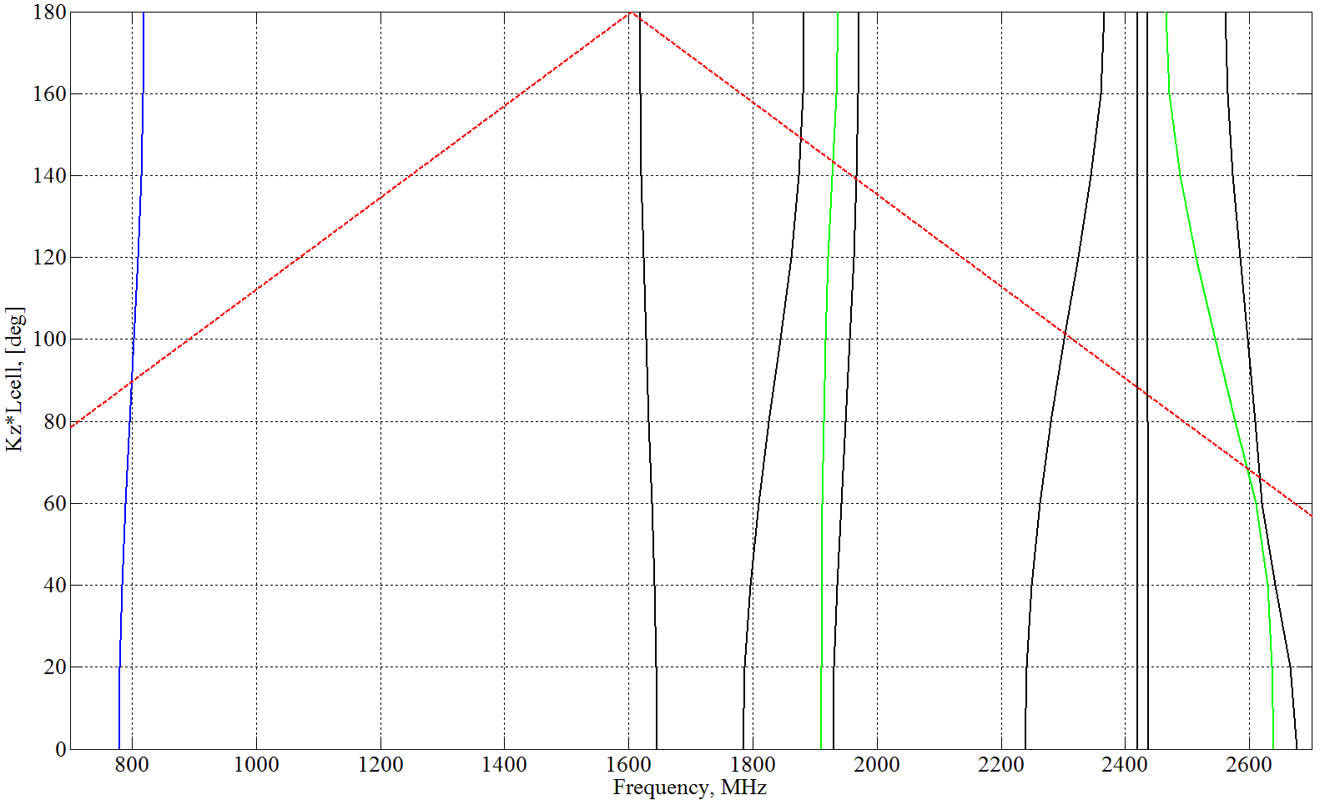
Figure 2. Dispersion diagram for 800 MHz cavity. HH symmetry planes (modes with longitudinal electric field on axis).

- The results of the calculations and measurements of the electric field for the fundamental wave.

The bead-pull measurement setup is shown in Fig. 3. We use a Rohde & Schwarz Vector Network Analyzer (VNA) for measurements. The device contains all the necessary components for high-frequency measurements (such as an RF generator, amplitude and phase detectors, etc) and is able to measure with very high accuracy.
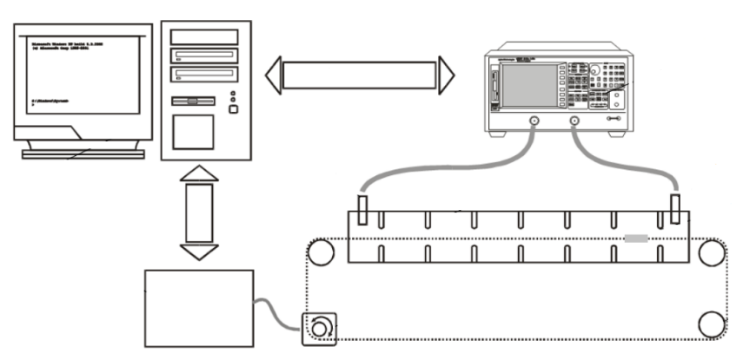
Figure 3. Bead-pull measurements setup.

A PC, equipped with an interface for communication with the VNA, controls the measurement, collection, processing and storage of data. In this case, we are interested in measuring the longitudinal electric field on axis. For this purpose, we use the non-resonant perturbation theory [3] and an appropriate perturbing object. The perturbing object is moved along the longitudinal axis of the structure on a thin dielectric line. The VNA measures the reflection coefficient as a function of the position of the needle. Since the on-axis magnetic field is zero for longitudinal modes the change S11 corresponds to the electric field amplitude as [3]:

$$P_{input}*\left({S11}_{p}-{S11}_{a}\right)= -jωk∙E_{z}∙E_{z}^{*}$$

where $P_{input}$ is the input power, ${S11}_{p}$ is the reflection coefficient in the presence of the perturbing object, ${S11}_{a}$ is the reflection coefficient in the absence of the perturbing object,$k$ is proportional to the longitudinal electric polarizability of the perturber and $E_{z}=|E_{z}|∙exp⁡(iφ)$ is the longitudinal component of the electric field.

Two series of the measurements were carried out. In the first series, a 18.33 mm long metallic needle (1.2 mm diameter) was used. A shorter needle, 14.33 mm, was used in the second series. The particular length of the needle is, in general, determined experimentally. The needle should be short compared to the wavelength at the measuring frequency, but long enough to have a good signal to noise ratio. A very low speed was chosen for the bead to go through the cavity. This minimizes vibrations on the thread and allows to measure a higher number of points. The bead takes 550 s to cross the 3.8 m long cavity. Four traces were taken at each measured frequency. This can reduce the impact of errors and allows for some statistics to be calculated. The measured field profiled were post processed in MATLAB and CST MWS was used to simulate the electromagnetic fields in the cavity.

Figure 4 shows the accelerating voltage of the cavity as a function of frequency over the fundamental passband. In order to compare the simulated and experimental results, the measured values are normalized to the input power $P_{input}=0.5 W$.
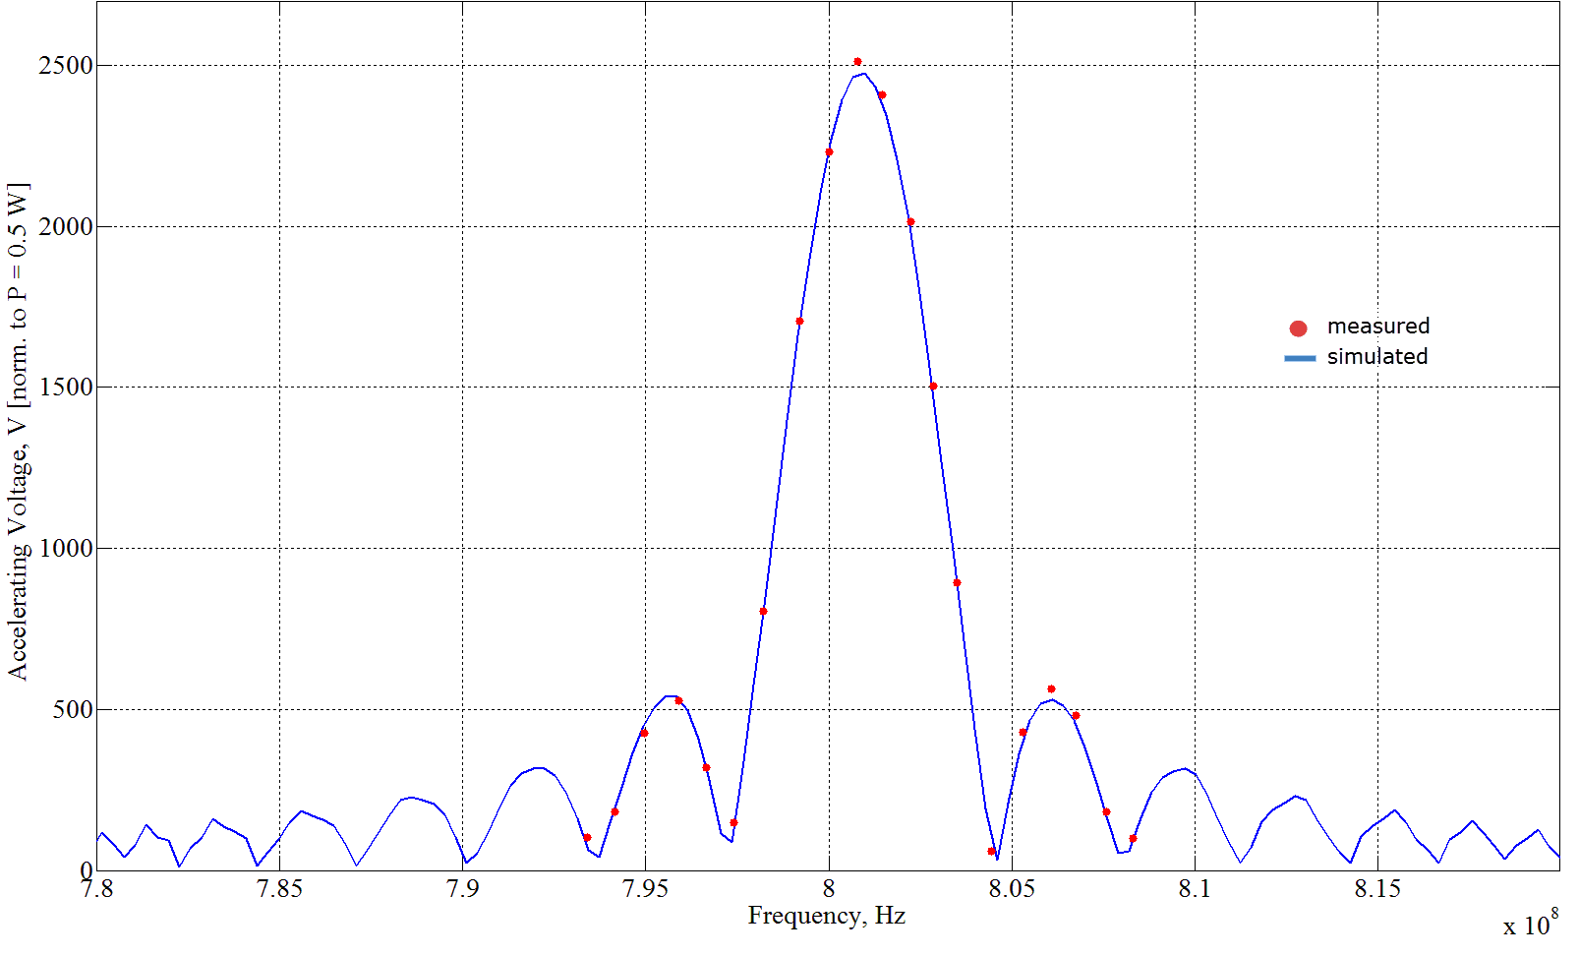

Figure 4. Accelerating voltage as a function of frequency over the fundamental passband. Simulation versus measurement.

- Longitudinal higher order modes.

It is well known that HOMs excited by the beam as it passes through the cavity can have a negative impact on the beam quality [3]. In order to get information about longitudinal HOMs in the 800 MHz cavity, a wakefield simulation was run in CST. The wakefield solver computes a number of relevant parameters such as the wake potential, the impedance or the loss factors. The computed longitudinal impedance is shown in Fig. 5. Three peaks can be clearly distinguished. The biggest one, at 800 MHz, corresponds to the fundamental passband. The two peaks in the vicinity of 1.9 GHz and 2.6 GHz are potentially dangerous high-impedance HOMs.
In addition to the wakefield simulation, more precise eigenmode simulations were run to compute the R/Q|| of these modes. Several resonances around 1.9 GHz were also measured to cross check the simulation results. Table 1 compares the results obtained. The simulated and calculated R/Q|| values are in a good agreement.

Table 1. Comparison between the simulated and measured R/Q|| values for some resonances around 1.9 GHz.

№ | F, MHz | Measured R/Q||, Ohm | Simulated R/Q||, Ohm
1 | 1921.90 | 0.19 | 0.51
2 | 1923.00 | 0.21 | 0.49
3 | 1930.70 | 11.9 | 11.30
4 | 1934.70 | 90.4 | 96.10
5 | 1936.71 | 16.4 | 13.10

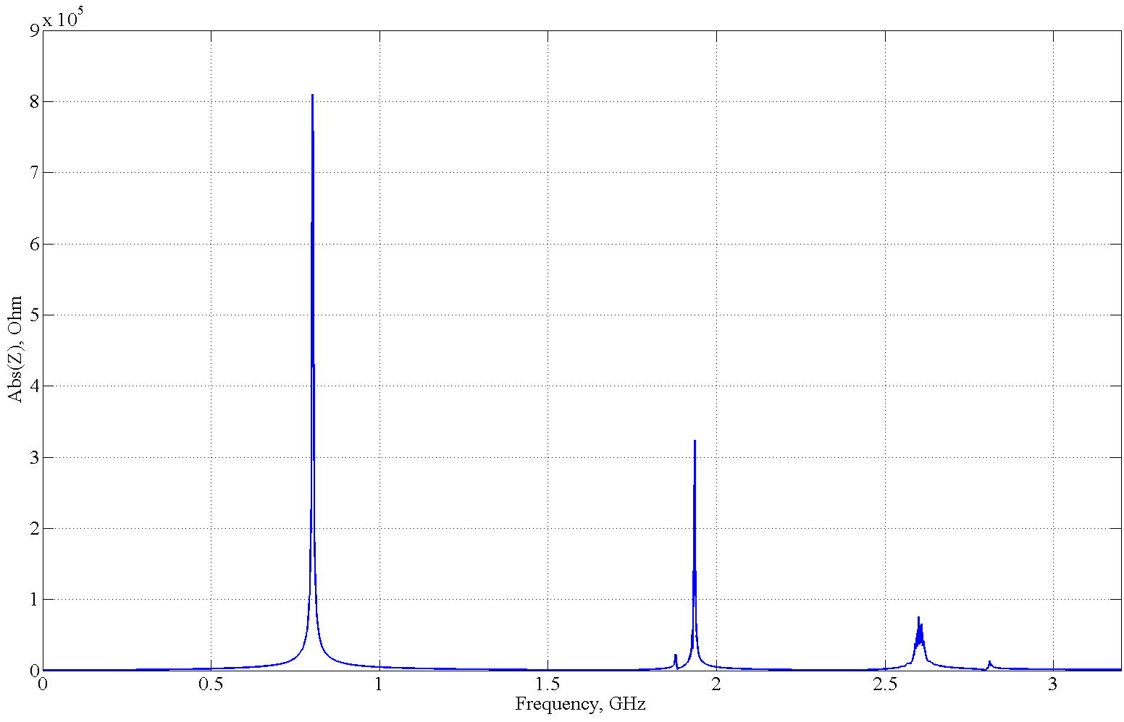

Figure 5. Longitudinal impedance versus frequency.

- Conclusion.

The 800 MHz TWC of the SPS has been studied. The accelerating voltage of the fundamental passband was simulated and measured with very good agreement. It is important to choose a proper perturbing object to get precise results.
Wakefield and e-mode simulations were run in order to investigate longitudinal higher order modes in the cavity. Due to the limited time of my internship, I was only able to do the measurements of the 1.9 GHz HOM. To get more precise results, we need a better signal excitation. Furthermore, the impedance model of 800 MHz will be given to the specialists who deal with beam dynamics, so they can check if these HOM are one of the reasons of the longitudinal instabilities in the SPS.

References
[1] Wake Fields and Impedance L. Palumbo, V.G. Vaccaro, M. Zobov // “CAS Advanced School on Accelerator Physics” lecture, 1994.
[2] https://www.cst.com/.
[3] A Nonresonant Perturbation Theory // Steele, C.W., Microwave Theory and Techniques, IEEE Transactions (Volume: 14, Issue: 2), 1966.

