Analysis on Higgs-> ZZ->4 leptons Channel Events Produced via VBF Mechanism
WITH THE CMS EXPERIMENT

Summer Student - Botan Elveren
Supervisors - Sabino Meola and Nicola De Filippis

Abstract
The purpose of this study is to investigate the properties of SM Higgs boson in the mass range 100<mH<1000 GeV in the H->ZZ->4l decay channel. For this purpose we worked to reduce the background and increase the event selection efficiency.

1 . CMS Experiment
The LHC smashes groups of protons together at close to the speed of light: 40 million times per second and with seven times the energy of the most powerful accelerators built up to now. Many of these will just be glancing blows but some will be head on collisions and very energetic. When this happens some of the energy of the collision is turned into mass and previously unobserved, short-lived particles – which could give clues about how Nature behaves at a fundamental level - fly out and into the detector.
CMS is a particle detector that is designed to see a wide range of particles and phenomena produced in high-energy collisions in the LHC. Like a cylindrical onion, different layers of detectors measure the different particles, and use this key data to build up a picture of events at the heart of the collision. [1]

2 . My Work at CERN
2 . 1 . a . Data Analysis
I had limited knowledge of C++ and I did not know anything about ROOT. Therefore it was a slow process for me. First few weeks are spent on understanding ROOT and C++. I also attended ROOT tutorial which helps the general concept of ROOT. After I get a general understanding in these topics I started to work on the code my supervisors provided me. I did some basic work which consists of reproducing some plots and trying to understand these. I was able to increase my knowledge and work on analysis code thanks to my supervisors in this manner. The next step for me was to produce new plots that my supervisor asked me to do. I also observed the testing of RPC. [2] That was a great experience that motivated me a lot and helped me understand the detector better in some sense.
2 . 1 . b . Conclusion
First of all it was a very informative work for me to understand the basics of an analysis. One of our purposes in our analysis was to determine the efficiency of some cuts in the analysis code so here is an example of the event selection efficiency for m4l>100 (mass of 4 leptons >100). Here we can see the efficiency increases for greater masses which makes sense regarding the cut. This may imply that we do not need to relax this cut since efficiency is quite good.
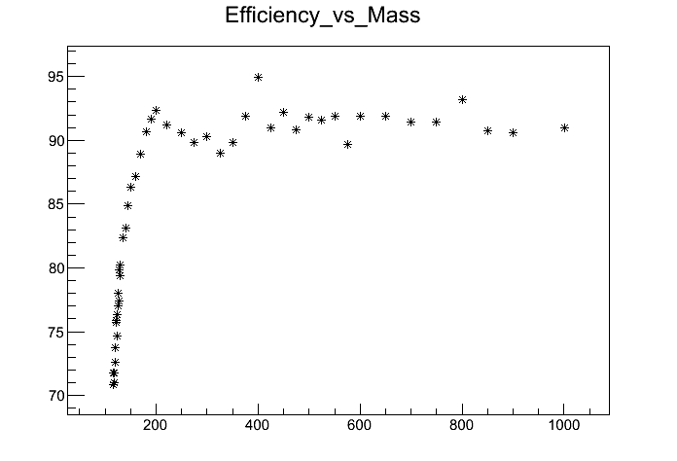
Basically our work is to reduce the background. Therefore the efficiency of cuts are very important for us. Also I noticed that some backgrounds are more important in our channel. Some backgrounds are really hard to reduce. Here is another plot which is the number of events surviving after each cut in H->ZZ->4mu channel.

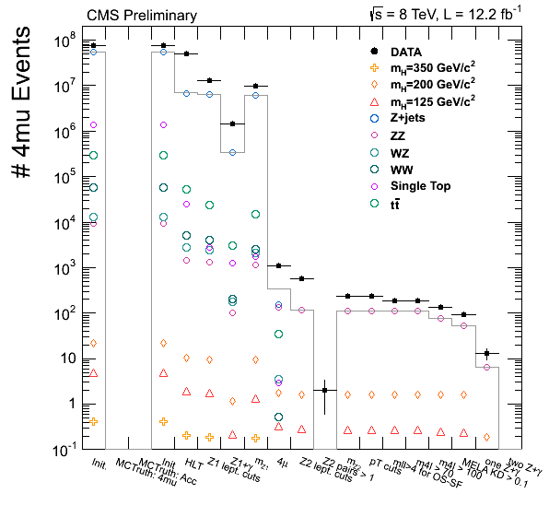
Looking at the plot above we can determine which backgrounds contribute more after each cut. One of the good things about H->ZZ->4l channel and VBF mechanism is that it has low background and high mass resolution.[3]

2 . 2 RPC production and testing
Thanks to my supervisor I was able to see the RPC testings which are made in building 904. I was able to observe the leakage tests during this time. The reason I mention this is that it becomes a whole in my mind when I see these tests alive and get a better knowledge of how the detector works. This leads to a better understanding of physics and mechanics behind the experiment.

Acknowledgements
I would like to take this opportunity to thank all the people who have helped and guided me during my stay at CERN. They have all made it possible for me to complete my project. Their positive attitude and constant support helped me continue efficiently.

- I would like to express my gratitude to my supervisors Sabino Meola and Nicola De Filippis, without their help, guidance and knowledge I do not see how my project would end up. I thank them for all the time and effort they have spent on this project with me. Valuable guidance and knowledge, this project would never have progressed.
- I also would like to thank Assoc. Prof. Bilge Demirköz who motivated me to apply CERN Summer Student Programme in the first place. I would like to thank her for making this dream come true.
- I also would like to thank Orso Iorio for his helps, guidance and organizing the CMS underground visit for me and my friend.
- Finally, I would like to thank all Summer Students Team especially Anca Burghart for making this summer a great one and helping me with the problems I faced during my stay.

References

[1] Information on CMS has been taken from http://cms.web.cern.ch/news/what-cms.

[2] More detailed information can be found at http://cms.web.cern.ch/news/resistive-plate-chambers.

[3] CMS Physics Analysis Summary, The CMS Collaboration 2013/03/07.

