Summer Student Internship Project Report

  - Development of gnuplot plotting package for MAD-X

  - Author:
Freddy Jose Romero Leiro

  - Supervisors:
Laurent Deniau
Ghislain Roy

Abstract

MAD-X is a general purpose software for charged-particle optics design and it needs a visualisation tool to be able to show the data in a more manageable way, this visualisation tools being already in MAD-X are the PLOT and SETPLOT commands. Nonetheless issues like compatibility and the desire of having alternative ways to show the plots in a more portable way have lead to explore the use of open source available software to reproduce the same results. The purpose of this project is to create a package compatible with the MAD-X output format, capable of generating publication quality plots, mainly lattice beamline plots and scatter plots by using the Gnuplot for creating plots. This software must support the same options as the PLOT and SETPLOT commands from MAD-X but additions or improvement over the present version are more than welcome. The main purpose of the program is to pre-process the data in order to be ready for Gnuplot to read it and plot it .This report is mostly a description of the development of the software as well as a basic introduction on how to use it, finally examples of the created plots are shown.

The data format

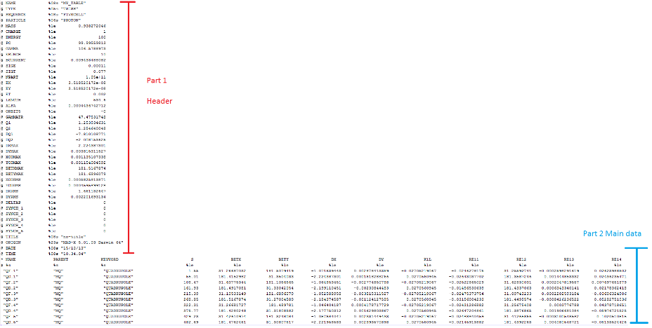
The data output that the program must read written in “Table File System” (TFS) format developed by CERN. This format consists of a text file separated into two parts: an upper part consisting on three columns containing the basic information regarding the data such as title, date, range etc. And a lower part containing the main data; this part can be composed by multiple columns describing the evolution of different variables (most of them describing the optics of the beam) in the entire length of a machine (particle accelerator) or in a cross section of it.
Figure 1: Example of a generic TFS file coming from MAD-X
This data must be read and organised in order to make sense of it for Gnuplot, and also to be able to implement all the options that the original MAD-X plotting tool has to offer.

The plot format
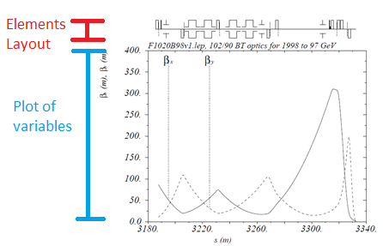
The main two types of plots to be done for this project are the “twiss” plots and “scatter” plots. The first one consists in a graph describing the evolution of the optics parameters of the particle beam in successive positions of the beamline, while at the same time showing on the top of the graph a schematic representation of the machine elements that the beam must pass through (Dipoles magnets, Quadrupole magnets, radio-frequency cavities, drift spaces etc.), all of them scaled horizontally depending on the elements’ lengths.
Figure 2: Example of twiss plot
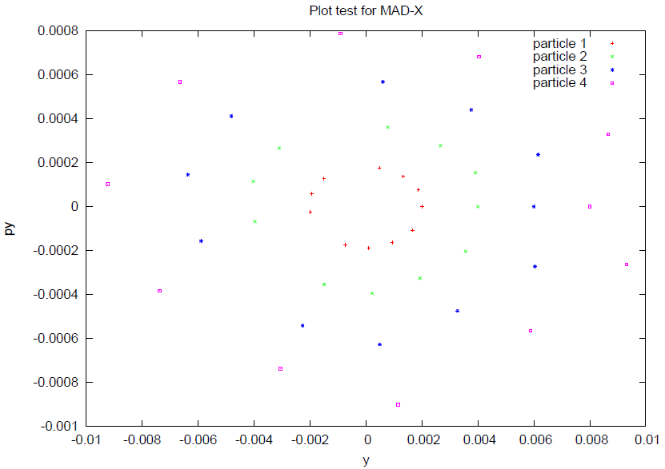
The second type of plot (scatter plot) is to show the position in phase space or real space of the particle coordinates, or set of particle coordinates at the location of a given point of the machine. This type of plot has the added difficulty of using multiple data sets in the same data file.
Figure 3: Example Scatter plot

Tools used
For making this we chose to do the data pre-processing using Lua 5.1 as the programming language. This language was chosen because many parts of the original MAD-X are already written in Lua, hence the desire to use the same language to avoid compatibility issues. We used Gnuplot versions 5.0 as well as 4.6, and all the tests have been done in both 32 and 64 bit windows machines.

Reading the data
To pre-process the data first it needs to be read; for that we took advantage of Lua’s string library. This tool facilitates pattern recognition in text files, such as the MAD-X TFS output files. Using this tool the files are stored in memory inside a Lua array or table. This table has different structures depending on the type of file to read. For the main file (the TFS one) the information is stored in two different tables one for the header and the other for the main data. In the header table the elements in the third column of the file are stored using the elements of the first column as keys: if the table is called Header and the plot title is “This is the title” we will have access to it by calling the element Header [“Title”] = “This is the title”. The second table (main data table) works similarly but the keys are the titles in the first row of the file, and for every key we do not have a variable but a vector containing all the values of the columns in order. The program also needs to read other types of files different from the main data: the shape files contain the points required to draw the elements of the beamline (dipoles, quadrupoles etc.). These text files must be read as a pattern to follow to create secondary .dat files with the respective elements in the precise position and scale for Gnuplot to show them on screen. The shape files are read using the first column as the x coordinates and second column as y coordinates.

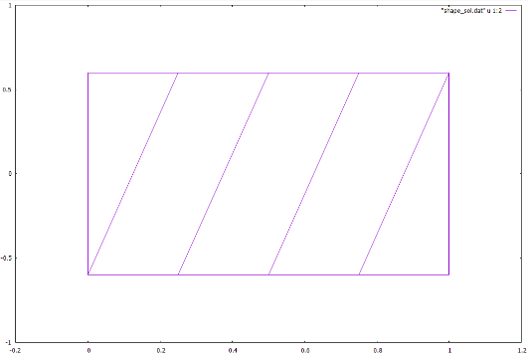
Once the data is read, we can process it. The program does that by preparing .dat files created based on the main file data and the shape files, these will be easier to read for Gnuplot having only the minimum required information to create the plot.
Figure 4: Example of solenoid shape file

Creating the elements layout

First of all, to scale a layout there are three necessary pieces of information: the element’s keyword, its position in the beamline and its length. This information is located in the main table coming out from the main file with the keys “KEYWORD”, “S” and “L” respectively; these three are the minimum to locate and scale horizontally the elements. Vertical scaling regarding the strength of the element is optional and can be defined by selecting the corresponding scaling variable (“ANGLE” for dipoles, “K1L” for quadrupoles etc.). So to identify these variables we compare the name of the expected elements with the keywords in the “KEYWORD” column; every time the two strings match, the position, length and strength of the element are stored. For this last feature, if the scaling variable is not defined then it stores the value <1>.
To create the layout for Gnuplot we use a routine that takes the table containing the length, position and height of every element and operates it with the table containing the coordinates that define the element’s shape. Basically it takes every x and y coordinates from the shape files and does two transformations for each position, length and height as follows:
$$X^{'}= X*length+position-length$$
$$Y^{'}=Y*height$$
X and Y the original coordinates; X’ and Y’ the new scaled set of coordinates. For a shape file that contains <n> points and for an element table containing <m> elements of that type, the program generates a <.dat> file with m*n points. It also creates an empty line between each set of points and also whenever there is an empty line in the shape file itself, so that Gnuplot does not connect the first and last points from different elements of a same type. This function is called for every type of element to be shown in the layout.

Creating gnuplot scripts and organizing the screen

Having all the necessary data in a readable format, we must create the Gnuplot script containing the ranges, the tics, labels and the plots in their respective places. This script makes use of the multiplot feature which allows to create multiple plots in one screen by using the plot command and defining the drawing limits for every graph. The screen is organized as follows:
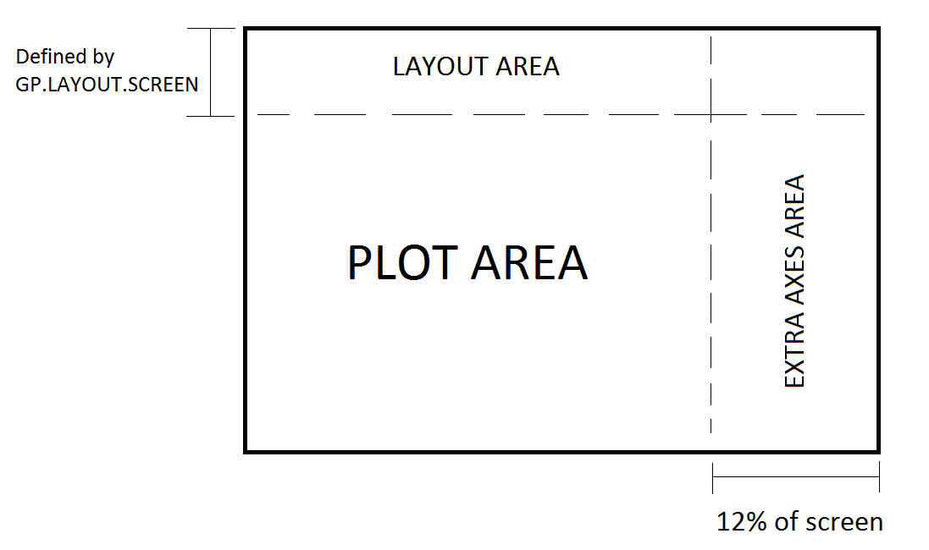
The main plot corresponds to between 100% and 88% of the screen length depending whether there are more than two Y axes (Gnuplot can nomially only allow for two axes, therefore we need a second plot to create the third and fourth axes), in that case the script would create a second plot covering 12% of the screen to contain the two other axes each one having 6% of the length. This proportion is fixed and cannot be modified by the user because it can lead to the overlapping of labels and tics. In the case of the elements layout at the top, its appearance can be activated or deactivated by the user as well as its space in the screen, this space in controlled by a variable called GP.LAYOUT.SCREEN in the program main script. The layout can only be shown if the graph corresponds to a twiss plot that is if the horizontal variable is “S” (position in the beamline).

Conclusions

The code developed has successfully managed to create scatter plots and lattice plots with and without a beamline layout. The plots can contain up to 4 axes just like the regular MAD-X graphic interface, and there is no limit to how many variables can be assigned to each vertical axis. The program is capable of supporting most of the options that the MAD-X PLOT and SETPLOT commands can support. Nonetheless there are certain remarks that must be addressed:

- An automatic vertical scaling was introduced such that combined with the user defined tics and a grid, it could be used to have an easy scaling and lecture with multiple axes, nonetheless sometimes this can end up with tic marks having non pleasing numbers such as periodic or irrational numbers.
- Even if the possibility of having multiple sets of data and also multiple axes in a graph is not really something common, on the possibility of that scenario it may end up with variables from different axes sharing a same colour and line style.
- For the scaling of the beamline elements, if a variable is assigned for the strength of certain type of element (K3L for an octupole for example) and it happens to be that all the octupoles are OFF (K3L = 0) then the program will define a vertical range of [0:0] to which Gnuplot will show an error and therefor won’t show the rest of the plot.
- For now the program creates a .dat file for every type of element in the beamline, even for those that share the same shape file. So the string tables containing their names are really long given the amount of different types of elements. This can be managed by using the string library to recognise patterns instead of comparing individually the keyword for each type of element.
- As for positioning of the multiple axes, it has been tested with font sizes up to 27, for fonts bigger than that the labels and tics from the additional axis may start to overlap even though they have a reserved area in the screen.
Having addressed these issues, we can conclude that we have successfully created a package that uses Gnuplot to obtain near publication quality plots. There is a lot work to do but I hope my work has help you to know that it was actually possible to do it, I hope this grain of sand has help CERN to grow a little bigger.

Annexes: Final code structure
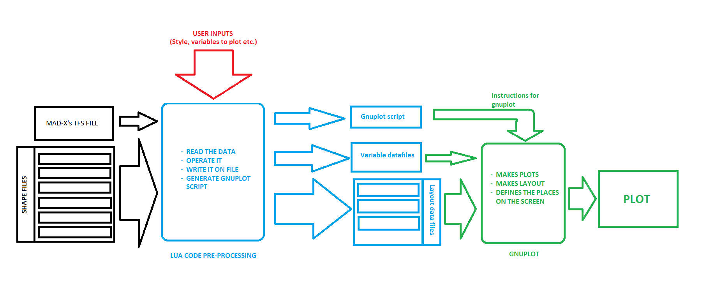
Figure 5: Schematic structure of the code

Annexes: plot results
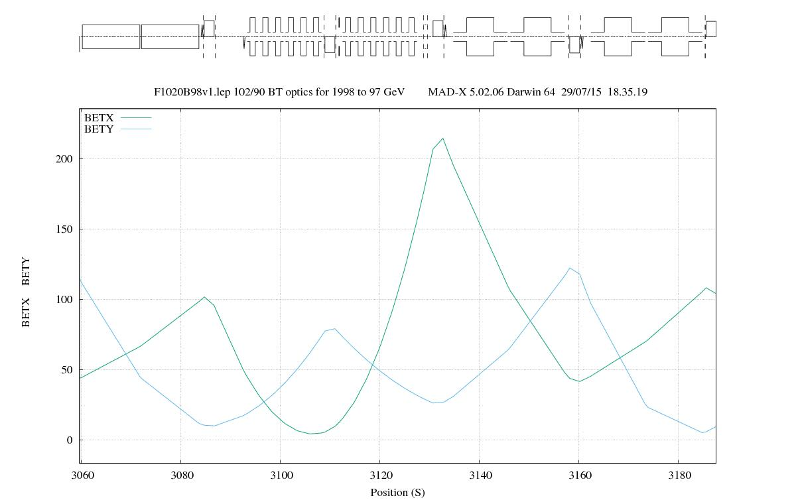
These are some of the plots created by the program:
Figure 6: Example of resulting twiss plot
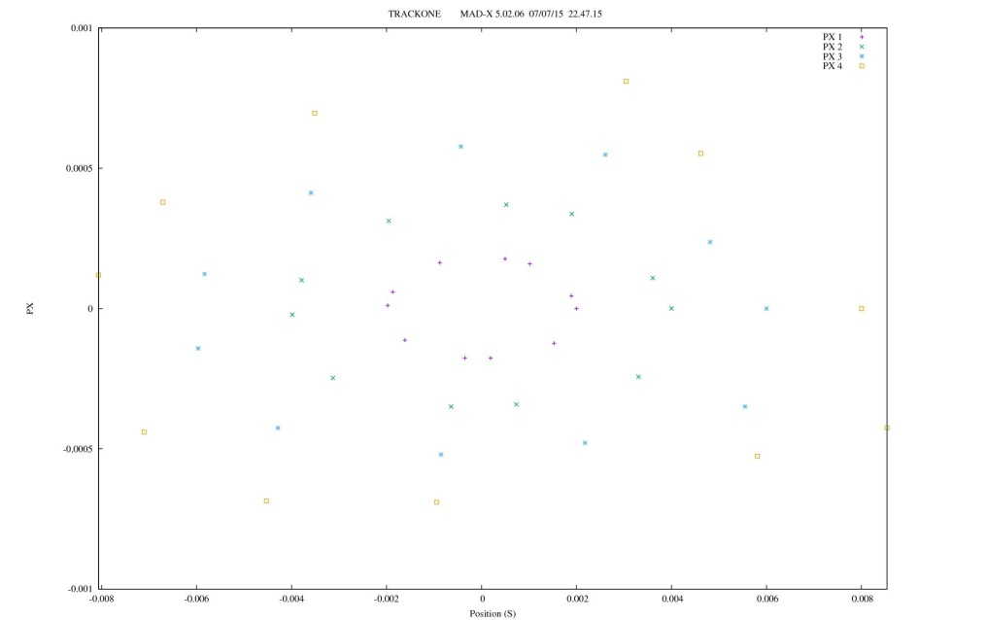

Figure 7: Example of resulting scatter plot

