Gas Electron Multiplier Technology in the CMS
Victoria Reddington
University of Denver - Denver, United States

Main Supervisor: Dr. Jeremie A. Merlin
Secondary Supervisor: Francesco Fallavollita
August 2018

Contact: victoria.reddington@du.edu

ABSTRACT

The forward region of the end-caps of the muon system of the CMS currently contain only Cathode Strip Chambers, which my face significant performance degradation after the high-luminosity upgrades of the LHC. The GEM Laboratory has researched and developed a solution to this problem that involves implementing the CMS muon system with Gas Electron Multiplier (GEM) detectors. My research in the GEM Laboratory focused on developing and testing a GEM detector prototype with the same capabilities but reduced size of a regular GEM detector to serve as a tool for continued outgassing studies. This work included completing the standard quality control tests on the prototype to verify satisfactory functionality. With its performance verified, the prototype can be used for future outgassing and longevity tests. Not all parameters of the GEM technology are completely understood, so these tests provide important data without jeopardizing any full-size detectors that are reserved for the CMS.

1 Introduction
The Large Hadron Collider (LHC) will soon be upgraded to achieve higher collision rates of particles at higher energies. Most components of the LHC will also receive updates to improve their performance and longevity in the new, high luminosity environment of the LHC. Part of the upgrades to the Compact Muon Solenoid experiment (CMS) involve implementing the forward region of the end-caps of its muon system with Gas Electron Multiplier (GEM) detectors. The muon system of the CMS aims to provide efficient and fast identification of the muons produced in the proton-proton collisions. Currently, this region has Cathode Strip Chambers, which work similarly to the GEM detectors but will likely be degraded after the LHC upgrades.
GEM detectors amplify the electrical signals left by the crossing of a particle. The GEM structure consists of a thin polyimide foil, coated with copper on both sides and perforated with a high density of microscopic holes. They are compatible with high luminosity atmospheres and have been shown to maintain their functionality in such an atmosphere for at least thirty years. Adding GEM detectors to the muon system serves as an important redundancy to ensure the continued functionality of the CMS [1].
I conducted research in the GEM Laboratory where the GEM detectors that CERN intends to implement into the CMS are assembled and tested for quality and satisfactory performance. My work focused on developing and testing a GEM detector prototype with the same capabilities but reduced size of a regular GEM detector to serve as a tool for continued outgassing studies. GEM detectors are subject to performance degradation if contaminants accumulate and block the microscopic GEM detector holes. Most of the contaminates that could cause this problem are a result of outgassing from a material used in the assembly of the GEM detectors [1]. Prototypes are therefore useful for outgassing tests because different contaminants can be injected into the gas chamber while the detectors performance is monitored. The longevity of the detector in the presence of the specific contaminant can also be determined. Before I could begin this work though, my supervisor assigned a smaller project to serve as training on the basic scientific principles behind the GEM detectors and the equipment used to test them. This project entailed the Multi-Wire Proportional Chamber (MWPC).
The MWPC provides detection and precise localization of particles that cross its path. It consists of a plane of parallel anode wires running through two parallel cathode plates. The average wire spacing is two millimeters and the distance between the wire plane and the cathode plates is six to eight millimeters. When a positive voltage is applied to the wires, an electric field develops from the external plates and focuses on the wires. When filled with the appropriate gas mixture, a particle crossing the detector releases electrons that drift along the field lines toward the vicinity of the wire. The electric field becomes intense enough to accelerate the electrons and trigger the rapid multiplication of electrons [2]. The GEM detectors work on the same basic principle as the MWPC, with the primary functionality of multiplying electrons, though the GEM detectors have the benefit of being more suited for long-term operation, the high rate environment of the CMS end-caps, and the type of gas used inside the detectors. Nevertheless, understanding the parameters involving the MWPC can be extended to understanding the GEM detectors [1].
Work with the MWPC provided valuable experience with the equipment, mechanisms, and general scientific principles of the GEM technology. Of course, there are important differences between the MWPC and the GEM detectors. Therefore, upon completing the training with the MWPC, my research shifted to work with a GEM detector prototype.
The prototype used was an older model of the GEM detectors currently planned for installation in the CMS, but with a few simple modifications, the older version was adapted to be akin to the newest version – we needed only change the spacing between the GEM foils inside to update it. As such, it works in exactly the same way as a full-size GEM detector.
The prototype was built in a clean room essentially in the same fashion as the full-size GEM detectors are built. There are three GEM foils and the drift plate with the standard 3-1-2-1 mm spacing between each layer, respectively. These layers are enclosed in a gas tight chamber and then encapsulated with a thin copper sheet to act as a Faraday cage and protect the prototype from background signals from other technological devices.
Before the prototype can be used in any experiments or outgassing studies, it must first be quality control tested and calibrated, if necessary, to ensure the full functionality of the prototype. There are five standard quality control tests (QC1-5) that are performed on every GEM detector at CERN before they are approved for installation. QC1 and QC2 consist of visual inspections that confirm the proper configurations of the detector. These were completed during the assembly of the prototype. QC3 tests if the chamber is gas tight. QC4 tests the voltage and current characteristics of the detector to identify possible malfunctions or spurious signals. QC5 tests the gain uniformity of the detector. After these tests are completed, there are additional quality control measures to ensure the complete functionality of the detectors upon compilation and installation into a super chamber; however, my research did not focus on these.
The QC tests served to verify the satisfactory performance of the prototype. Once verified, the prototype was used by other physicists to conduct several new experiments to investigate still not fully understood parameters of the GEM detectors. The conclusions deduced from these experiments equally apply to the full-sized GEM detectors. That is why this work is important: it offers new insights into the GEM technology.

2 Method
The following explanations provide a brief overview of how each experiment was accomplished.
MWPC: The general purpose of this experiment was to measure the particle count from an x-ray radiation source with respect to varying voltage in the MWPC. The experimental set-up consisted of the MWPC and the radiation source, all connected appropriately to the Scalable Readout System, placed inside a Faraday cage. The radiation source was pointed in the direction of the MWPC while a voltage of 1000 volts was applied to the wires. The x-ray source emits radiation that ionizes the gas atoms inside the chamber, such that electrons are produced, which can also go on to ionize and produce additional electrons. These electrons inside the chamber are drawn toward the wires because of the potential difference created by keeping the wires at a high voltage and the casing at zero volts. A signal can be detected from these electrons if it is above the threshold value – this is the particle count that was record. Then, the voltage was increased from 1000 volts up to 2000 volts in steps of 50 volts. At each interval, the particle count was measured for the duration of one minute. The count without the source present was also measured to determine the background radiation, which was subtracted from the particle count with the source present to determine the particle count of the source alone. This experiment was repeated with several variations, including changing the type of radiation source used (x-ray, Cd-109, Fe-55, and Am-241), increasing the attenuation of the signal, and changing the threshold value (30 mV, 60 mV, and 90 mV).
QC3: To perform the QC3, gas (70% argon, 30% carbon dioxide) was run through the chamber’s input port and out through the output port at a steady rate of 5 liters per hour. The chamber was first flushed, then the input and output ports were closed such that the gas lines no longer had gas flow, but gas remained inside the chamber. The internal pressure of the chamber was monitored for the duration of 20 minutes. A significant drop in internal pressure indicates a gas leak.
QC4: To perform the QC4, the current and voltage characteristics of the GEM detector were recorded to identify possible malfunctions or spurious signals. The background noise was also monitored to ensure it was not too high.
QC5: Gain is defined as a measure of the ability of a two-port circuit to increase the power or amplitude of a signal from the input port to the output port when connected to a power supply. All of the characteristics and detection performance of the GEM detectors are functions of the gain. Therefore, gain variations over the surface of a large chamber is a serious concern. Resultingly, ensuring gain uniformity of every detector is a critical part of the quality control process. The QC5 test was conducted using the GEM R&D stand with the Scalable Readout System to control and monitor the voltage and current characteristics of the prototype, the Tektronix digital storage oscilloscope to monitor the signal from the Scalable Readout System, and the Keithley picoammeter to monitor the gain of the prototype. With the radiation source off and then subsequently with the radiation source on, a voltage of 2860 volts was applied to the prototype via its electronics board to measure the particle count for the duration of one minute. This procedure is identical to that used with the MWPC. Meanwhile, a current of 550 microamps was applied to the prototype. The Keithley picoammeter recorded the average current and standard deviation for a duration of two minutes. This data was inputted into an Excel file, created by Dr. Merlin, to calculate the gain. This calculation is complex as it considers the monitored voltage, the voltage from the drift plate, the current, the particle count rate, the temperature and pressure of the laboratory, and several other correction parameters. After the particle count rate and gain were determined at a voltage of 2860 volts and a current of 550 microamps, for both the source on and off, the voltage was then increased in steps of 52 volts up to a voltage of 3640 volts, and the current was increased in steps of ten microamps up to 700 microamps. All of the data from these measurements were compiled into the same Excel file to produce a single graph of the particle count rate/gain versus voltage/current.

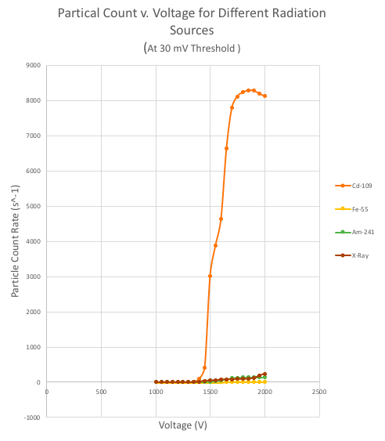
3 Results and Discussion
Graph 1
The central result of this thesis is that the GEM prototype passed the quality control tests and can therefore be used reliably to conduct outgassing tests. The satisfactory performance of the prototype ensures that future experiments can validly be related to parameters in the full-size detectors. The following information provides details about this central conclusion and others.
MWPC, Radiation Source Type: The individual graphs of particle count rate versus voltage for the cadmium, iron, americium, and x-ray sources all show a similar shape when scaled appropriately. There is a particle count of zero when the voltage is too low, then the particle count increases steadily until it eventually plateaus. All of the plateaus occur at around 1750 volts. Graph 1 compares the four radiation sources on the same scale. It is extremely clear from this graph that cadmium produces the highest particle count rate. This means that cadmium amplifies electrons more effectively than the other three sources, though all sources do capture similar readings when viewed on their respective scales. The significance of these results is the determination that any of the sources studied could be used with the MWPC to multiply electrons and detect signals, though cadmium would be the best choice if the amount of electron amplification was critical, meaning the higher the particle count rate the better.
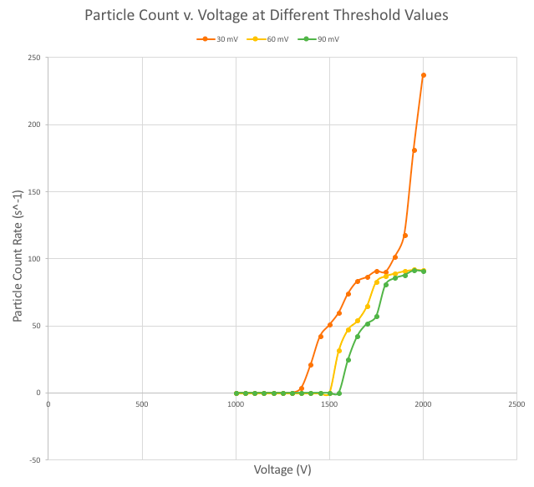
MWPC, Attenuation Amount: The attenuation, or the reduction of the amplitude of the electrical signal, was accomplished by placing several layers of copper tape between the detector and the radiation source to act as an impediment to the radiation and reduce the overall particle count. While the particle count for the x-ray source, at a threshold of 30 mV, was measured with several different levels of attenuation, the overall shape of the data, when plotted against voltage, remained the same. Increased attenuation may be necessary to essentially “clean up” the data and ensure that the particle count is not too high for the equipment to accurately measure. However, in this specific case, the change in attenuation did not significantly affect the experimental results.
Graph 2
MWPC, Threshold Value: Graph 2 shows the particle count rate versus voltage for the x-ray source at three different threshold values: 30 mV, 60 mV, and 90 mV. The three lines have extremely similar shapes, which was expected because the radiation source did not change. Changing the threshold value essentially just right-shifted the data. As a result, when the threshold is higher, the plateau occurs at a higher voltage. This is important information because the Scalable Readout System has voltage limits that cannot be surpassed or else the equipment could be permanently damaged. The threshold value provides a means by which more of the data can be “seen” at lower voltages. The threshold value of 30 mV was therefore deemed most suitable for the rest of the experiments.
QC3, QC4, QC5: The quality control tests completed on the prototype followed the standard procedure of each test, for which all GEM detectors undergo. Therefore, the details of the results of these tests will not be given here; the important result for each test is an indication of whether the detector passed or failed. The prototype passed all five quality control tests performed on it. Consequently, the prototype was deemed ready for use in future experiments because its functionality was verified to be satisfactory by the GEM Laboratory standards.

4 Conclusion/Final Remarks
Particle physics is about advancing humanity’s knowledge and understanding of the universe by investigating the fundamental constituents of all matter and the forces that they interact with. If CERN is the bedrock of particle physics, then my research is a pebble in that bedrock. As a member of the CERN Summer Student Program, the primary goal of my research was simply to learn. I can proudly confirm that this goal was accomplished. I deepened my understanding of particle physics with the CERN Summer Lecture Series, improved my repertoire of scientific equipment with daily use of the Scalable Readout System, Tektronix digital storage oscilloscope, and Keithley picoammeter, and tested my patience with the GEM detector quality control tests. In tangible terms, I built a functioning prototype. This prototype holds eminent implications for the outgassing studies of the GEM detectors. The GEM detectors are a notable sub-system of the muon system within the CMS. Their continued range of capabilities will be relied on after the LHC upgrades, which is why the outgassing tests to verify their sustained performance are so important. Ultimately, the GEM detectors will contribute to the CMS in identifying new elementary particles. Progress may be slow, but the ramifications of improvements to the Standard Model and beyond are astronomical. CERN is about accelerating science. My research was an effort in collaboration – a small, but not insignificant, contribution to this acceleration.

Acknowledgements
I participated in the CERN Summer Student Program from June to August of 2018, with the sponsorship of the University of Michigan - CERN REU Program and funding from the National Science Foundation, USA. Thank you to all of these organizations for supporting my research. I would also like to thank my supervisors, the summer students I worked closely with (Daniel Bosworth and Maxime Lepine), and the GEM Laboratory for their guidance and assistance throughout the summer.

References
[1] Merlin, J. A. (2016). Study of Long-Term Sustained Operation of Gaseous Detectors for the High Rate Environment in CMS (Doctoral thesis). CERN, University of Strasbourg.
[2] Sauli, F. (1977, May 3). Principles of Operation of Multiwire Proportional and Drift Chambers [PDF]. Geneva: CERN.

