CERN Summer Student Essay 2016
Naomi Mburu
CERN supervisors: R. Guida, B.Mandelli

1. Introduction
The experiments along the Large Hadron Collider (LHC) at CERN utilize gaseous detectors to track muons in the outermost portion of the experiment. For example, in the Compact Muon Solenoid (CMS) experiment three types of gaseous detectors are used as muon trackers: Resistive Plate Chambers (RPCs), Drift Tubes (DTs) and Cathode Strip Chambers (CSCs). RPCs use a gas mixture of Freon (C₂H₂F₄), sulfur hexafluoride (SF₆) and isobutane (iC₄H₁₀). The Freon is used to induce an avalanche ionization reaction once a muon has entered the chamber. The isobutane serves as a quenching gas to absorb photons created in the avalanche, and sulfur hexafluoride provides a source of electronegativity to absorb the possible excess of free electrons of the avalanche. The components of this gas mixture are both expensive and have high global warming potentials, so most of the gas mixture must be recycled and purified through a gas recirculation system. For this reason, RPCs employ purification systems that remove impurities due to the contamination and irradiation of the gas mixture that occur during normal operation of the LHC. My goal for this summer was to set up gas analysis tools to study impurities produced in the RPCs and to quantify the ability of the purification systems to remove these impurities.

2. Gas analysis devices used at CERN for particle detectors
At CERN three devices can be used to study gas quality: ion selective electrode (ISE), gas chromatograph (GC), and mass spectrometer (MS).

2.1 Ion Selective Electrode
The ISE works by determining the potential difference between the working electrode, which is immersed in the sample, and the reference electrode, which is immersed in the standard ion solution. This potential difference is converted to a concentration of ion in the sample solution using the Nernst equation:
$$E_{cell}=E^{O}-\frac{RT}{nF}lnQ$$

where E is the potential of the sample solution, E^{O} is the reference potential, R is the gas constant, T is the temperature, n is number of electrons transferred per reaction, F is Faraday’s constant and Q is the reaction quotient, which can be used to determine ion concentration. The final goal was to set up the ISE station before and after one of the purifiers to determine the quantity of fluoride ions coming from the irradiated detectors and how the purifier handles the accumulation of fluoride ions over time. To do this, the electrodes first must be calibrated, stability tests must be run and finally it is possible to install the ISE station in the experimental gas racks.
I began my summer by calibrating the electrodes we had in the lab and determining which ones were working. To create a calibration curve, the electrodes must be calibrated with 0.1, 1, 10, and 100 ppm Fluoride standard solution and then tested with a variety of solutions between 0.1 and 100 ppm. I used 0.2 ppm, 0.5 ppm, 1 ppm, 2 ppm, 10 ppm, and 100 ppm for my calibration curve. The potential value was recorded for each data point and graphed against the negative log of the solution concentration. A slope of 56+/- 4 mV indicates a working electrode. Figure 1 shows the calibration curve for seven of the eight electrodes that I began with. The eighth electrode was damaged and did not register differences in fluoride concentration, so it was not included in the results.

Figure 1. Calibration curves for seven tested electrodes

From the calibration curve results, I concluded that electrodes A, C, D, and OLD were working properly. The working electrodes were then tested for stability by placing them in 1 ppm solution for an extended period of time and recording the results. Stability tests are important because it is necessary to distinguish electrode fluctuations from actual changes in fluoride concentration. Figure 2 shows the initial 26 hour stability test that was performed on all four working electrodes at once. All of the tested electrodes except electrode A showed stable readings over the 26 hour time period, so electrode A required troubleshooting. The four broken electrodes also required troubleshooting to determine which part of electrode was not working. Once the broken part of the electrode was identified, restorative procedures detailed in the manual were then carried out in an attempt to fix the broken electrodes. I was able to restore electrode A by shaking down the crystal sensor and thoroughly cleaning the electrode. The four initially broken electrodes were not able to be restored, so replacement electrodes were ordered. A secondary stability test was run on electrode A in parallel with electrode D as shown in Figure 3, and both electrodes showed relatively stable readings.

Figure 2. Stability graph for electrodes A, C, D, and OLD in 1 ppm solution

Figure 3. Stability graph for electrodes A and D in 1 ppm solution

After the electrodes were calibrated and tested, the ISE station was then ready to be assembled at a gas system rack. Gas lines before and after the purifier were bubbled into an Erlenmeyer flask filled with water where the electrodes were inserted. The increase in fluoride concentration over time is currently being monitored. Future work will include comparing the fluoride increase for before versus after the purifier and determining the effect of the fluoride build up over time on the lifetime of the detector.

2.2 Gas Chromatograph and Mass Spectrometer
The remaining two devices used to analyze gas mixtures, gas chromatography and mass spectrometry, are used together to separate gas components and determine the amount and identity of each component. During gas chromatography, a gas mixture is sent through a column lined with a substance that reacts with the gas mixture components in varying amounts. The components that react the least with the column lining will travel the fastest, thus creating a time separation of the gas mixture components. These separated components are then sent to a thermal conductivity detector (TCD) which determines the amount of each component using a Wheatstone bridge that compares the thermal conductivity of the gas component to the thermal conductivity of the carrier gas. Since the GC and TCD do not destroy the sample gas, the MS can be coupled with this system. MS identifies the components of a gas mixtures by ionizing the gas and sending the accelerated gas through a magnetic field. The deflection of the particle is inversely proportional to the mass of the particle, so light particles will be deflected the most in the field. Mass to charge ratios are then determined and graphed against relative abundance. The mass spectrums for many compounds have already been determined, so reference spectrums are used to determine the identity of the component.

GCs are already used in the CMS and LHCb experiments to monitor the gas mixture composition and quality. The GC/MS combination is useful in this research for quantifying and identifying new possible impurities in the gas system. Before analysis can be carried out, the systems must be physically set up and the software must be properly installed and understood. After that, the system can be used to analyze gas mixtures. This summer, I have worked on understanding the GC/MS software and learning how to identify new impurities in the gas chromatograms. A previous study conducted at CERN a few years ago identified several gas impurities that can be found before and after the purifier. This study, however, was completed on RPC detectors that were irradiated with a strong gamma source and were placed in a gas system where about 90% of the gas was being recirculated, so the impurities were more prevalent. The systems that I am now studying are circulating about 50% of the gas mixture. Figure 4 shows a typical chromatograph. The impurities are present in much smaller quantities than Freon, isobutane, and sulfur hexalfuoride, so it is necessary to zoom in to discover these peaks, especially if the beam has just been turned on. As the time the beam has been running continuously increases, the prominence of the peaks also increases. Figure 5 shows a zoomed in chromatogram before the purifier where potential difluoromethane and propane peaks are visible. Future work will involve running analysis after the beam has remained on for a longer period of time, and also comparing the before purifier and after purifier chromatograms to determine whether the impurities stem from the detector or from the purifier.
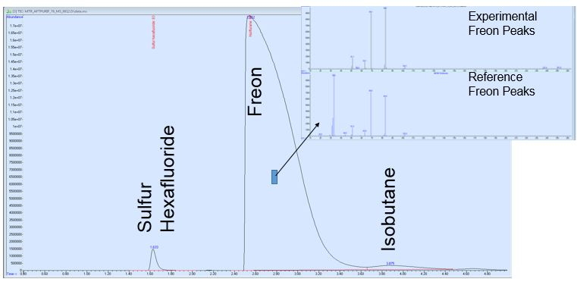
Figure 4. GC showing relative amounts of Freon, sulfur hexafluoride, and isobutane. The subset image shows experimental and reference MS peaks for Freon.

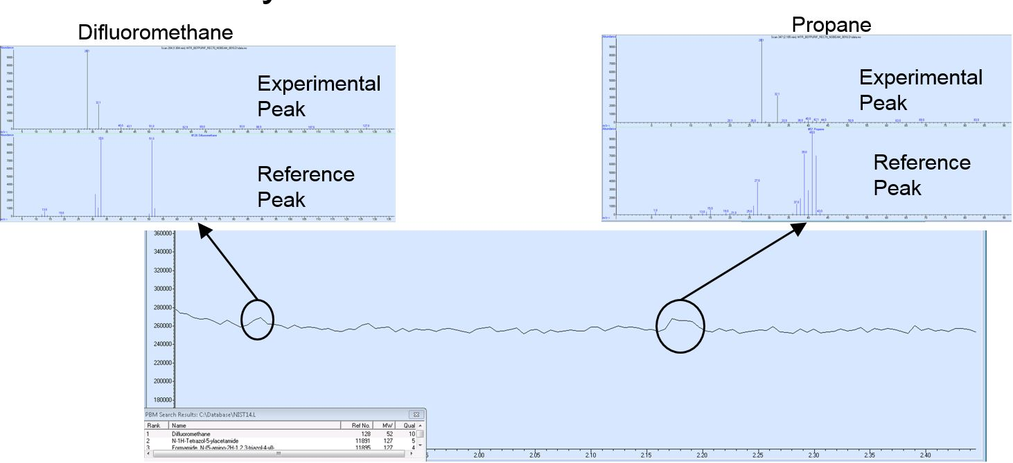
Figure 5. Zoomed in image of GC/MS results, in which potential difluoromethane and propane peaks are identified.

My project also involved upgrading one of the GC systems to automate the selection of the sample gas. This involved setting up a valve system that connects to all of the gas lines of interest, and configuring the GC software to allow for remote switching of the gas lines. So far, the valve system has been set-up, and the software has been installed. Future work will include syncing the software with the physical valve system and creating a method that will allow for the remote analysis of a series of gas mixtures.

3. Conclusions
In conclusion, this summer I have worked on setting up and completing analysis with the ISE, GC, and MS devices. I have successfully set up the ISE station and the system will be collecting data continuously after I leave. I also was able to learn the GC/MS software and complete some analysis on gas mixtures before and after the purifier. Lastly, I was able to set up valve control software and learn more about how the gas lines are connected for a typical LHC experiment. Overall, this experience has provided a very practical atmosphere to utilize engineering skills that I have learned thus far in my studies. I thoroughly enjoyed mixing with physicists, engineers, mathematicians and computer scientists throughout the summer, and I look forward to more opportunities to expand my knowledge of engineering in the future.

The crystal sensor is composed of a Lanthanum Fluoride crystal membrane. This is the part of the electrode that is placed in the sample solution.

