

Summer Student Programme Report:

FMCM Test-Bench

  - By: Kristina Hedin
  - Supervisor: Ivan Romera Ramirez
  - Date: 24/08/16

1. Introduction
The High-Luminosity Large Hadron Collider (HL-LHC) project, which aims for increasing the performance of the LHC, requires a review and upgrade of the existing machine protection and interlock systems. One of these interlock systems is the Fast Magnet Current Change Monitor (FMCM), which protects accelerator equipment from being damaged by the beam in case of powering failures in normal conducting magnets. The FMCM measures the current in warm magnets in the Large Hadron Collider (LHC) and its transfer lines (TL), in order to detect rapid current changes due to powering failures. It is connected to the Beam Interlock System (BIS) through a user interface (CIBU), providing the system with a beam permit signal. If an FMCM detects fast changes in the magnet current caused by powering failure, it removes the beam permit causing a beam dump. Considering the HL-LHC project, a new batch production of FMCMs has been launched. The goal of the project was to design a test-bench platform to program, configure and functionally test the new FMCM interlock devices after their factory assembly to validate the functioning of these.

2. FMCM functional description
The FMCM is an interlock system used for detecting fast current changes in case of powering failures, and in these cases issue a beam dump request to the BIS. The FMCM detects critical powering failures by monitoring the voltage from a magnet, performing calculations on the signal to obtain a signal representation of the fast current changes in the magnet, and comparing this signal to a threshold.
The magnet voltage is firstly conditioned with an external voltage divider box and an isolation amplifier box. The signal then enters the FMCM where it passes through a low pass filter and a high pass filter. The low pass filter provides a signal that is a representation of the magnet current. The high pass filter is used to amplify the fast current changes that are significant for a powering failure of the circuit. The FMCM only detects fast changes within the last millisecond. The signal representing the fast current changes in the magnet is fed into a comparator, which compares this with a threshold to detect if it is outside of a certain threshold window. The threshold window is set by the user with a manual knob on the front panel. The threshold defines the threshold window’s upper and lower limits. Any value of the signal from the high pass filter that is outside of the tolerance window is detected by the FMCM, which then issues a beam dump request.
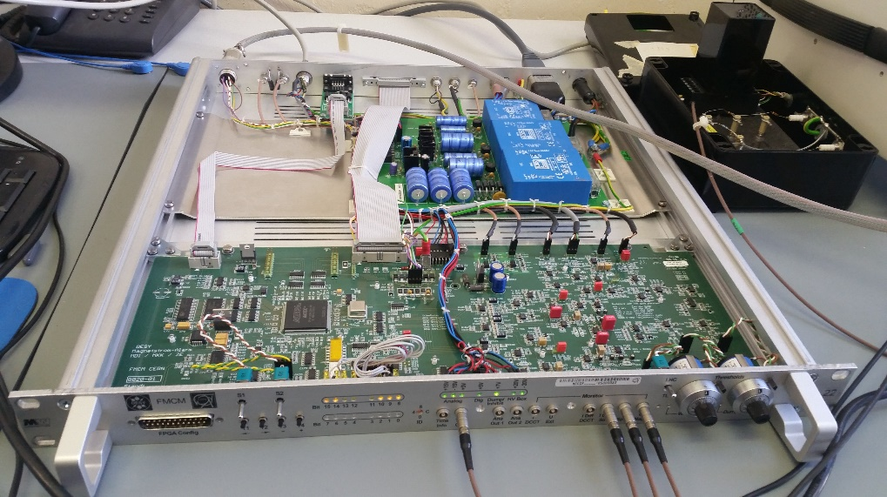
Figure 1: The figure displays a FMCM with power supply, voltage divider box and isolation amplifier.

3. Electrical Test
Electrical test of the printed circuit board and power supply was performed, in order to ensure electrical correctness.
The power supply was powered and the transformer, rectifier bridge and voltage regulator where examined using a multimeter to measure the voltage on corresponding components. The output voltages from the power supply ±20 V, ±15 V, ±5 V Digital and ±5 V Dump were also verified using a multimeter.
±15 V and ±5 V were provided to the main PCB from an external power supply, ensuring that current flow in the circuit did not surpass dangerous levels. Power supply to all active components in the PCB was verified, and signal to FPGA was confirmed. This was done using a multimeter to measure voltages on different components.
Short circuits where found in the PCB. After further examination it was found that, due to errors in assembly of the PCB, a resistor was accidentally placed under an operational amplifier causing it to float above the board. However, the main reason for the short circuit is believed to be that two resistors where accidentally mounted where there should be capacitors placed. This was found using a thermal camera. Another error found was that a voltage regulator ordered and placed on the board was accidentally the wrong type. All the errors were corrected and the PCB could be verified to be electrically correct.

4. FMCM Test-bench
The purpose of the test-bench is to be able to verify the performance of the FMCM. This will be done by connecting a simulated magnet voltage to the FMCM, acquiring the response signals from the FMCM, calculating a theoretical FMCM output in the test program and comparing the theoretical response to the actual response from the FMCM. The theoretical output is plotted against the actual output from the FMCM, and the user is able to visually verify the performance of the FMCM. The difference between the theoretical output and the actual output from the FMCM in each data sample is measured to examine the accuracy of the FMCM output. This difference is compared to a user defined tolerance value, and if the difference exceeds the tolerance the test is not passed. The test is developed using a National Instruments PXI system programmed with LabWindows/CVI.

4.1 Data generation and acquisition
For the data generation and acquisition, there is one differential analogue output channel and six differential analogue input channels. The program generates and acquires a finite number of voltage samples each time the program runs.
The analogue output channel is used for simulating the magnet voltage (Umag) which is to be connected to the FMCM. There are two ways to generate the analogue output, creating a square wave or applying a pattern from a file. The values of the signal are converted to voltages in the PXI chassis and connected to the FMCM input. When generating a square wave, the user must define an amplitude. The square wave is a step function from the given amplitude to zero, in which the step occurs after half of the generated samples (i.e. 50% duty cycle). The possibility of generating a pattern from a file allows the user to generate an actual magnet voltage signal taken from post mortem data so the FMCM can be tested for the response to real magnet voltage perturbations.
The six analogue input channels are all outputs from the FMCM. Table 1 displays the different analogue inputs with description.
Table 1: Analogue input signals to the tester from the FMCM board and description of these.
Signal name | Description
umag | Umag is the signal that the FMCM receives. This signal is used for simulating the theoretical response.
ISim | ISim is the current representation of the magnet voltage in the FMCM. This is the signal after the low pass filter.
IDiffSim | IDiffSim is the representation of the fast current changes in the magnet. This is the signal after the high pass filter.
TrigOut | TrigOut is a representation of the user permit used for testing. It is approximately 5 V (fail-safe logic) when user permit is true and 0 V when user permit is false.
UserPermit a | UserPermitA is a user permit signal that is connected to the CIBU. This signal is approximately 5-8 V (depending on the power supply) when user permit is true, and 0 V when user permit is false.
userpermit b | For redundancy, there are two user permit signals. UserPermitB functions the same way as User Permit A.

4.2 Program functionality
The GUI has three tabs, the Overview, the Parameters and the Test tab. The Overview tab includes a help button and exit button. The Parameters tab includes all necessary inputs the user may need to provide for the test and some informational indicators. The test tab includes the start button for the test, indicators displaying some of the chosen parameters and the test output.

4.2.1 Parameters for testing
Figure 2 displays the Parameters tab. Under “Data Generation” the user must choose what type of signal should be generated for the analogue output. As previously mentioned, the user can choose between a square wave and a pattern from a file. The voltage divider is not used for testing, so a scaling factor, which will be multiplied with the samples in the pattern, must be provided by the user if an actual magnet voltage pattern is to be applied. The reason for this is that magnets can work with voltages up to 1000 volts, whereas the FMCM is designed to monitor voltages in the range of -10 to 10 V.
The user must specify the time constant (Tau=RC) for the low pass filter and the high pass filter. This is used for calculating the theoretical output of the filters. The user can choose if the FMCM should operate in LHC-mode or in TL-mode by flipping a switch on the front panel of the FMCM. The time constant in TL-mode is smaller than in LHC-mode, because they usually have lower time constants and therefore changes of the current are faster there. When TL-mode is chosen, a resistor is connected in parallel to the first one to reduce the size of R. Therefore, the value of the total R must be inserted by the user to calculate the correct theoretical response from the filters.
The FMCM can operate in unipolar or bipolar mode to be compatible with both unipolar and bipolar magnets. The user can select polarity using the PARAM[6] switch on the main board. In unipolar mode the analogue output and input voltages range between 0 to 10 V, and in bipolar mode they range between -10 to 10 V. Therefore, the user should provide the polarity to configure the tester correctly.
The user should make sure the threshold for the theoretical response calculation is the same as the actual FMCM threshold on the front panel. The tolerance represents the maximum deviation the FMCM IDiffSim is allowed to have from the theoretical IDiffSim. The tolerance is given by the user as a percentage, which is then used for calculating a maximum value the FMCM IDiffSim can deviate from the theoretical IDiffSim depending on the theoretical IDiffSim value. This percentage represents the maximum deviation the FMCM output is allowed to have from the theoretical output in each sample.
Furthermore, the user can choose a desired rate of generating and acquiring signals. This is provided because the maximum possible rate can vary between different types of PXI systems. The user can also choose how many samples per channel is wanted for the analogue input and output channels in the square wave configuration.

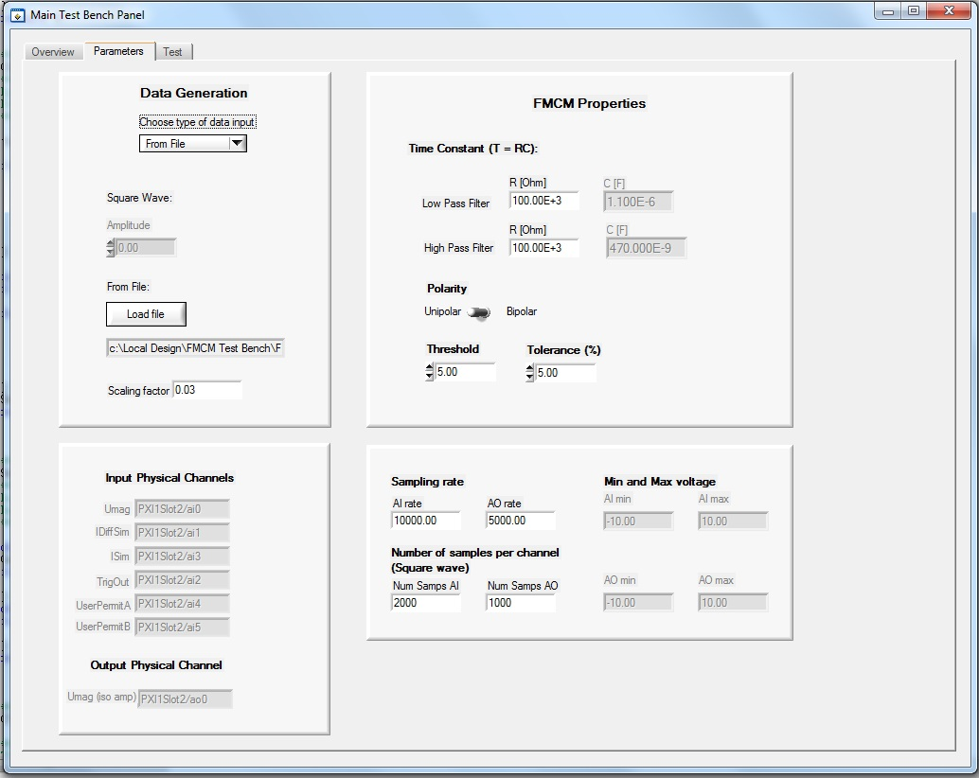
Figure 2:The figure shows the parameter tab in the user interface.

4.2.2 Test output
The theoretical output consists of the three signals ISimTH, IDiffSimTH and TrigOutTH, which are the theoretical calculations of the FMCM response. A low pass filter is simulated to obtain ISimTH and a high pass filter is simulated to obtain IDiffSimTH. The signal IDiffSimTH is compared to the threshold that the user provided. If IDiffSimTH exceeds the threshold TrigoutTH is set to 0 V, otherwise TrigOutTH is 5 V.
The verification of the FMCM is partly done visually by the user by examining the plot with the theoretical output signals and the FMCM output signals. Furthermore, the difference between the FMCM output (IDiffSim) and the theoretical output (IDiffSimTH) in each point is measured and plotted in a separate plot. This plot also includes the tolerance for each data sample. The deviation between the theoretical IDiffSim and the IDiffSim from the FMCM is compared to the tolerance in each data sample. If the deviation exceeds the tolerance the test fails. Figure 2 shows the Test tab after a test. The green LED indicates that the tolerance was not exceeded and the test passed.

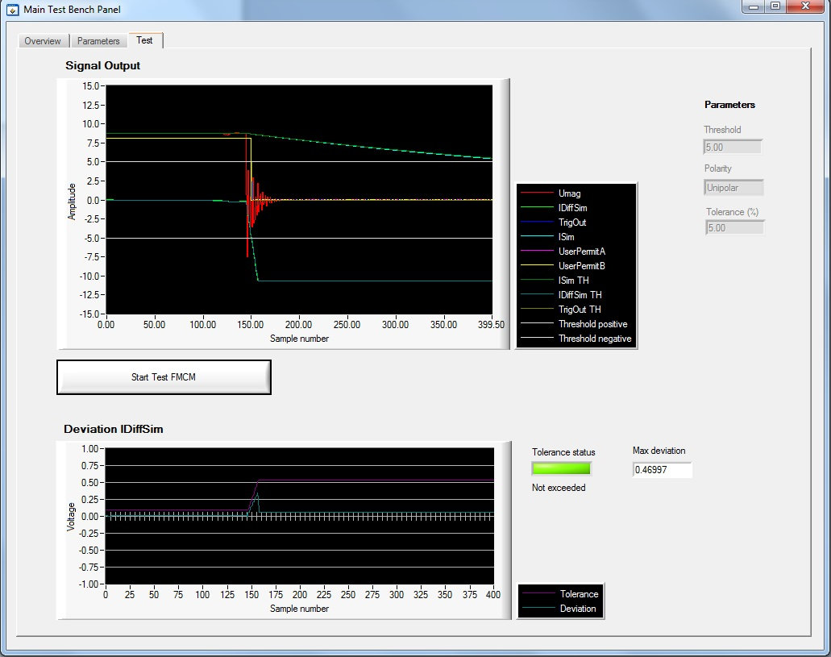
Figure 3: The figure shows an example of the Test tab after performing a test.

Learning outcome
During this summer student programme, I have gained experience in many different areas. I have learned how to electrically test a PCB, how to use LabWindows/CVI to programme a test-bench and the main difference between LabWindows/CVI and LabVIEW. I also gained understanding of the FMCM, its functionality and how it is connected to the Beam Interlock System. I have gained valuable experience from working in a multidisciplinary and multicultural environment, and made new important contacts and friends.

References
- User manual of the FMCM – EDMS 1609872
- Requirements for the FMCM in the LHC and the SPS-TLs – EDMS 678140
- http://hilumilhc.web.cern.ch/

