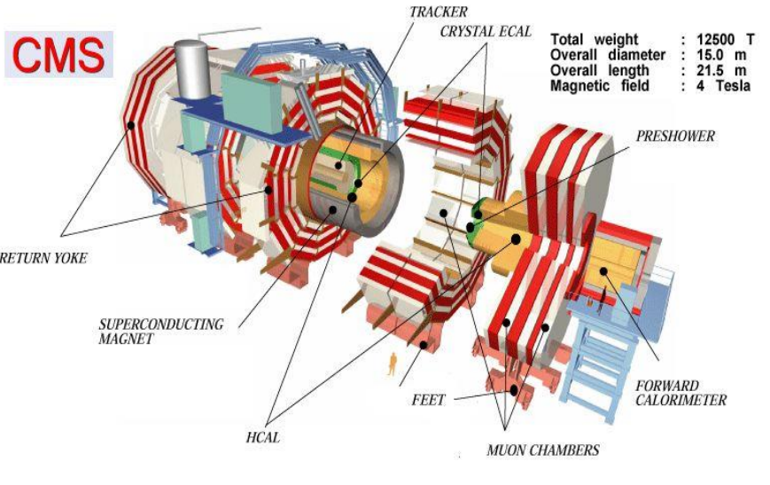

CERN NMS Summer Student Program 2016
CMS GEM Detectors
Fahad Al-Thani
Supervisor:
Dr. Archana Sharma

Introduction
For the last year I worked as a researcher on the CMS GEM detector with Dr. Othmane at Texas A&M University at Qatar. The summer internship at CERN was a great opportunity for me to visit and see how the detectors are build and to help on testing them. Also during my stay here I was able to attend the morning lecture series along with some visits to various facilities at CERN. I have attended some of the workshops in the first weeks which were both informative and interesting. The following are brief summary about each of these things I did. Picture 1 shows the CMS GEM detectors that will be installed in the future.
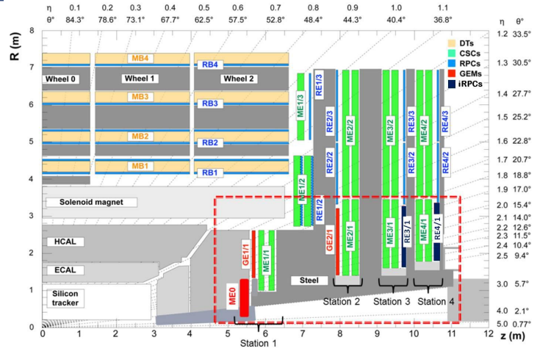
Picture 1CMS GEM Detectors Upgrades
Summer Lectures
The summer lectures in the morning was a six months course that started from the 28th of June to the 5th of August. The presentations were from 9:15 to around 12:30 and they were about various topics about physics, work here at CERN and the future of it. The physics lecture focused more about the standard model and its problems. Also it introduced the BSM physics and how it can be approached. The lectures about CERN focused on its facilities (like ISOLDE) and its upgrades and the FCC. I think one of the best lectures was about antimatter and it was given by Dr. Michael Doser. The presentation introduced dark matter, what it is and if it can be used and produced. After the lecture Dr. Michael showed us the antimatter device of the movie angles and demons and its picture is shown in picture 2.
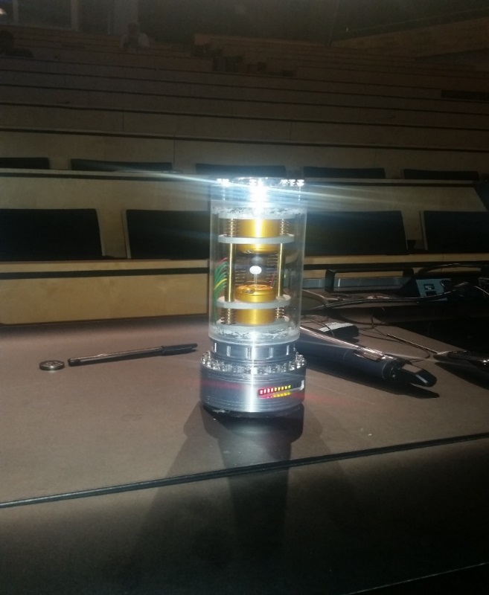
Picture 2 Antimatter canister From Angles and Demons
Visits
We had two visits scheduled to us to different facilities at CERN. The first one was on the 7th of July and it was to the antiproton decelerator and to the data center. In both of them we were introduced to the facilities, what they are doing in it and what are the future upgrades to them. The same thing was for the second visits which were on the 21st of July (to ATLAS and Synchrocyclotron), however for the synchrocyclotron we were given a presentation about its history and the CERN history in general. The fifth visit we had was to the ISOLDE facilities and we had a presentation about it given by Dr. Magdalena Kowalska who works there. The following pictures (3-7) are for the places we visits.
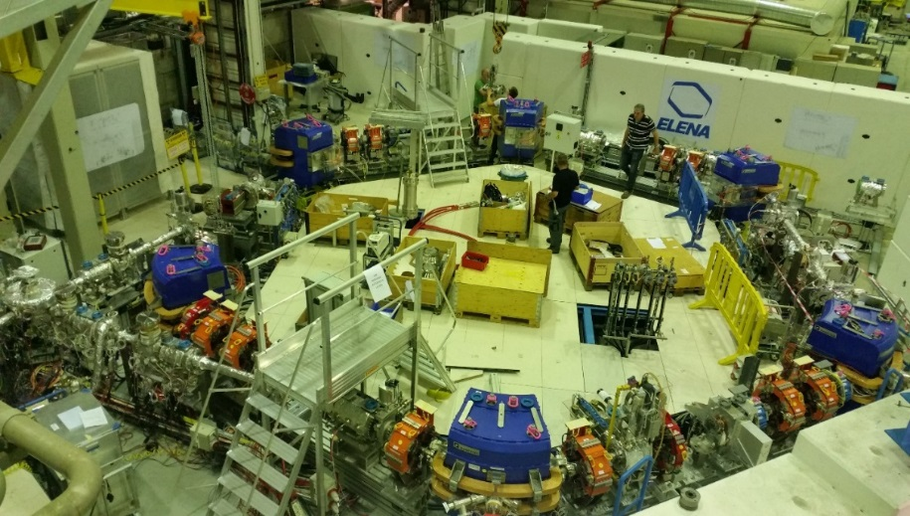
Picture 3 AD Facilities
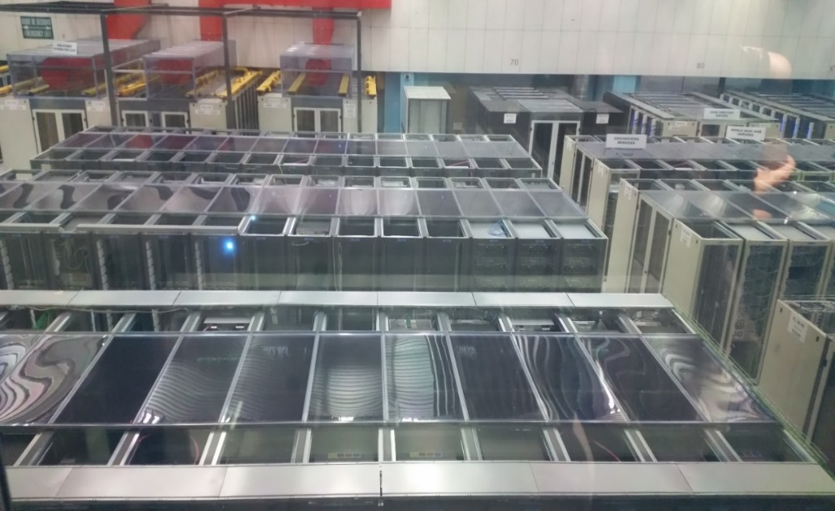
Picture 4 DC Facilities
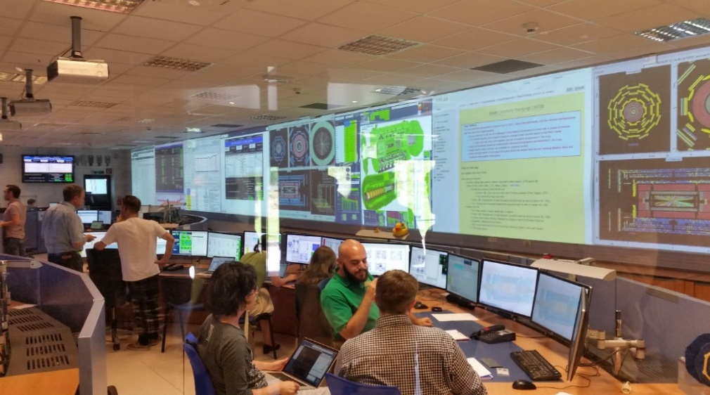
Picture 5 ATLAS Control Room
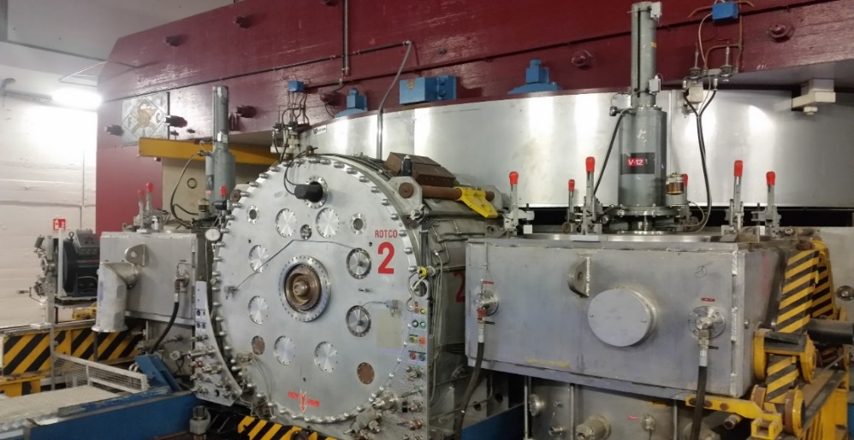
Picture 6 SC
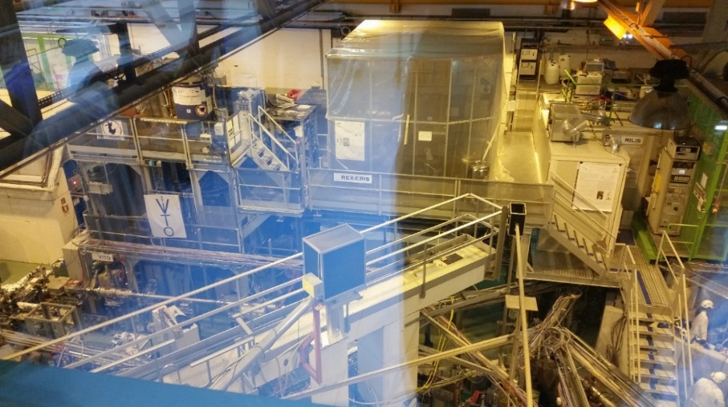
Picture 7 ISOLDE Facilities
Workshops
During my stay here I was able to register for two workshops (although I tried to register in more workshops but unfortunately they were full all of the time). The first one was about a programing language called ROOT. We were introduce to it and its uses also the similarities and differences between it and other programming languages. The second workshop was called Cloud Chamber and it was aimed to show us how to make a cloud chamber using tools found at homes. The following picture shows the tracks of the cosmic particles in the cloud chamber (picture 8).
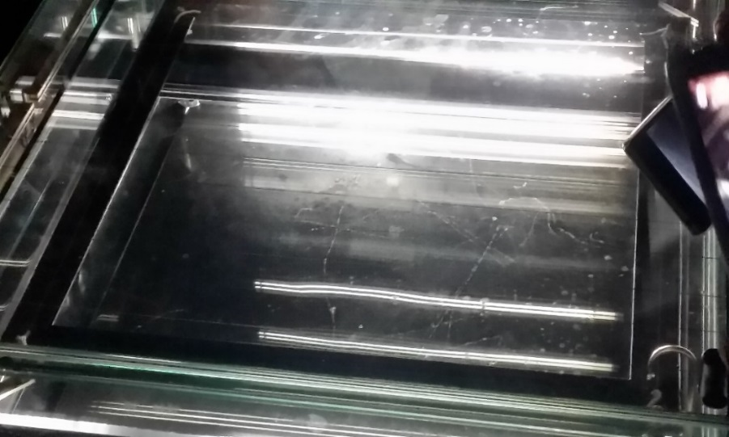
Picture 8 Cloud Chamber
Testing the CMS GEM Foils in 102 and 186
We worked mainly in QC2 (both long and fast) testes for the CMS GEM foils. The QC2 fast was done in the workshop (102) and the lab (186). It is done by suppling a constant voltage of 550 V by the megger (picture 9) to the foils and then measure the abidance and the number of sparks for 10 minutes (once every 1 minute). This determine whether the foil is clean or not (if it is clean we go to the next step otherwise it returned back to be cleaned). The QC2 long consists of two parts local and remote modes. Before stating them the foils are rolled by a Roller to clean it and then they placed into the HV box. For all the various tests of the QC2 the temperature and the humidity are measured. After finishing the test the foils will be ready to be installed in GEM chambers (picture 10) and go for the other QC tests.
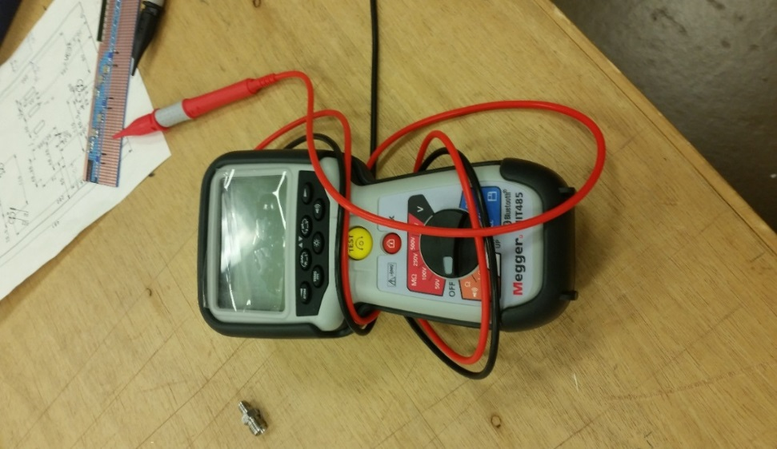
Picture 9 Megger
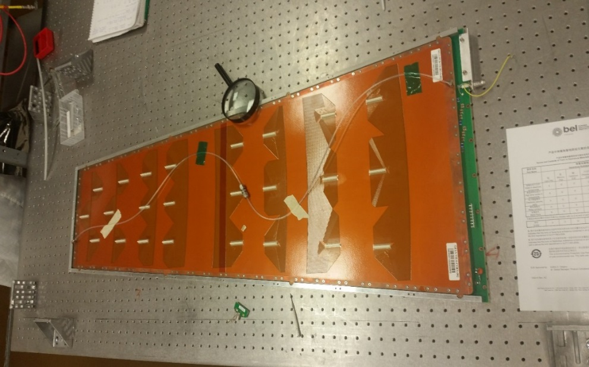
Picture 10 GEM

Conclusion
To sum up, the internship helped me to understand CERN in general and the GEM detectors specifically. I also enjoyed meeting new peoples and working with them. From working in the lab to attending the morning lectures I learned lots of things about not only CERN but the components of the universe around us along with its history and what could happened to it in the future. I liked the work environment here and the people were very kind and helpful. I am looking forward to visit CERN again in the future.

